**[](https://falconchristmas.com/forum/index.php)**

**Falcon Player Manual**

**Version 2.0**

**August 2019**

**Written by Rick Harris**

**Technical editor Mark Amber**

**This couldn’t have been possible without the help and support of Chris Murdoch and Dan Kulp answering my never ending questions.**

# Introduction

The Falcon Player (FPP) is a lightweight, optimized, feature-rich sequence player designed to run on low-cost Single Board Computers (SBC). It was originally created to run on the $35 Raspberry Pi, hence the middle 'P' in the short name but now the FPP supports many more systems. The FPP shorthand is still used but it is now just called Falcon Player. FPP is a software solution that you download and install on hardware which can be purchased from numerous sources around the internet. FPP aims to be controller agnostic, it can talk E1.31, DDP, DMX, Pixelnet, and Renard to hardware from multiple hardware vendors. This includes controller hardware from Falcon Christmas available via COOPs or in the store on <https://FalconChristmas.com>.

Up until the end of the 2015 Christmas season, most users of FPP used the Raspberry Pi as the main player. Since then it has expanded with the BeagleBone series of SBCs being utilized as well.

The FPP can interface to a number of controllers. It can also play synchronized audio via an audio port /FM transmitter, synchronized video (via an HDMI or VGA port), it supports USB devices, and external interfaces via the GPIO bus. It can also drive pixels directly via the GPIO bus.

Many people use FPP as the main and only player by connecting it to one or more (E.131/DMX) controllers and run their light show sequences and audio off it. Others will use several FPPs operating in various modes to run their shows, play videos from a remote projector, control animatronics, or handle outside events that are all synched to the main (master) FPP.

The Raspberry Pi hardware running FPP software can be utilized with a cape to act as a controller to control a small matrix (36 P10 or 15 P5 panels) or 2 strings of pixels (approximately 1600 pixels per string at 20 fps, (800 pixels per string at 40 fps) depending on the cape.)

The BeagleBone series SBCs have been extensively used with a cape to drive up to 96 P10 or 40 P5 panels (depending on the cape, a PocketBeagle only has 6 ports so can control 72 P10 or 30 P5 panels). The Beagle Bone series SBCs can also support other capes and act as a controller, such as the F4-B, F8-B, F16-B, F32-B, F8-PB, F40D-PB etc.

This manual covers the functional aspects of installing, configuring and operating the FPP, the most popular show player for Christmas and Halloween animated lighting displays.

The current version of Falcon Player will run on the following hardware:

Raspberry Pi 2 Model B

Raspberry Pi 3 Model B

Raspberry Pi 3 Model B+

Raspberry Pi 3 Model A+

Raspberry Pi 4 Model B

Raspberry Pi Zero-W

Raspberry Pi Zero

BeagleBone Black (Rev C)

BeagleBone Black Wireless

BeagleBone Green

BeagleBone Green Wireless (not recommended if using any capes)

PocketBeagle

The philosophy of the FPP developers is to make the FPP as easy to install and use as possible, while still providing for much of the flexibility required by a diverse group of enthusiasts.

The FPP software is free to download and use and is provided by and supported by a number of volunteers.

Please refer to the Falcon Christmas website <https://FalconChristmas.com> for the latest news and discussions. In particular, the FPP forum page on the website is a great resource for help.

# Acknowledgements

The developers and authors of this software are volunteers.

A very special thanks go out to our families for supporting us in this hobby. Without your support we could not do this.

Table of Contents

Contents

Introduction 1

Acknowledgements 2

Hardware Needed 6

Raspberry Pi 6

BeagleBone series (BB) 6

Installing the FPP Software 7

Required Programs 7

Configuring the uSD Card 7

Getting the FPP software 7

Raspberry Pi/BeagleBone with Ethernet Port Software Installation 9

BeagleBone Black/Green Wireless/PocketBeagle Software Installation 9

Raspberry Pi Zero W Software Installation 10

Configuring FPP 10

BeagleBone Black Wireless, PocketBeagle and Pi Zero W Special Setup 11

Setup-Continued 13

Updating the Software 16

Program Settings and Navigation 20

Status/Control 22

Status Page 22

Set UI Password 24

Config/Set Time 24

Network 25

Interface Settings 26

Host & DNS Settings 27

Tethering 28

Interface Routing 28

MultiSync 28

FPP Settings 30

Beagle Bone only settings 34

Advanced Settings 34

FPP Backup 36

Backup Configuration (creating a backup) 36

Restore Configuration 37

Email Setup 38

Proxy Settings 38

Events 39

Effects 41

Display Testing 41

Channel Testing 41

Test Patterns 42

Sequence 43

Content Setup 45

File Manager 45

Playlists 46

Scheduler 48

Script Repository Browser 50

Plugin Manager 51

Retrieve Plugin Info 52

Installed Plugins 52

Available Plugins 53

Template Plugin 53

Incompatible Plugins 53

Input/Output Setup 54

Channel Inputs 54

Adding E1.31 Bridge Mode Input 55

Channel Outputs 56

E1.31/ ArtNet/ DDP 57

Adding E1.31 Output Channels 58

Falcon Pixelnet/DMX 59

Pi Pixel Strings 60

LED Panels 61

LED Panel Layout 62

BBB Strings 63

Other 65

Output Processors 65

Pixel Overlay Models 66

GPIO Inputs 67

Help 68

Wiki/Help 68

Help Index 68

fpp & fppmm 69

Troubleshooting Commands 70

SSH Shell 72

About 72

Version Info 72

System Utilization 73

Credits 73

Glossary 75

Advanced Options 78

Network Configuration 78

Common Network Setups 78

Standalone 78

Wired on Home Network 79

Wired with Separate Show Network 80

Master/Remote 81

Booting from eMMC on BeagleBone 82

Using USB for Media Storage 83

Plugins 84

Big Buttons 85

Matrix Tools 88

Message Queue Aggregator for Plugins 90

Message Queue to Matrix Overlay 92

Event Date 94

Plugin Development 96

Resources 99

Help 99

Networks 99

Universes, Channels and Ports, oh my! 100

# Hardware Needed

The Raspberry Pi and BeagleBone series SBC’s have different requirements and setup instructions. Follow the instructions for your specific case. These instructions are the basics to get your device(s) running. Depending on your setup, you will need additional items after the initial setup to actually run your show (like power supply, network cables, wiring etc.)

## Raspberry Pi

Required Items:

* Supported Raspberry Pi
* Micro SD memory card. 4GB minimum, Class10 or better. 16GB will probably be easier to find.
* Power Supply for the Pi.
* 5vdc 2A microUSB
* 5vdc 2.5A microUSB for Pi 3B series
* 5vdc 3.0A microUSB for Pi 4 series

Optional Items:

* Ethernet cable (can make installation easier, or you have to use the tethering option.
* WiFi USB adapter if you’re using a Pi that does not have built-in WiFi (Edimax Nano is recommended)
* Cape installed if you are using one.

## BeagleBone series (BB)

It is recommended to use the Beaglebone Black or PocketBeagle. The BeagleBone Green is better suited for embedded applications than the BeagleBone Black, but you can still use the BeagleBone Green as an FPP device. The BeagleBone Green Wireless cannot be used with capes.

Required Items:

* Supported BeagleBone SBC
* Micro SD memory card. 4GB minimum, Class10 or better. 16GB will probably be easier to find.
* If you are using a BeagleBone Black (not the Wireless version) or BeagleBone Green- you will need an appropriate power supply
* Ethernet Cable
* **If you are using a PocketBeagle- A Wireless USB adapter is required to complete your setup if you are going to connect wirelessly to your FPP** (Edimax Nano is recommended)
* If you are using a PocketBeagle or BeagleBone Black Wireless- you will need a USB to Mini USB cable (Micro USB if you are using a PocketBeagle)

Optional Items:

* Octoscroller type Cape if connecting the BB to (P10/P5) Panels (most common use for the BB series SBC)
* Other cape installed if you are using one.

# Installing the FPP Software

## Required Programs

To install the software, you will need a couple programs, one for formatting the MicroSD card and one for “burning” the image.

**Note: You cannot just copy the files to the card!**

If you don’t have programs to accomplish this, here are a couple suggestions:

An SD card formatter

<https://www.sdcard.org/downloads/index.html> has a version for both Mac and Windows.

<https://gparted.org/> has a version for Linux systems.

An image writer program

<https://www.balena.io/etcher/> has a version for Windows, Mac and Linux operating systems.

Canispater Christmas has some great tutorials and he has one on how to install the FPP software at <https://youtu.be/X95Rv4JGG_Y> and you can follow the instructions there if you like.

Note: If this is the first time you are installing a version of FPP greater than 2.0 on a BeagleBone Black (not any other derivative) then you have to hold down the boot button as shown in the video on powering up. Some people miss this while watching the video.

## Configuring the uSD Card

After you have installed the two programs listed above (or use the versions that you have), then insert the MicroSD (uSD) card into your computer and do a Quick Format using the Formatting software (Not Windows or MAC file managers). For Linux systems, format the entire disk as a single vFAT partition.

Below is a Windows screenshot as an example.

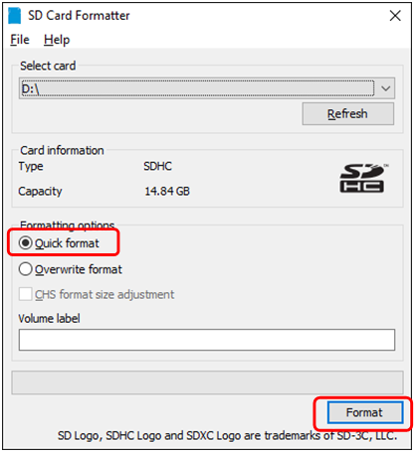

## Getting the FPP software

You will then need to go to <https://github.com/FalconChristmas/fpp/releases> and download **the most current** **Image File, not the source code for your application!**

The Image Files are the files that start with FPP and then indicates the version and SBC image. Download the file that corresponds to the SBC you are using (Pi or BB).

**Depending on your image-writing software, you may have to unzip the file before you can use it.**

Here is an example of the most current release as of August 2019 (pick the most current release for your application)

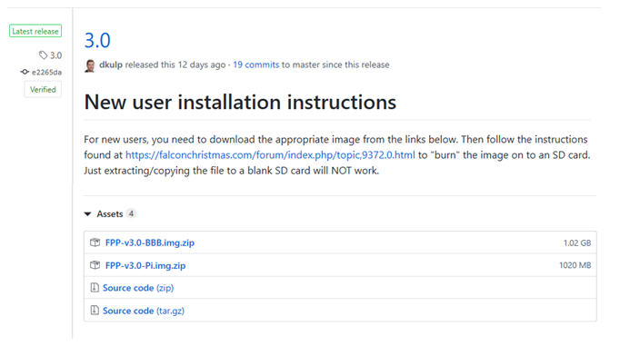

Once you have downloaded the zip file for your application, you might have to extract the file first depending on your imaging program. Then you have to burn the image onto the uSD card using the software for burning images (in this case, I am using Etcher) Make sure you are flashing the .img file and not the .zip file if your imaging software does not support imaging from a .zip file. If you are not sure, unzip the file first.

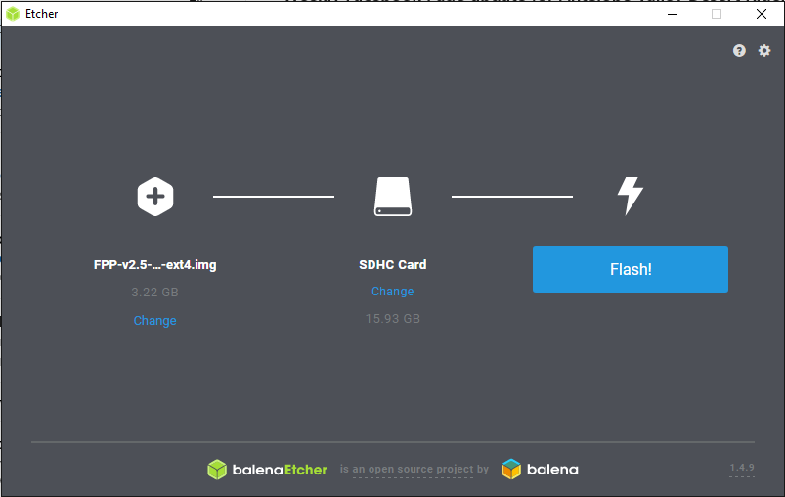

The image that is burned onto the card is not in a format that Windows or Macs can read so you might get an error message after the image is burned. DO NOT perform the format process after you have loaded the image.

Once you have the image file on the uSD card, make sure your Pi or BB is turned off and insert the uSD card into your Pi/BB.

Because the PocketBeagle, BeagleBone Black Wireless and Raspberry Pi Zero W do not have an Ethernet connection, you will need to follow a slightly different process. Follow the method below for installing FPP on the device you are using.

Note: Some capes have RJ45 ports but they are NOT Ethernet ports they are used for DMX or Differential Receivers. They are not network connections and you cannot use these ports for initial setup.

## Raspberry Pi/BeagleBone with Ethernet Port Software Installation

1. Connect the Raspberry Pi/BB to your router with the Ethernet cable.
2. Make sure the uSD card with the proper image is inserted into slot
3. If you are installing FPP to a BeagleBone **Black** and it is the **first time** that you are installing an FPP version release 2.0 or higher is being installed, then press and hold the S2 (Located near the uSD card.) button for 5 seconds after you connect the USB/power cable. (see image below)
4. Connect the Raspberry Pi/BB to power.
5. Wait approximately one minute.

## BeagleBone Black/Green Wireless/PocketBeagle Software Installation

1. Make sure the uSD card with the proper image is inserted into slot.
2. If you are installing to a BeagleBone **Black** and it is the **first time** that an FPP version release 2.0 or higher is being installed, then press and hold the S2 button for 5 seconds after you connect the USB cable. (Located near the uSD card.)

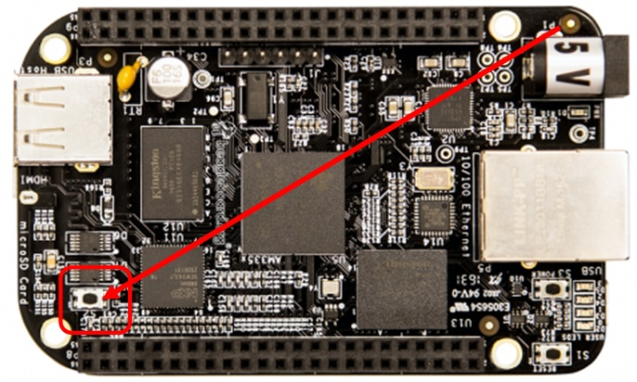

1. Connect the BBB/PocketBeagle to your computer with the USB cable.
2. Wait approximately one minute.

## Raspberry Pi Zero W Software Installation

Because the Raspberry Pi Zero W does not have an Ethernet port or a direct USB to Ethernet connection, there are some extra steps to setup the Pi using a tethering method. This will require using a computer with a wireless connection. Depending on your computer operating system, the method and screenshots will be slightly different.

1. Make sure the uSD card with the proper image is inserted into slot
2. Connect the Raspberry Pi Zero W to power with the microUSB cord.
3. Wait approximately one minute.
4. Go to your wireless networks and connect to the wireless network identified as FPP. The password is Christmas.

## Configuring FPP

Once the FPP has been installed on your Pi/BB, then you need to complete your setup and if you are using a PocketBeagle, BeagleBone Black Wireless or Raspberry Pi Zero W then you will need to setup your network.

You should be able to access the FPP using <http://fpp.local/> or <http://fpp> in your browser

Note, sometimes clicking the link above doesn’t work and you will need to paste the address in the address bar of your browser.

You should have a screen similar to this if you are using a BeagleBone Black Wireless or PocketBeagle:

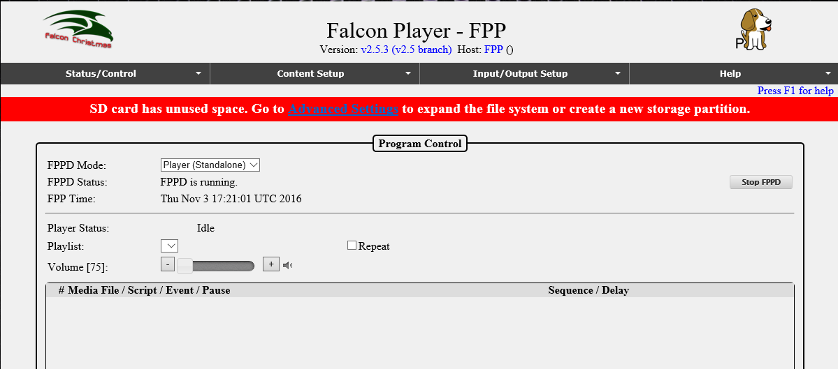

If you are using a Raspberry Pi or other BeagleBone device that is not wireless only, the screen will look something like this:

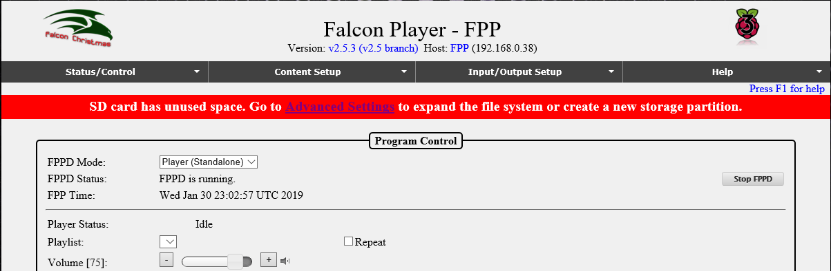

If you are on a BB series SBC (not including the Pocket Beagle) and want the SBC to boot from the eMMC, then refer to the Advanced Options section of this manual before proceeding.

The wireless only versions of the BB systems and the Raspberry Pi Zero W need to have the wireless network setup before you can continue. If you are using a BeagleBone Black Wireless, PocketBeagle, or Raspberry Pi Zero then follow the instructions below, if you are using any other device then skip to **Setup-Continued.**

### BeagleBone Black Wireless, PocketBeagle and Pi Zero W Special Setup

If you are using a PocketBeagle, make sure you have your Wireless adapter installed before powering it up.

Click on the Status/Control and then Network tab.

.

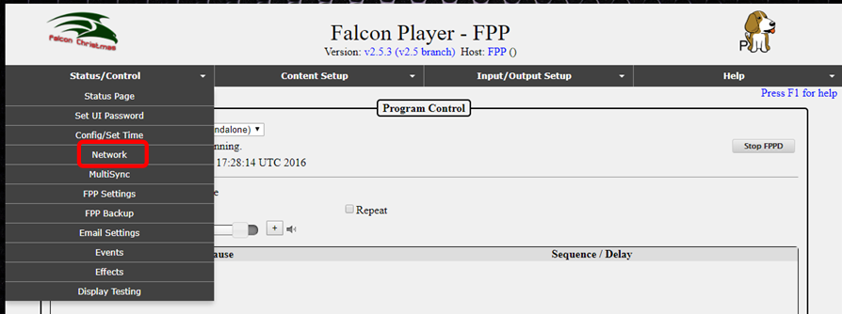

You should have a screen similar to this:

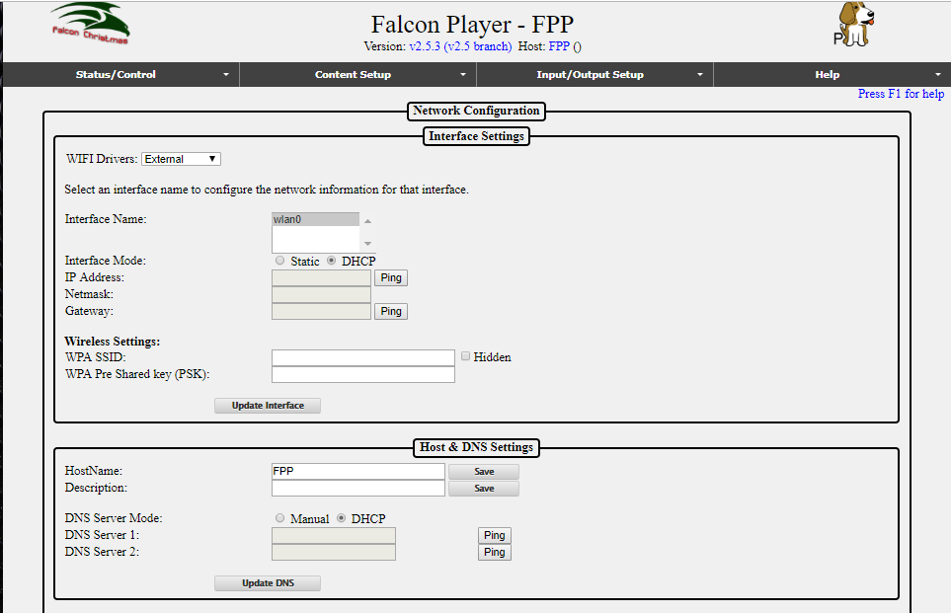

Normally the External Wi-Fi drivers work best so keep that setting.

1. Click on the wlan0 interface (wlan0 is the wireless interface, eth0 is the wired Ethernet interface but you shouldn’t have the eth0 option).
2. Make sure that DHCP is selected.
3. Enter your WPA SSID and WPA Pre Shared Key (PSK). The WPA SSID is the name of your wireless network. The WPA Pre Shared key (PSK) is the password for your wireless network.
4. After you enter your wireless name and password, click on Update Interface
5. Restart Network button will appear, Do **Not** click on the Restart Network button.

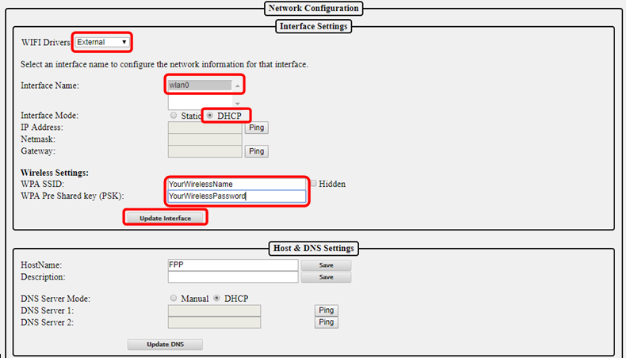

If you are **NOT** using a Raspberry Pi Zero W, then **go to Setup-Continued**.

If you are using a Raspberry Pi Zero W, then go to the bottom of the screen and click on Reboot.

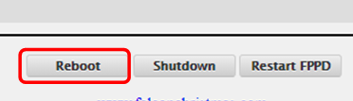

This should disconnect you from your FPP wireless connection and connect back to your default wireless connection.

Click on the Status/Control tab and then Status Page

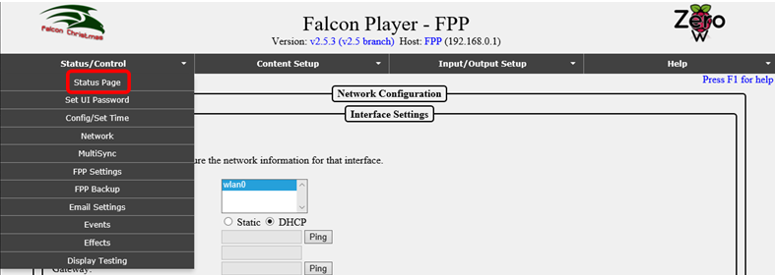

## Setup-Continued

You need to click on the Advanced Settings that is in the red banner.

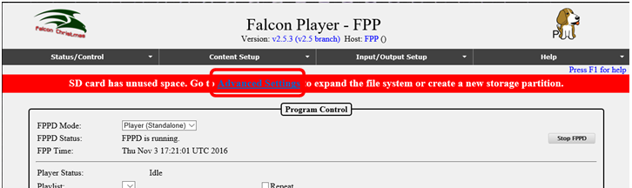

Click on the Grow Filesystem button.

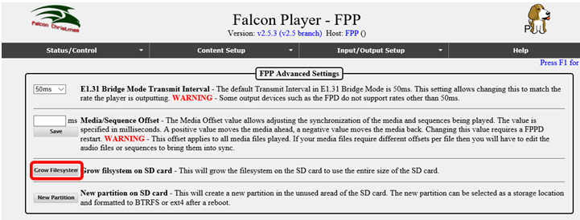

This should bring you to this screen, click on Yes:

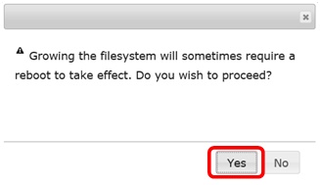

You should get to a screen similar to this, click on the “Go to FPP Main Status Page” to go back to your FPP:

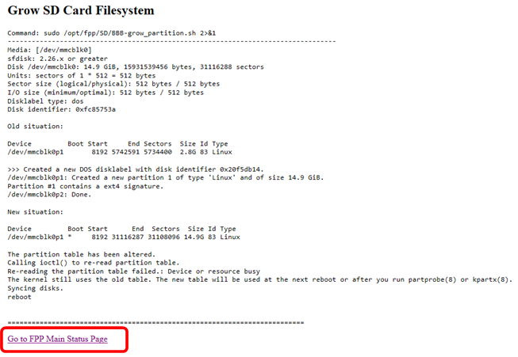

When you get back to the main screen, click on the Reboot button

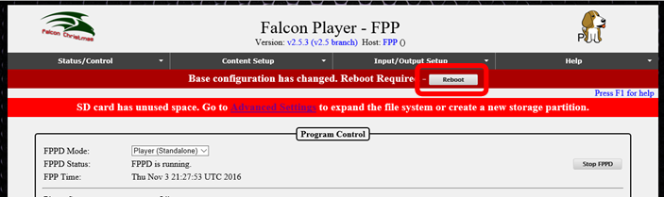

You will get a confirmation screen, click on “OK”

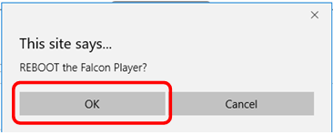

It will take a few seconds for it to reboot. After it reboots, you will need to set up other configurations and update the system to the current version.

You will need to click on the Status/Control and Network.

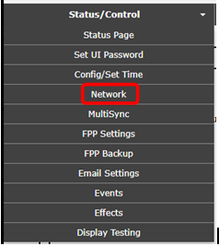

At the top of the page, you should see what IP address is assigned to the FPP for future access. Document this somewhere for future reference. This is one way to get to the web interface of the FPP.

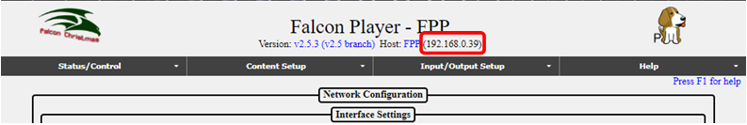

In this case, the IP address for this FPP is 192.168.0.39 and the Host (HostName) is FPP. You can access the interface by typing the IP address or HostName in the address bar of your browser.

The HostName is the “human” name that you can use to access your FPP. It is like typing google.com instead of typing 172.217.3.174 but be aware that if you don’t have a proper DNS server set up or another part of your network isn’t configured properly, then the HostName might not work properly. You will need to change the HostName to something that is meaningful to you. Something like FPPMaster, FrontLawn, HouseOutline, whatever fits your situation and makes sense to you. If you are not going to have any other FPP instances then you can keep it as FPP if you want. In this hobby, people have a tendency to expand their show and it is highly recommended that you rename it so there will be no confusion in the future. The HostName can only have letters, numbers, and hyphens (-). It may not begin or end with a hyphen and cannot have any spaces. Once you change the HostName you will no longer be able to access it in your web browser using <http://fpp.local/>. You can access it using the name that you just created, that is why the name should make sense to you. Make sure you save your name after entering it. So if you changed the HostName to YardProps, then you could access the FPP by typing <http://Yardprops>. You can also add more descriptive information about this FPP in the Description box.

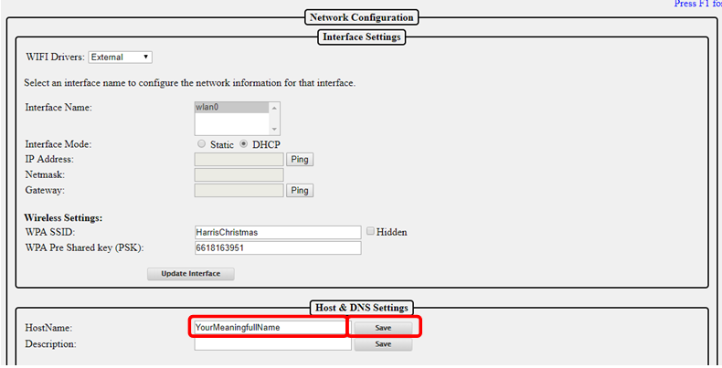

If the FPP is going to be connected to a controller with an Ethernet cable (a very common setup), then you need to check the box at the bottom of the page to allow the data to pass through the FPP to the controller (this does not apply if you are using a cape or hat or running in Standalone mode)

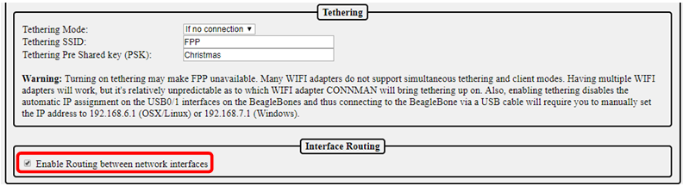

The next step is to configure your time settings, click on Status/Control and then Config/Set Time.

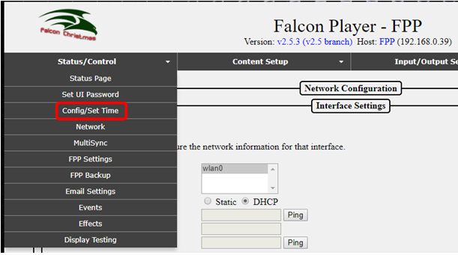

This will get you to this page. In most setup configurations, the FPP will have access to the internet and you can use the internet to keep the correct time.

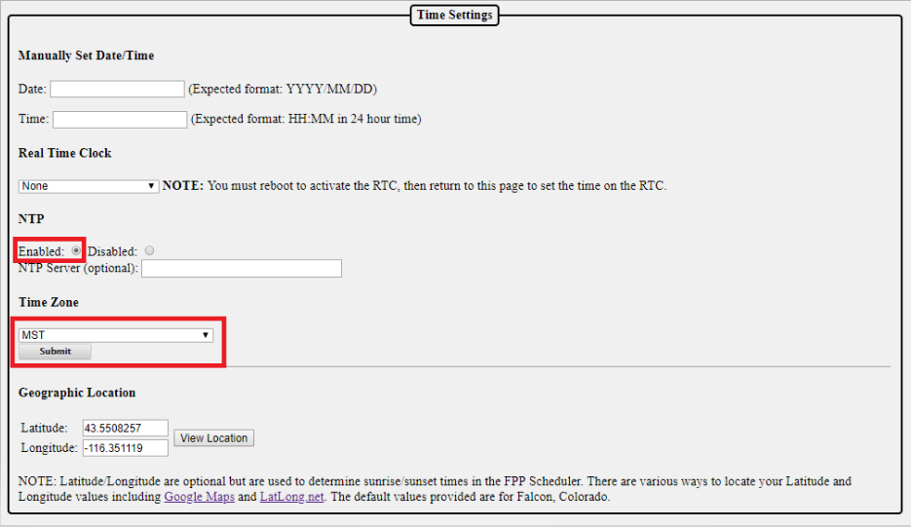

To use the internet to keep accurate time, select Enabled for the NTP and select the correct time zone. NTP is Network Time Protocol and will get the current time from the internet.

If your FPP will not have access to the internet, then you can manually set the date and time. Most Pi and BB computers do not have a Real Time Clock installed so the time will probably become inaccurate the longer it is running and if you power down the FPP, you will need to reset the time and date if you need an accurate time (for scheduling the start and stop time of your show).

# Updating the Software

You should update to the current version of the software. To check for updates click on the Help then About:

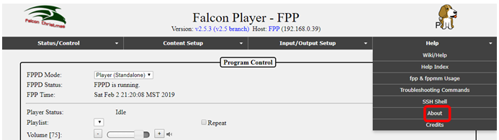

On this screen, you will see the FPP Version you are using (in this case it is 2.5.3) and if there is an update available, it will give you a notice. Click on the Manual Update button. If next to Remote Git Version it says Unknown, that usually means that your network is not set up properly.

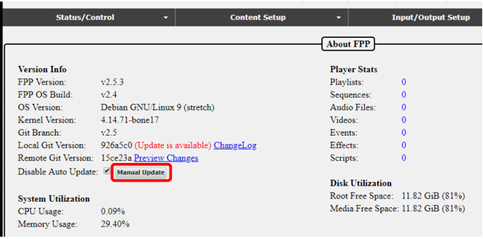

You will get a progress screen similar to this; it could take several minutes to update:

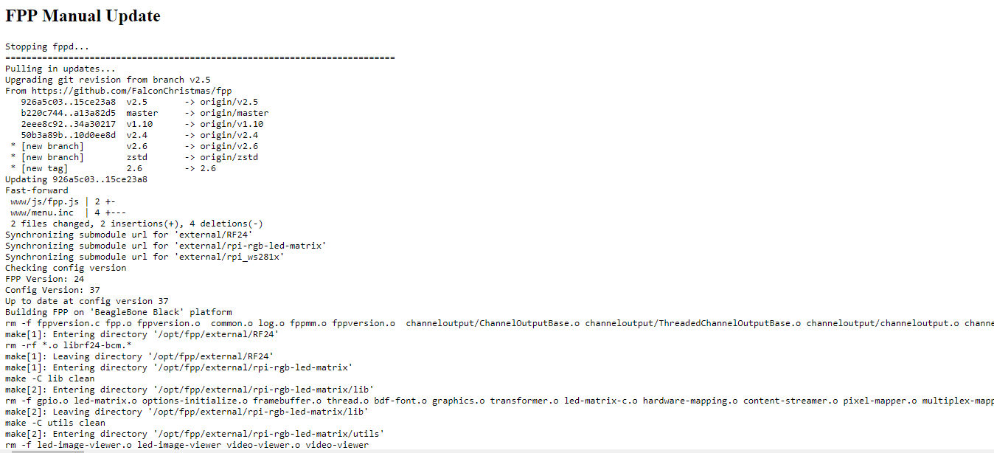

Once it has updated, scroll to the bottom of the screen and click on the Go back to FPP About page.

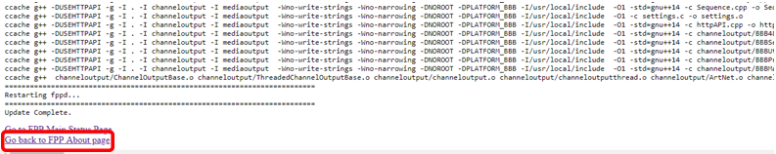

Sometimes there will be an additional update available, if so, click on the Upgrade button.

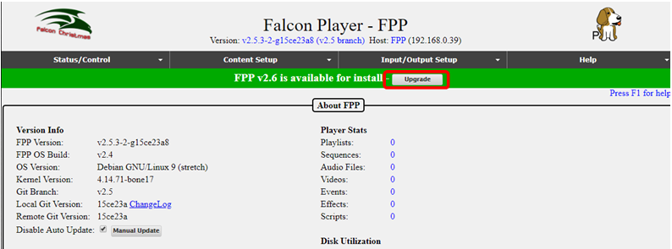

You will usually get a Release notes page, click on the Upgrade button.

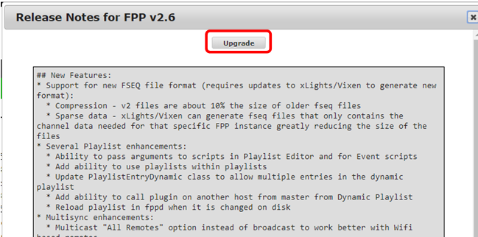

You should get a confirmation page, click OK

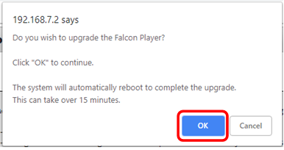

**It will take a while to update and look like nothing is happening.**

When the update is complete, the screen will return to the About Page. You can verify that it is up to date. If it is up to date, the Local Git version will be the same as the Remote Git Version.

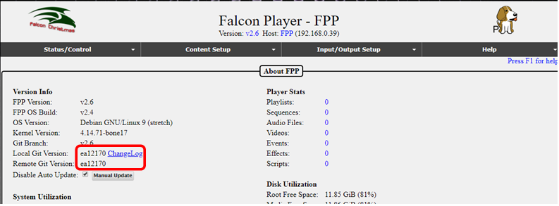

Your FPP software is now installed and up to date. There are many ways that FPP can be used and the settings required to run your show will vary depending on your particular setup. Refer to the appropriate section(s) for more information.

# Program Settings and Navigation

The following sections will explain the program sections and settings and explain how they work. Depending on your current setup or version of FPP, the screens might be slightly different. There are 4 main sections in FPP. Status/Control, Content Setup, Input/Output Setup and Help.

At the top of each page is a status/navigation page.

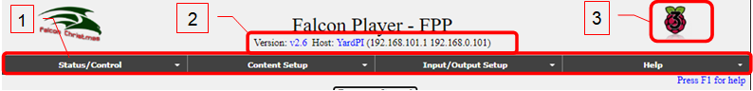

The Main Page is accessed by using a web browser and entering the IP address or HostName of the Raspberry Pi/BB that you previously setup. For example in this case: 192.168.0.101 or http://YardPi (the actual IP or host name will be different depending on your setup).

1. Main navigation toolbar for different areas for settings/configurations and will be on every page. Clicking on one of these headings will give you more options to choose for that category and will be explained in the section pertaining to that selection below.
2. At the top of each page, the current FPP version number is displayed along with the host name and IP address(es) of the FPP.
   1. In this case, the Version is 2.6.
   2. In this case, the HostName is YardPi and can be used to access this FPP using [http://YardPi](http://YardPI) (your actual name may be different depending on how you set it up)
   3. There are two IP addresses listed here, one for the wired (eth0 Ethernet connection) going to a controller, 192.168.101.1 and a wireless (wlan0) connection connecting to my home network, 192.168.0.101, (your IP addresses will be different or missing depending on your setup.) If your network is setup correctly, then you can access the FPP using either IP address.

Note: You will normally need to configure a static route in your computer or router in order to access both subnets (see the Networking section in the Advanced settings)

1. This is a graphical representation of the SBC that the FPP is installed on. It will be different for the different versions of Pi or BB.
2. In the upper right corner is a link that says “Press F1 for help.” Clicking on this link or pressing F1 on the keyboard will bring up help topics specific to the page you are currently viewing.

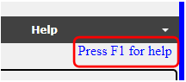

1. At the bottom of each page are controls for the Pi/BB SBC. These are used to reboot or shut down the Pi/BB. The Restart FPPD button, turns off the FPP Daemon, and restarts it. This allows the FPP to reload many of the configuration changes without having to do a full reboot of the Pi/BB.



If there is a major upgrade available for the installed version, then a green bar will be displayed to give you the opportunity to upgrade to the next version. Minor versions will have to be manually installed (this is the default setting) unless you have the settings set to automatically update (not recommended)

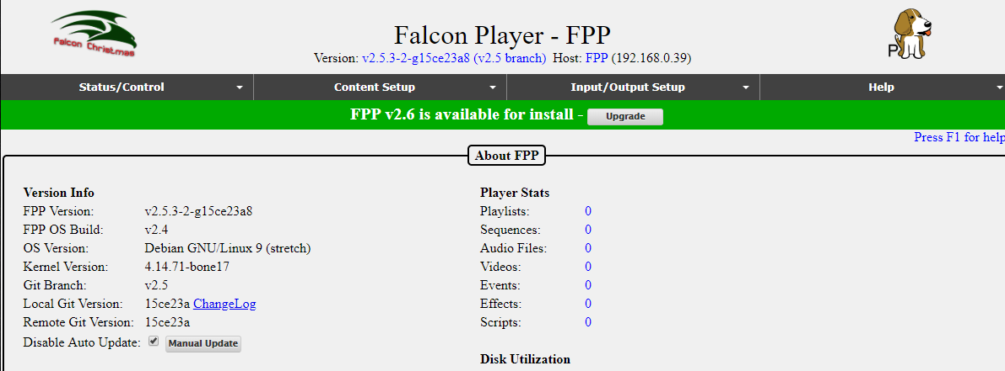

# Status/Control

This section is for various settings and status reports. Clicking on the Status/Control tab will give you several options to choose from:

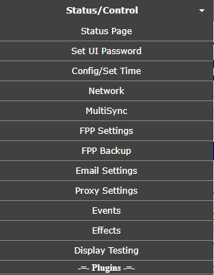

.

## Status Page

The Status Page is the default page that will load when you first log into FPP.

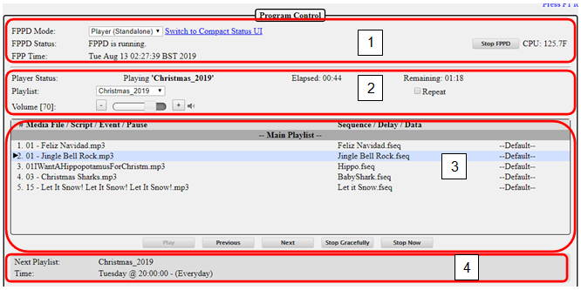

1. Program Control-this will give you the main settings for the mode of the FPP and the current status.
   1. FPPD Mode- There are four modes for the FPP
      1. Player (Standalone)-This setting is used when this FPP is going to operate without any interaction from an outside source like xSchedule, xLights, or another FPP. This is commonly used if you only have one FPP in your show and have a playlist and schedule set up, or if you have an independent display that is not synchronized to the rest of your show. You will also need to have the appropriate Channel Outputs setup.
      2. Player (Master)-This setting is used if you are going to have more than one FPP and you want them to all be synchronized. The Master will need a copy of the sequences (.fseq) and media (music) files. The Master FPP will also be where your Playlists and Schedules are created. The Remotes that you want to be synchronized need to be identified in the MultiSync page as well. If the Master is also connected to a controller then the appropriate Channel Outputs will need to be setup.
      3. Player (Remote)-This setting is used if you are going to synchronize this FPP and attached controller to a Master FPP. The Remote will need a copy of all the sequences (.fseq) that are going to be played. If the remote is going to be projecting videos to a projector, the video file will need to be saved on the remote as well. You will also need to have the appropriate Channel Outputs setup.
      4. Bridge-This setting is used to accept E.131 or DDP input data and pass them on to the attached controllers (i.e. Bridge). This is typically used for testing directly from XLights without creating a sequence.
   2. FPPD Status- This will show you the current status of the FPP.
      1. FPPD is Running-This indicates that the FPP is running and ready to run your show.
      2. FPPD is Stopped-This indicates that the FPPD has been temporarily stopped, either manually or via a script.
      3. FPPD is Updating-This indicates that the FPPD is updating the software and when complete should resume to FPPD is Running.
   3. FPP time-This will show the current date and time for the FPP. This is important if you have playlists or events scheduled.
   4. Switch to Compact Status UI- This will make the browser window show a minimal list which is good if you are viewing the webpage from a cell phone.
   5. Stop/Start FPPD-This is used to stop or start the FPPD system.
   6. Raspberry Pis (the newer models) have a temperature sensor on the board and if you are using a Raspberry Pi then you can see the temperature. If you click on the temperature, it will toggle between Fahrenheit and Celsius.
2. Playlist Info-This section will give you the current status of your playlists
   1. Player Status-this tells you if a playlist is playing and what the current playlist is playing. It will also tell you how long the current song has been playing and how much time is left until the end of the song. If there is no playlist playing, the status will be “Idle.” It will also indicate if a song is shutting down gracefully (finishing the song and then shutting down.)
   2. Playlist-This is a dropdown box with your playlists so that you can manually start one of your stored playlists.
   3. Volume-This is where you can control the output volume for the currently playing sequence. This can be used to control the volume supplied to an FM transmitter or external speakers.
   4. Repeat-If this box is checked then the playlist will continue to play until it is manually stopped.
   5. Media file/Script/Event-This will show you the details of the currently queued playlist. If the playlist is playing, it will indicate which song is playing by highlighting it and putting an arrow next to it.
3. Player controls-This controls the currently queued playlist.
   1. Play-This will play the queued playlist. If the Repeat box is checked, the playlist will continue to play until manually stopped.
   2. Previous- This will step to the previous playlist item when a playlist is playing.
   3. Next- This will step to the next playlist item when a playlist is playing.
   4. Stop Gracefully-This will finish the song that is currently playing and then stop the playlist.
   5. Stop Now-This will stop the playlist immediately.
4. Next Playlist-This will show if there is a Playlist scheduled to begin in the future and what day and time it is scheduled to start.

## Set UI Password

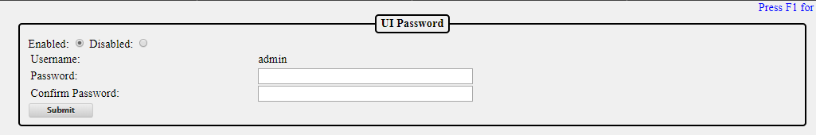

There is no password required to access FPP via the web interface or the ssh shell from within the UI. You can setup a user password to access the UI. The password has to be at least 8 characters. Once the password is set, you will have to use the username of admin and the password you set to access any of the screens. It is not usually required to setup a UI password.

## Config/Set Time

This page is used to configure your time and location settings. If you want your Playlists to automatically start at scheduled times, then the FPP has to be configured to keep accurate time.

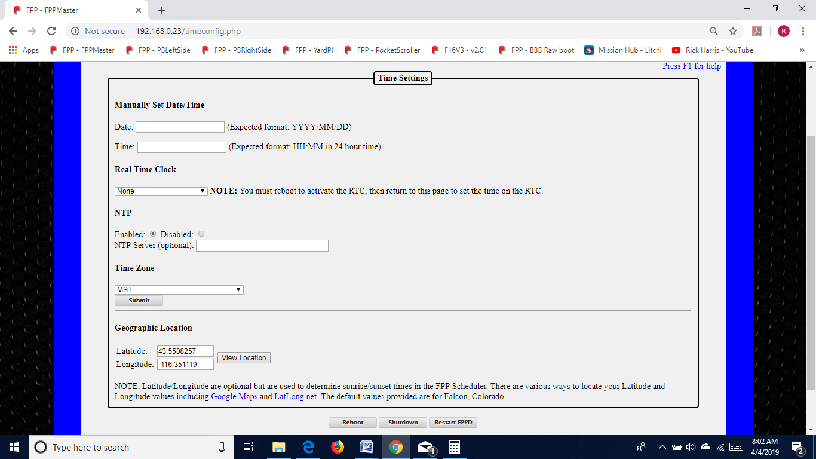

Manually Set Date/Time-If your FPP doesn’t have access to the internet, then you can manually set the date and time in this section. The time is in 24 hour format (Military Time).

Note: if your FPP is not configured to get the current time from the internet or a Real Time Clock Hat/Cape is not attached and configured, then the time on the FPP will gradually drift away from the actual current Date/Time

Real Time Clock-If you have a Cape/Hat attached that has a Real Time Clock (RTC), you can select the Cape/Hat from the drop down list. Once you select the correct Hat/Cape, you will need to reboot the FPP device and then setup the time from this page.

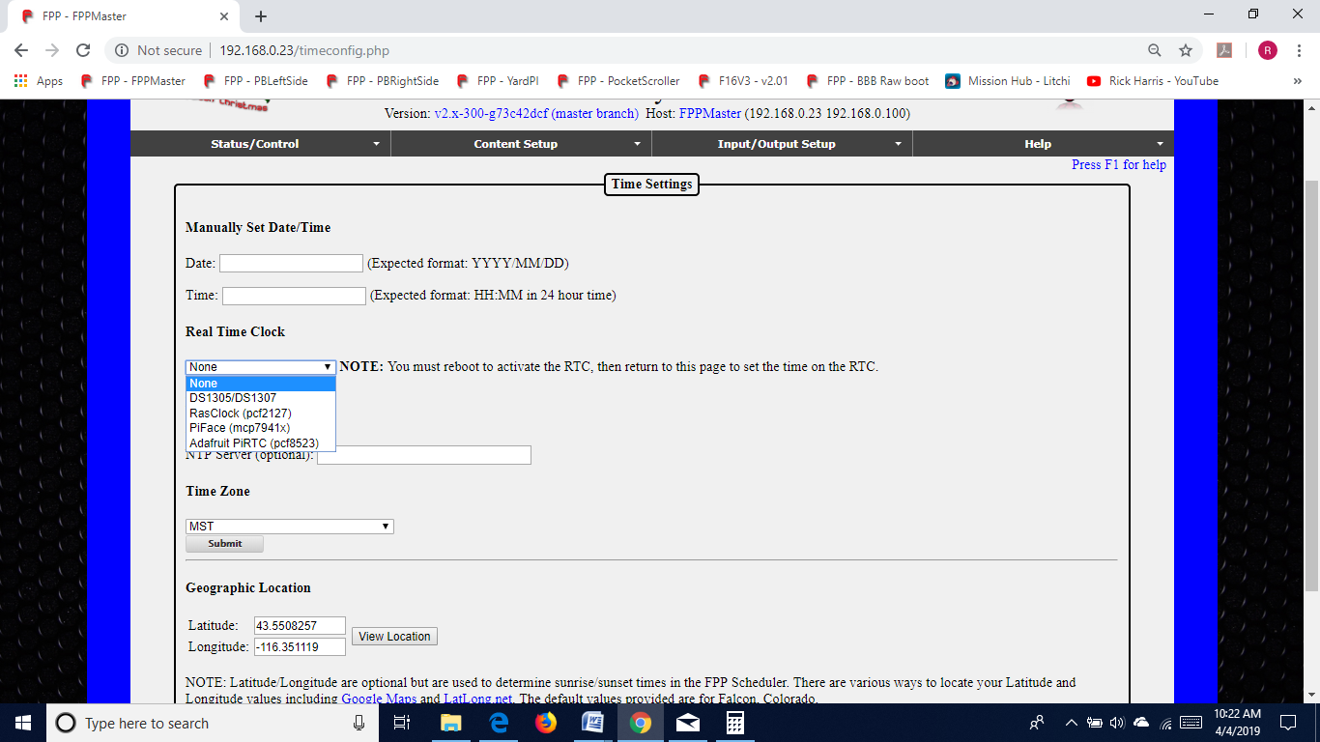

NTP-This is Network Time Protocol and if your FPP device is connected to the internet, then you can configure your FPP to keep current time with the NTP. You would select the Enabled radio button. If you want a different Time server than the default then you can enter the http address of the Time Server you want to use. You should normally keep the NTP Server blank.

Time Zone-If you are using a Time Protocol server to keep the current Date/Time, then you will need to select your time zone so that your FPP can adjust the time accordingly.

Geographic Location- If you want to use the Sunrise or Sunset option of scheduling your Playlist to start or end, then you will need to enter your location in Latitude and Longitude. You can get this information by entering your address into LatLong.net or GoogleMaps.com. If you use GoogleMaps, then after you enter your address, the Latitude and Longitude will be in the address bar after the @ symbol. The Latitude is listed first and then the Longitude. Make sure to use the – sign if it is indicated. You can double check the entry by clicking on the View Location button and verify that the coordinates are correct.

## Network

The Network Configuration page is where you setup your Network settings so that you can communicate with your FPPs and controllers and all of your FPPs and controllers can communicate as needed with each other. Networking works similar whether you use wireless or wired and they work together.

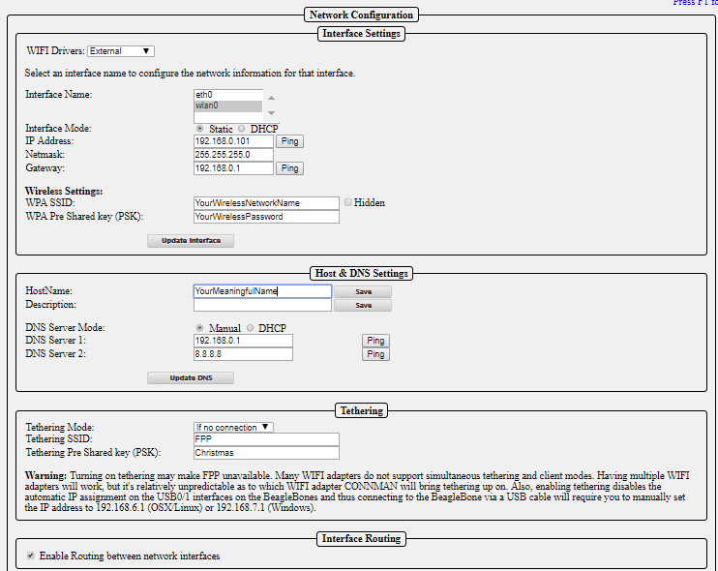

Because there are so many variations of setting up your network, the network settings seem to be problematic for some people. The basic setup at the beginning of this manual should get you running. That setup might not be the best for you in the long run. The following should get you a better understanding for a better setup for your particular situation.

Canispater Christmas has a good video at <https://youtu.be/kn1BiolQbgw> and Keith Westley, one of the xLights developers, has a good video as well at <https://youtu.be/g0fOZs6UgXw>.

There is a good article that you should read about wireless and remotes at: <https://falconchristmas.com/forum/index.php/topic,4231.0.html>.

If you need more information on networks and IP addresses and how they work, then refer to the Networking Configuration section of the Advanced Options section.

### Interface Settings

Depending on the device, the FPP could have up to 2 network devices built-in (more if you install network adapters, but this is not common). One is labeled eth0 for Ethernet connections (wired) and the other is wlan0 connections (wireless). If you have both eth0 and wlan0 on your FPP, then you have to select and set each one up separately.

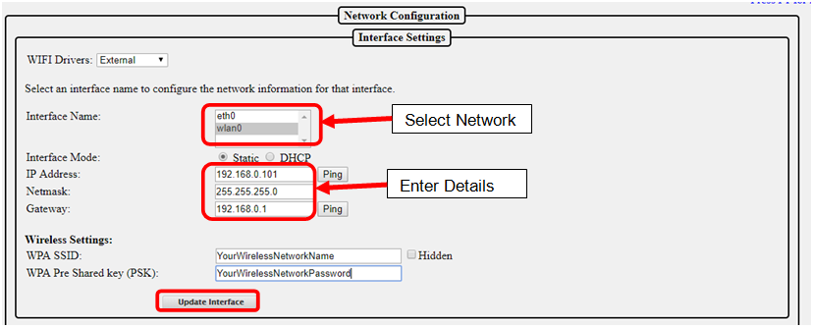

There are two options for Interface Mode, Static and DHCP.

* DHCP-Your home router will assign and manage the IP address(es) for your FPPs and controllers, this is the easiest method but has some drawbacks. Your router might not save the IP address if your FPP has been disconnected from the network for a lengthy time so it might cause problems in the future
* Static-You will assign the IP address for your FPPs and controllers. This is usually the preferred method so that you can always access your devices. Using this option, you have to make sure that the IP addresses are unique. You have to be careful to not assign an IP address to an address that your router has already assigned to another device through the DHCP process. Most routers will assign DHCP addresses at the lower end of the range, but this isn’t always true. Some routers have the ability for you to limit the range of IP addresses that it will use for DHCP in order to prevent any conflicts.

To set up your networks, select the network (Interface Name) you want to setup and enter the details. Once that is complete, then click on the Update Interface button. This saves your settings. If you need to setup the other network, click on that network and then you will have new options to enter your details. Click on Update Interface when completed. When you are finished with all of your changes, reboot the FPP. If you are setting up your eth0 network, the Wireless Settings will not be available.

### Host & DNS Settings

This section is to assign some networking settings that are for this device.

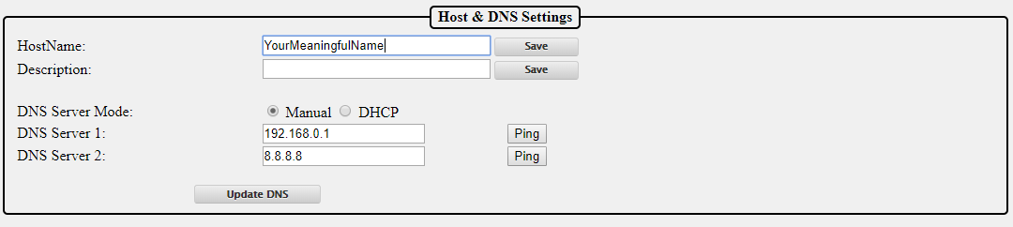

* HostName- You can give a meaningful name to your FPP and this can be used to access your device in a web browser instead of using the IP address. It is important that your FPP/Controllers have unique Host names.
* Description-This is used to provide some additional information or a more meaningful name for your device. This will show up in your Multi-Sync page and the xLights FPP connect screen.
* DNS Server Mode- This is to select what DNS server the FPP is going to use. Selecting Manual allows you to set the IP address for the DNS server. You have the option of selecting a main DNS Server and a backup one. If you select DHCP then the FPP device will attempt to get a DNS address from the DHCP Server (usually your home router). Not all connected devices have a DNS server so selecting DHCP might not work. (See the Networking section for more information)

### Tethering

Tethering is an option to allow the FPP to behave as its own Access Point. This is useful for accessing the FPP if there is no network connected to either the Ethernet or Wi-Fi connections. This is useful for the Raspberry Pi where there is no Ethernet connection and the Wi-Fi connection has not been set up yet. To connect to the FPP device when the Tethering mode is active, your FPP device will need to be fairly near your computer. You will then need to connect to the FPP network that should be visible in your network settings. The password for the network will be Christmas. Once you are connected to the FPP network, you can access the FPP with the IP address of 192.168.0.1if you are using a Raspberry Pi or 192.168.1.1 if you are using one of the wireless versions of the BeagleBone SBCs.

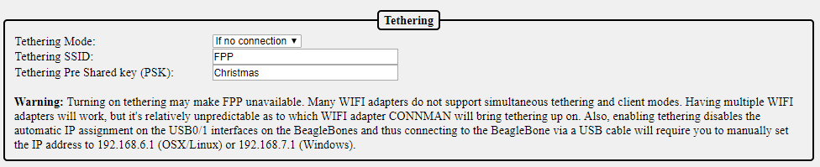

There are 3 tethering modes available

* If no connection-This is the default setting for Pis. If the FPP device does not detect a network connected to any of the network ports, it will activate a Wi-Fi access point when it powers up.
* Enabled-When this option is selected, the FPP device will boot up and activate the Wi-Fi access point.
* Disabled-When this option is selected, the Wi-Fi access point will not be activated.

You can change the SSID name and password if you want, but it is not recommended. There is a warning but this warning is more for the BeagleBone SBCs where you have to add a separate Wi-Fi adapter. The Raspberry Pi’s Wi-Fi works well in the Wi-Fi Tether option and if you are using a BB SBC it is recommended to use a standard Wi-Fi connection or Ethernet connection.

### Interface Routing

If you have a controller attached to your FPP device (not a hat or cape) you should check the Enable Routing between network interfaces. This will allow communications to pass through your FPP device to the connected controller.



## MultiSync

The Multi Sync page is where you setup a Master/Remote layout. A Master/Remote layout eliminates the need for Ethernet cables connecting all of your FPPs/controllers and allows for widespread model placement. See the Master/Remote section of the Advances Settings section for more information on the setup and functionality of the Master/Remote layout.

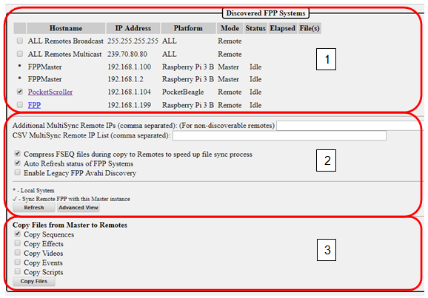

1. Discovered FPP systems-This section will list all of the FPP devices that were discovered. In this section, you can select which FPP systems you want to sync with your master.
   1. ALL Remotes Broadcast-This will send a Broadcast sync package to every device on the network whether they need it or not. This is an older method that was used but not commonly used. Broadcast packages are sent at a slower speed and not as often as Multicast.
   2. ALL Remotes Multicast-This will send a Multicast package to all devices that have been identified as needing the sync packages. This is a newer method and preferred over All Remotes Broadcast but does not work with FPPs with a version less than 2.6 or if you are using a Falcon Controller as a remote*
   3. Individual FPP selection-This can be used if you want to specifically select the FPPs that you want to synchronize or upload files from the Master FPP. If any of your FPP devices are not using a version of FPP equal or greater than 2.6 or you have a Falcon Controller as a remote* than this is the recommended method.

* As of the writing of this manual, the Falcon Controllers did not support the Multicast format but this should be fixed in a future update to the Falcon Controller. Also, not all home networking equipment supports Multicast, most do but not all of them.

1. Additional Settings-This section is to add some additional options in how you want your Master FPP to sync with your remotes.
   1. Additional MultiSync Remote IPs-This field will show previously synched remotes that were not discovered when the MultiSync page loaded. It can also be used to manually add devices that don’t respond to the discovery process, such as Falcon controllers set to Remote or a Remote FPP that is on a different network subnet.
   2. CSV MultiSync Remote IP list-This is no longer used. It was used for setting up a few devices, but those devices have been updated and this will probably be removed in a future update.
   3. Compress FSEQ Files-If this box is checked, the Master FPP will compress the files before sending them to the remotes. This saves a lot of time in the upload process.
   4. Auto Refresh status of FPP Systems-If this box is checked, the status and the currently playing file will continually update and show how much time has elapsed on the current file. If it is not checked, it will just show the status of the controllers at the moment the page was loaded.
   5. Enable Legacy FPP AVAHI Discovery- If any of your remotes are running a version of FPP before 2.4 then you will need to enable this. The AVAHI discovery is slower.
   6. Refresh button-If the Auto Refresh status is not checked, this will refresh the status of all the discovered remotes.
   7. Advanced View-This will show you some additional information on all of your remotes, such as current FPP version, if an update is available and the CPU utilization.

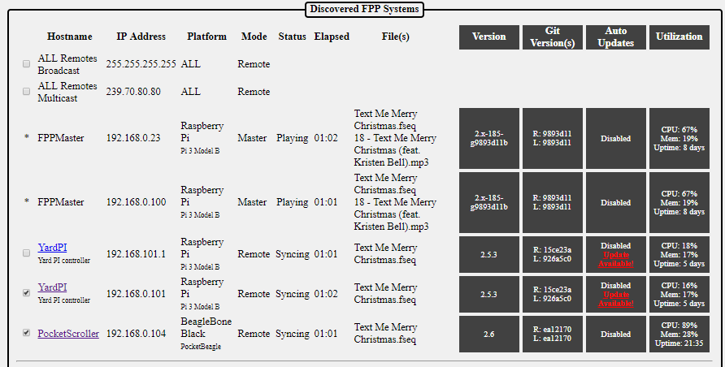

1. Copy files from Master to Remotes-When you click this button, the Master FPP will upload all of the selected files that are stored on the Master FPP to all of the selected Remotes. The Master will try to upload to the controllers that are in the Additional MultiSync Remote IP field as well. During the upload, the Master will only upload files that are needed. If the Remote already has the most current file that is saved on the Master, it will skip that file.

## FPP Settings

This page is to setup some administrative functions and master settings.

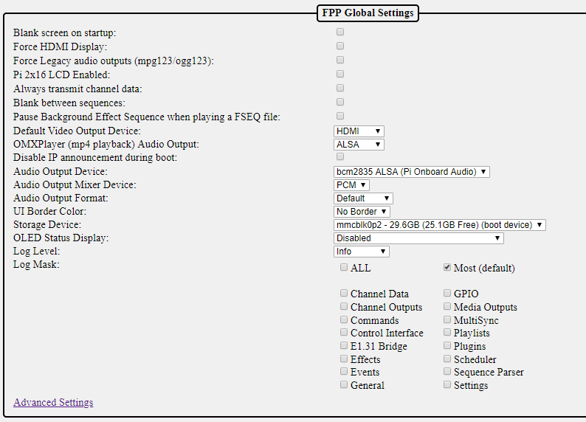

Blank Screen on Startup- If you are using this FPP to play video through the HDMI port, then you want to enable this setting. By default the FPP will display system data to the HDMI port so that you can connect a monitor, but if you are using the HDMI to output video, the video will not block the system output to the HDMI port so you could get the system display showing along with your video. The screen blanking will turn the text console off after one minute so that it does not show through when you are not playing a video or when playing a video that doesn't match the screen's aspect ratio.

Force HDMI Display- This option should be enabled if you are playing video on a projector via the HDMI output.

Force Legacy audio outputs (mpg123/ogg123)- This was an old option to allow mpg123/ogg123 files to be processed by an external program and not the FPP. The FPP now has the capability to process those files so will probably be deleted in a future release.

Pi 2x16 LCD enabled- Enable use of the PI Plate with 16x2 Character LCD display and Keypad.

Always transmit channel data- Force transmission of channel data out to controllers whenever FPP is running. FPP will normally only transmit data when there is a sequence playing or the system is running in Bridge mode or a Pixel Overlay model is enabled. Some older controllers go into test mode when not receiving data. This setting causes FPP to always send data so the controllers do not go into test mode.

If selected, FPP will ensure that lights turn off at the end of a sequence or when a ‘Stop Now’ is selected.

Blank between sequences-This setting will send out blanking data to turn the pixels off when a sequence finishes. This is for some older DMX controllers that keep sending out the last command that they were given so models would stay lit until the next sequence began to play.

Pause Background Effect Sequence when playing a FSEQ file- Effect sequences take priority over FSEQ files. Select this option if you have Background Effect Sequences and you want the FSEQ file to take priority over the Background Effect Sequence.

Default Video Output Device- If you are using your FPP to directly play a video, then you can select which device you want the video to play on. You can select the HDMI output port or you can select a Pixel Overlay model which is usually a P10 or P5 panel display.

OMXPlayer (mp4 playback) Audio Output- If you are using your FPP to directly play a video, and you want to use the audio from the actual video, then you can select what device you want to play the audio. This is normally used when the FPP playing the video is acting as a stand-alone set up. If you want the video to be synched with the rest of your show, then your saved video will need to have the same filename as the sequence file that is playing on your master.

Disable IP announcement during boot-When the Raspberry Pi boots up, it will announce its IP address over the audio device. If you do not want this announcement, then select this option.

Audio Output Device-You can select which device you want to play your audio. If you do not have any audio devices installed, like a SoundBlaster, then you will only have the option of bcm2835 ALSA (Pi onboard audio.) The Pi onboard audio will output the sound to the 3.5mm audio jack on the Pi.

Audio Output Mixer Device- FPP will identify the available installed output devices and provide the option to select which device you want to output the audio. By default, it is normally set to speaker which is normally the preferred device.

Audio Output Format- You can select a specific sampling rate and device, normally the default works the best.

UI Border Color-You can select the border color of the user interface (webpage). This could be helpful if you have several devices and you want some visual clue which FPP device you are working on.

**No Border**

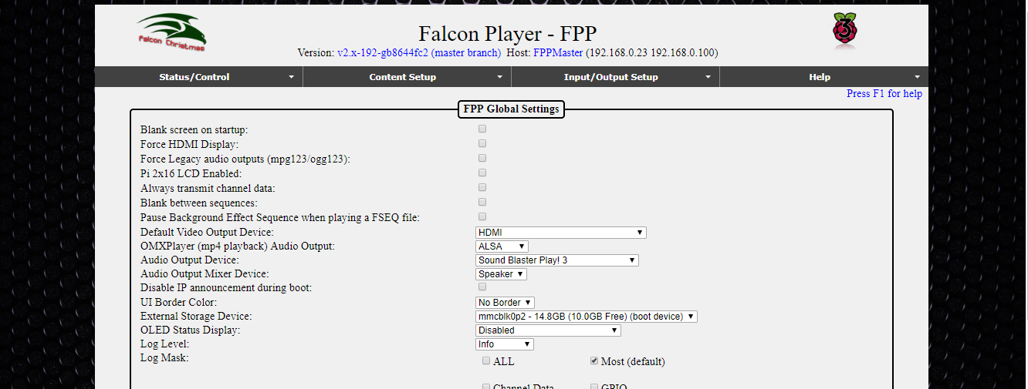

**Blue Border**

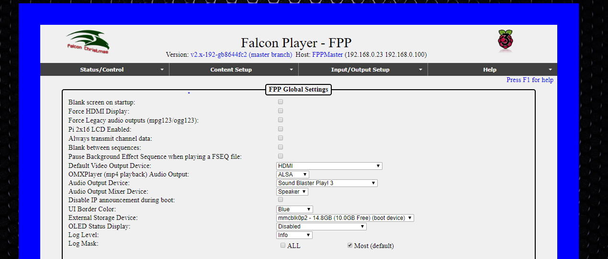

External Storage Device- You can select what device you want to store all of your user data such as FSEQ files, media files, configuration settings, etc. By default the uSD card is used. It is usually the fastest storage device. You can select other options such as USB drive, if they are installed.

OLED Status display-You can attach a small OLED display that will give you some basic information on the FPP. The FPP will accept a few different types of OLED boards.

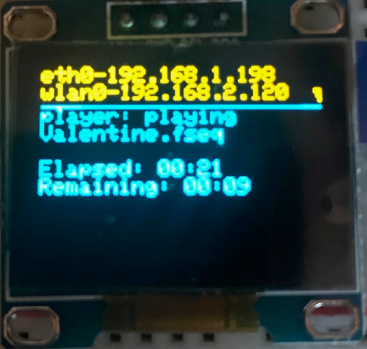

Log Level-This setting is used for advanced trouble shooting. You should leave this setting at “Info” unless directed by the FPP development team.

Log Mask- This setting is used for advanced trouble shooting. You should leave this setting at “Most” unless directed by the FPP development team.

#### Beagle Bone only settings

The BeagleBone series of SBCs have 4 LEDs on the board and the function of each can be controlled.

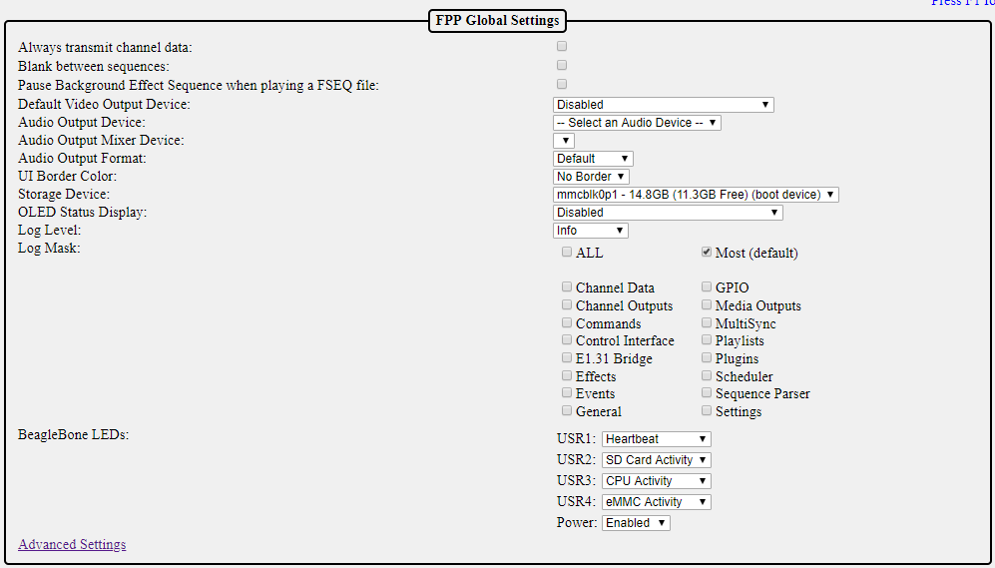

You can change the default settings for the LEDs, the most common change is to disable them if the lights might be distracting. It is recommended to keep the defaults.

### Advanced Settings

The Advanced settings are used for some specialized settings.

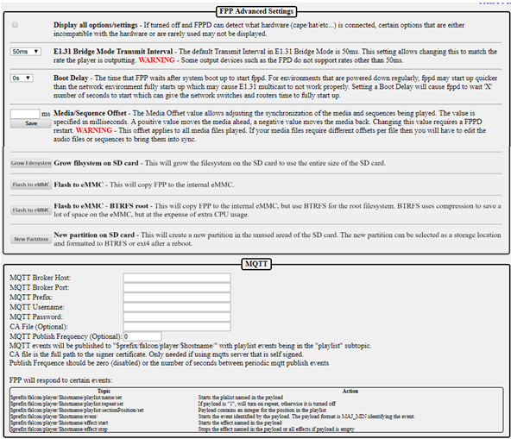

Display all options/settings- FPP can detect most hardware configurations and by default will not show options that incompatible with your configuration. You can allow FPP to show all options by checking this box, but you will then be able to select settings that might not work as intended.

E1.31Bridge Mode Transmit Interval- This setting allows for a different timing interval when operating in Bridge mode. The default is 50ms and it is recommended to keep this setting.

Boot Delay- You can add a delay to booting up the FPP. This is helpful if you power down all components in your show, like routers and switches, and turn them on all at the same time. FPP could start before the routers and/or switches have had a chance to fully initialize which can cause communication errors. If you are not powering down your routers and/or switches, then leave the default setting of 0.

Media/Sequence Offset- This setting is used to synchronize the media to the sequence. This can be used if your FM transmitter or other audio processing device(s) creates a consistent lag in the broadcast (this is rare, but it does happen). This can also be used to fine tune the synchronization in a Master/Remote configuration where there is consistent network delay between Master and Remote. (e.g. if you are using a WiFi extender to reach an FPP remote that is far away from the Master and has additional network delay because of the extender)

Grow filesystem on SD card- When you do a fresh install, the microSD card will be partitioned for just the size needed for the operating system. You will need to expand the filesystem so that you have access to the entire microSD card for storing sequences and media files. If the filesystem has been expanded, this option will not be available.

Flash to eMMC- (BeagleBone SBCs only) if you are using a BB series device, then you have two options if you want the device to boot from its internal memory and not the uSD card. Selecting the Flash to eMMC option will save the boot information in the BeagleBone’s native file format.

Flash to eMMC- (BeagleBone SBCs only) BTRFS root option will save the boot information in the compressed BTRFS format which will take up less space on the BB memory but will cause a slight impact on CPU usage.

New partition on SD card- If you select this setting, then you can create a separate partition on your microSD card and format it different than the operating system of the microSD card. This will allow you to remove the SD card and access the FSEQ files, media files, configuration settings, etc. on a different device such as your computer.

MQTT- This section is used to setup MQTT settings if you are going to automate your FPP with an MQTT server such as a home automation system.

## 

## FPP Backup

This screen enables you to backup configuration data or to restore configuration data that has been previously backed up.

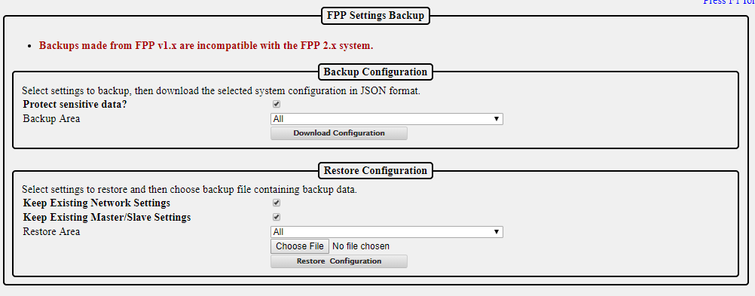

### Backup Configuration (creating a backup)

Protect sensitive data- If you have this selected, then the password to your wlan0 network will not be saved and you will have to log into the device once the configurations have been restored and enter your wlan0 password. If it is not selected, then a complete backup will be saved and when restored the FPP should be functional. Just be aware that anyone that has access to the backup file you saved will be able to view your wireless password if they open up the backup file. If you change the setting to allow a complete backup, you will get the following information box.

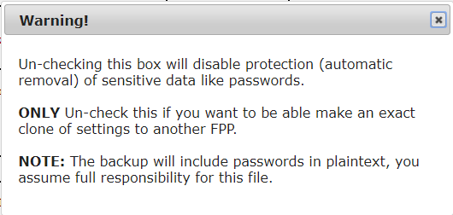

Backup area-This will select what portions of your FPP configuration you want to save, normally you will select all.

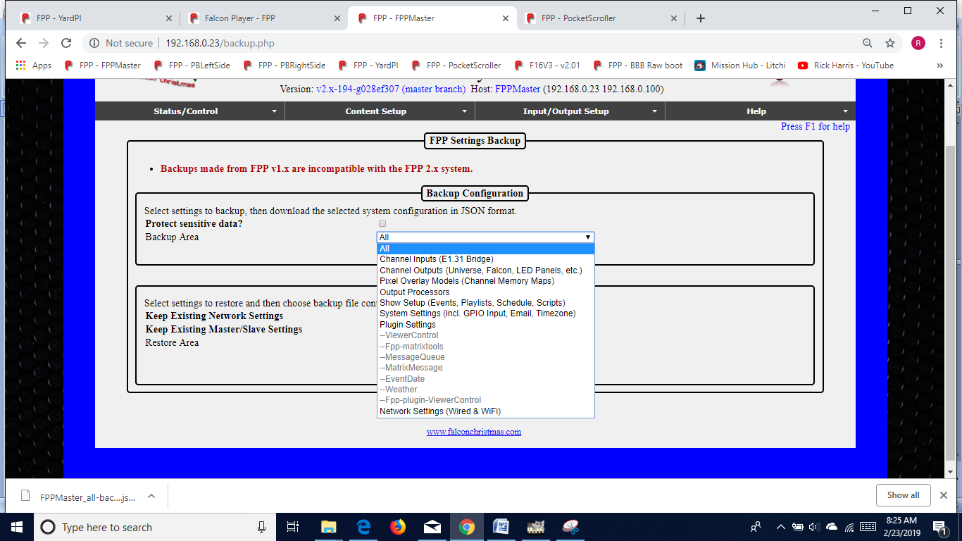

Download Configuration- click on this button to save your configuration settings. This will prompt you for a location to save your configuration file. The file will be named with the device name and a timestamp in the name so that you can identify the most current version in case you have more than one backup.

**NOTE:** This will not save your media files such as sequences, music, or videos.

### Restore Configuration

Keep Existing Network Settings-If this is selected, then the network settings that are saved on the FPP will not be updated to the settings on the saved backup.

Keep Existing Master/Slave Settings- If this is selected, then the Master/Slave settings that are saved on the FPP will not be updated to the settings on the saved backup.

Restore Area-You can select only a specific are to restore on the FPP. Any other settings that are configured on the FPP will not be updated.

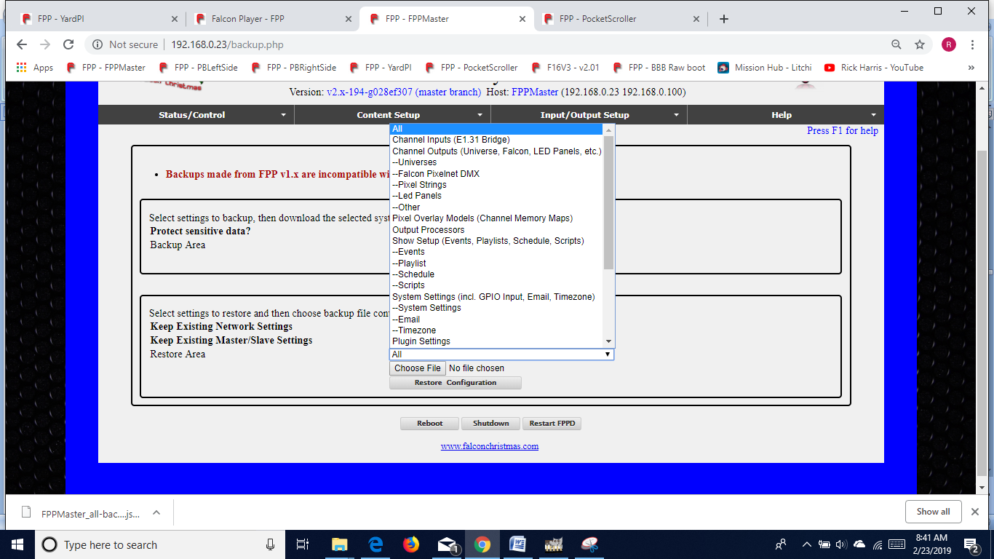

Choose File-Click on this button and find the backup file that you want to use for your restored settings. Make sure it is the correct one if you have multiple configurations saved.

Restore Configuration-If you have a backup file selected, then you can click this button to restore the FPP from your backup file with the settings selected.

## Email Setup

You can setup an email account in FPP to use for sending information to an email account by using a script. Due to some ISP blocking protocols, the FPP has to be setup to use a Gmail account to send the emails.

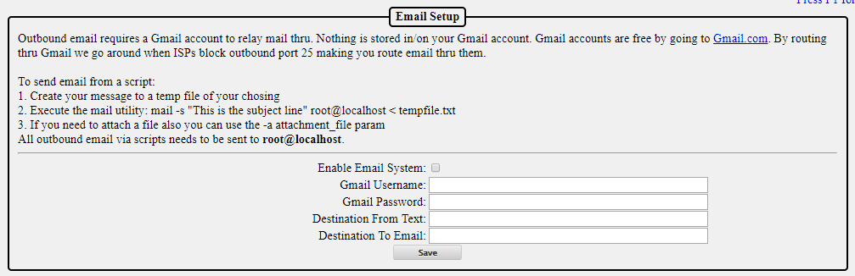

Enable Email System- This box has to be checked if you want to allow FPP to send emails through the Gmail account set up.

Gmail Username-This is the username of the Gmail account you want to use to send your email. It will be your full Gmail login name, such as [johndoe@gmail.com](mailto:johndoe@gmail.com).

Gmail Password-This is the password for the Gmail account you identified.

Destination From Text-This can be used to identify the FPP that is sending the email. Usually it is the Gmail account used for the FPP emails.

Destination To Email-You need to enter the email address that you want your email messages to be sent.

## Proxy Settings

The Proxy Settings allows you to route network traffic through an FPP device to a connected controller.

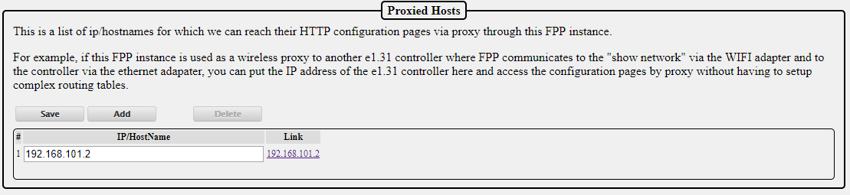

You can configure the FPP to act as a Proxy Host by entering the IP address of the controller(s) that are attached to the FPP device. By doing so, you do not need to enter static route(s) in either your computer or router. This is helpful for people using Mac computers where the route is not persistent. If you need to access the controller through the web UI then you can click on the link in the Proxied Hosts page or type the IP address of your FPP device that is connected to the controller followed by /proxy/ and then the address of your controller.

Note: If you use xLights for configuration settings, then you can enter the controller’s proxy settings in xLights and xLights will be able to communicate with your controller.

## Events

Events are a method to activate an effect or script. The event can be activated as part of a playlist, in a sequence or triggered by an external event that can be captured on one or more of the GPIO pins.

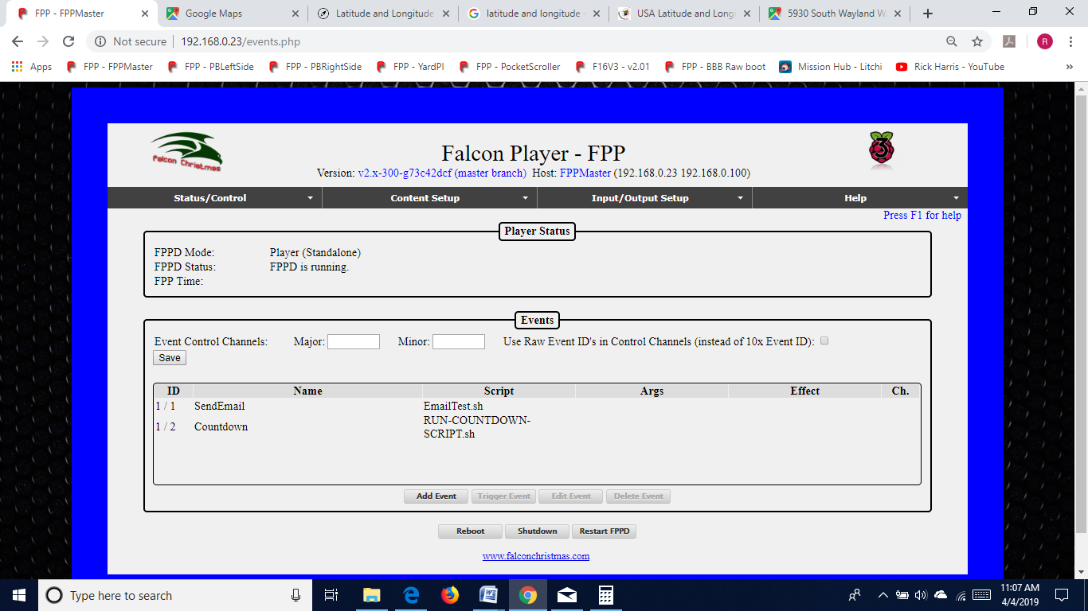

Event Control Channels-The Event Control Channels are used to identify what channels in your sequence you are going to use to trigger your events. This will usually be 2 consecutive channels. If you are not going to trigger your events from within a sequence, then you can leave these blank. If you are going to trigger events from within a sequence, then you will need to setup a 1 pixel single line model in your layout as a placeholder to process your events and the Major Event Control Channel will be the first channel for this pixel and the Minor Event Control Channel will be the next channel. If you make changes to the Event Control Channels, make sure you click on the Save button.

Use Raw Event ID’s-Some sequencing programs do not reflect channel numbers from 0-255 on DMX channels internally as 0-255 so a method was developed so all sequencers worked the same. In order to do so, when you entered the Major and Minor ID number in your DMX channel for your Major and Minor ID numbers, you had to enter the ID numbers after you multiplied them by 10. xLights and most current sequencing software handles channel numbers from 0-255. You can select this option if you want to enter the event Id in your sequencing program without multiplying it by 10.

Event List-This will list all of the events that you have created along with the relevant details. From this section you can add an event, trigger an event, edit an existing event or delete an existing event. If you select Edit Event, or Add Event, the Event Editor will open so that you can make the appropriate changes/additions.

Event Editor- This section is for entering the details of the event that you want to setup.

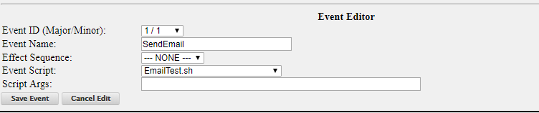

* Event ID (Major/Minor)-This setting is used to identify each event. This is used when you are triggering an event from a sequence. To trigger an event from a sequence, you will use a DMX effect on the model you have setup to handle your event triggers. To trigger an event from within a sequence, you will need to set the Major and Minor Event Control Channel to the corresponding Event ID with a multiplier of 10 unless you selected the “Use Raw Event ID’s in Control Channels” option. For example, you have a single line model of one pixel set up in your xLights layout with a start channel of 485 and you want to trigger an event with a Major Id of 5 and a Minor Id of 3. Your Event Control Channels would be set with 485 as Major Channel and 486 as the Minor channel. You would put a DMX effect on your model at the time you want to trigger the event. If you **did** **not** check the “Use Raw Event ID’s in Control Channels” option, then You would set channel 1 to 50 (Major Id of 5 times 10) and channel 2 to 30 (Minor Id of 3 times 10). If you did select the “Use Raw Event ID’s in Control Channels” option, then you would set Channel 1 to 5 and Channel 2 to 3.

**Note:** Triggering the event will only occur once per trigger. It won’t trigger several times depending on the length of the DMX effect.

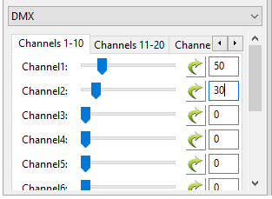

* Event Name-Enter a name that makes sense to you as to what the event does. You might have several events that are similar so make the name clear as to what it does like StartMainPlaylist and StartOvernightPlaylist.
* Effect Sequence-Your event can trigger an effect (.eseq file) to play. Select the Effect that you want to play in this selection box.
* Event Script-Your event can trigger a script to run. There are several prewritten scripts in the Script Repository, or you can create your own. Select the script you want to run in this selection box
* Event Args-If your Script accepts arguments, then you can enter them in this box.

Don’t forget to save your event once you are done.

## Effects

Effects or effect sequences are normally used where you want to have some components of your show run and/or turn off or in parallel with and independent of the main show sequences.

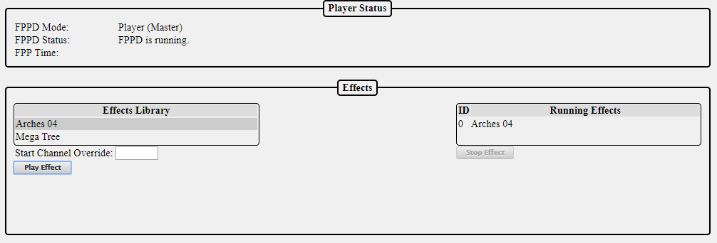

The Effects page is used to manually start or stop effects. You can run multiple effects on two models that have the same attributes. In order to do so, you will need to enter the channel offset from the model that the effect was created on. For example, you have two mini tree models and you created an effect on one of the trees and this tree has a start channel of 1326. To apply the same effect to another mini tree of the same size that has a start channel of 1842 you would select the effect from the Effects Library and enter 516 in the Start Channel Override and then click on the Play Effect. If the second model had a start channel that was lower than the one the effect was created on, then you would enter a negative Start Channel Override.

## Display Testing

The Display Testing screen can be used to test the channel outputs as well as to quickly test sequences without having to define playlists etc. This is a useful tool for troubleshooting!

### Channel Testing

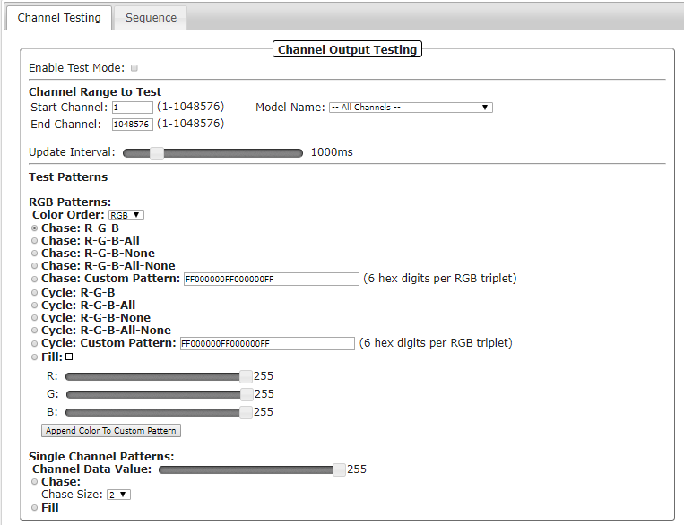

Enable Test mode-When this is selected, (a checkmark in the box) then the test mode is active. **Make sure you deselect this when you are done testing or you will get unexpected results.**

Channel Range to Test-This section is used to select a range of channels that you want to test. You do not need to change anything here unless you want to select specific channel ranges. You can also select testing by individual models if you have your models setup in the Pixel Overlay Models. This setting will apply to the settings selected in the other options

Update Interval-You can change how quickly the pattern changes with this slider.

#### Test Patterns

There are two different test patterns you can run. You can run them by channel pattern or by RGB Pattern. The RGB Patterns is used for testing the lights. The Single Channel Pattern is used to test items like servos, relays, DMX channels, etc.

RGB Patterns-This setting will test the lights based on specified colors. The color order can be changed to match the color order of the lights you are testing.

* Chase R-G-B This pattern will set every 3 lights in a red, green, blue pattern and then shift this pattern up the string of lights.
* Chase R-G-B-All > This pattern will set every 4 lights in a red, green, blue, white pattern and then shift this pattern up the string of lights.
* Chase R-G-B-None> This pattern will set every 4 lights in a red, green, blue, off pattern and then shift this pattern up the string of lights.
* Chase R-G-B-All-None> This pattern will set every 5 lights in a red, green, blue, white, off pattern and then shift this pattern up the string of lights.
* Chase Custom Pattern-You can create a custom pattern for your chase. The numbers for the colors are the standard hexadecimal RGB color notation where there are 6 total digits and the first 2 are the intensity of red (00-FF), the second 2 are the intensity of green (00-FF), and the third set is the intensity of blue (00-FF). You can enter up to 9 colors.
* Cycle R-G-B > This pattern will cycle all the lights in a red, green, blue pattern.
* Cycle R-G-B-All > This pattern will cycle the lights in a red, green, blue, white pattern.
* Cycle R-G-B-None> This pattern will cycle the lights in a red, green, blue, off pattern.
* Cycle R-G-B-All-None> This pattern will cycle the lights in a red, green, blue, white, off pattern.
* Cycle Custom Pattern-You can create a custom pattern for your cycle. The numbers for the colors are the standard hexadecimal RGB color notation where there are 6 total digits and the first 2 are the intensity of red (00-FF), the second 2 are the intensity of green (00-FF), and the third set is the intensity of blue (00-FF). You can enter up to 9 colors.
* Fill- If you select this option, then all of the lights will be illuminated with the color selected in the sliders. There is a graphical representation of the color in the box next to the Fill option.

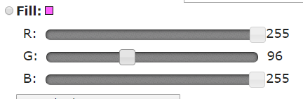

You can also click on the color indicator box to choose from a color picker tool.

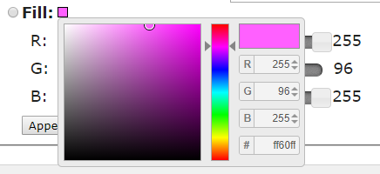

Append Color to Custom Pattern- This will add the color selected by the color sliders to the Chase: Custom Pattern text box.

Single Channel Patterns-This setting will test your prop based on channel value. Test Value is the value sent. The fill option will send the Test value to all the channels. There are several Chase Sizes options.

When you select a Chase Size, it will send out a packet the size of the selected chase size with the first channel being the Test Value selected and the remainder of the packet channels set to 0, and then the packet will repeat.

### Sequence

The Sequence testing tab will allow you to test a stored sequence.

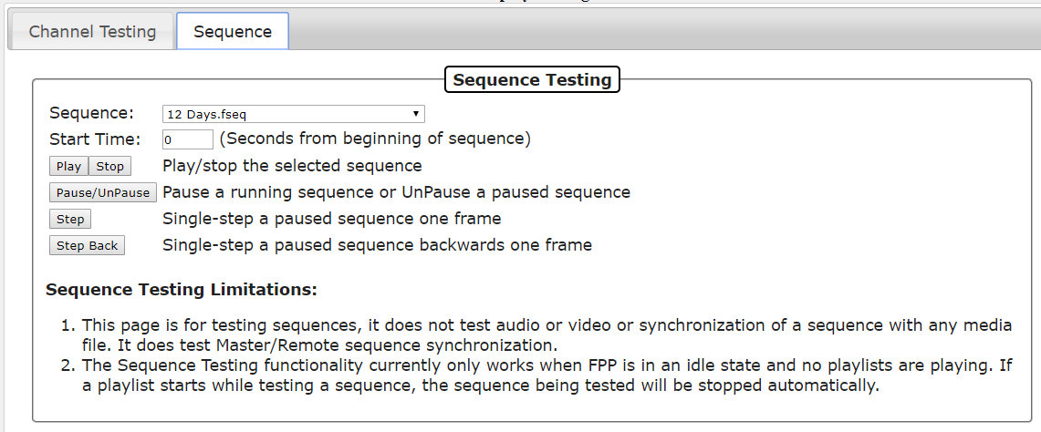

Select the sequence that you wish to test from the drop down list. You can specify the start time (offset) if you wish to start from any point other than the beginning of the sequence. Use the Control buttons (Play, Stop) to play through the sequence if you are using a Master/Remote configuration. If you are using the Stand Alone mode, then all of the player functions will work.

**Note:** Only the sequence data is output on the local system. Audio or video is not played.

Network and channel configuration definitions must have been defined prior to Display Testing.

Ensure that Enable Test Mode on the Channel testing tab is not enabled.

# Content Setup

This section is to manage the contents that you can customize for this FPP

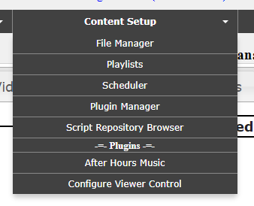

## File Manager

The file manager is where you can manage your personalized files on your FPP. From this screen, you can upload, download, and in some cases, modify the files that are on the FPP. Some of the personalized files are: sequence files, effect sequences, music files, video files, scripts, system logs and miscellaneous files.

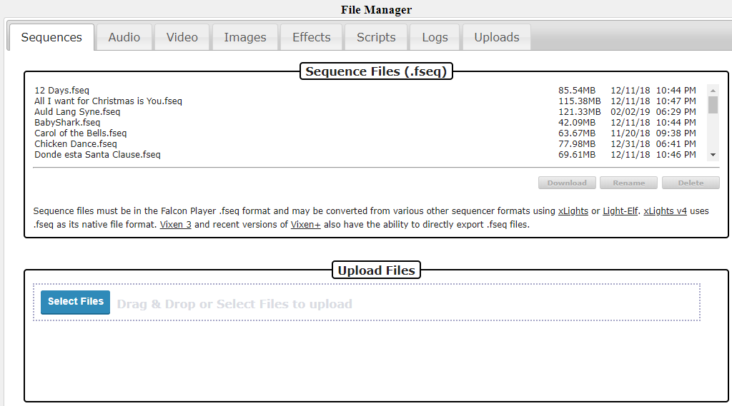

You can upload files to your FPP by dragging them from your computer’s file manager onto the Upload Files section of the FPP File Manager. You have to drag it into the small box that has the dotted lines surrounding it.

The FPP will display the files in the tab that is appropriate for the file type. If you have uploaded a file that doesn’t match one of the standard file types, they will be displayed in the upload tab.

Some tabs will have some additional options besides download, rename and delete.

Audio-This tab will also have the option to listen to the audio.

Video-This tab will also have the option to view the video properties such as encoding, video length, bitrate, resolution, frames per second, and various other properties.

Images- This tab will also have the option to view the file.

Scripts-This tab will have several options.

* View-You can view the script code
* Run-You can run the script code. This is helpful for testing purposes.
* Edit-You can edit the script code from within the browser.
* Copy-You can copy an existing script and save it with a different name. This is useful if you have similar scripts with different options.

Logs-This tab displays a list of several system logs that can be used for troubleshooting. You can view or download an individual log or you can select the Zip option which will bundle all of the system logs into a Zip file and download than onto your computer. (The location it is downloaded to depends on your computer’s configuration but is usually in the downloads section)

Uploads-This tab will contain any files that do not fit the standard FPP formats.

## Playlists

FPP is mainly designed to play playlists, but a playlist is far more than a list of songs. The playlist is a very versatile function of the FPP. A playlist is an organized group of sequences, events, scripts, videos, etc. that are to be played in a particular order. The playlist is where you combine your sequences, videos, events etc. to create your light show. You can have several playlists so that you can have a different show for certain timeframes or days of the week or any other combination of playlists.

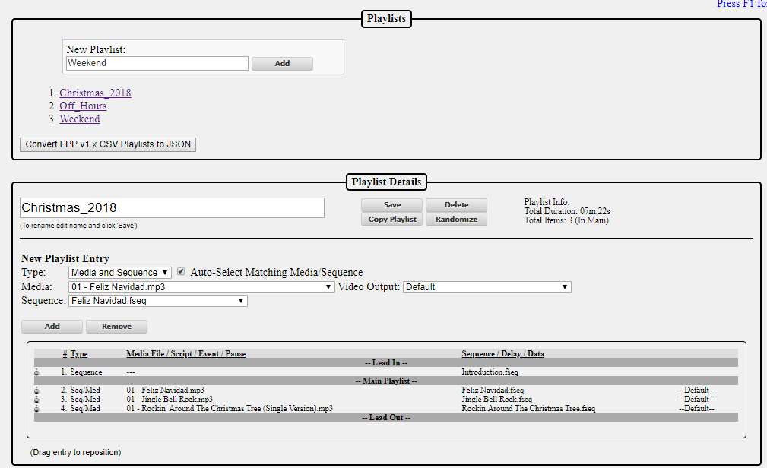

For example, during the week, you might only want a small portion of your sequences to play and on the weekend, all of your sequences to play. Then you would create 2 playlists with the order of the sequences/events to play for each playlist.

The Playlist tab has two sections for managing your playlists.

Playlists- This section shows a list of all of your saved playlists and the option to add additional playlists to your FPP.

* If you want to edit one of your existing playlists, then you can select the playlist that you want to edit in this section and the details will populate in the Playlist Details section below.
* If you want to add a new playlist then you would type in the name of the playlist you want to create in the New Playlist textbox and then click on the Add button. The playlist will be in the Playlist Details section below so that you can add your Sequences, events, etc. to your playlist.

Playlist Details- This section is used to manage your individual playlists. The playlist that is being edited will be displayed in the textbox at the top of the Playlist Details section.

* Save-This will save the changes that you have made to your playlist
* Delete-This will delete the playlist that has been selected
* Copy Playlist-This will copy the current playlist and give you an option to create a name for the new playlist.

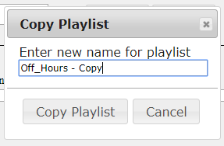

* Randomize-This will reorder the items in your Main Playlist in a random order.

New Playlist Entry-This section is used to add/edit the details of your playlist.

* Type-Select the type of playlist entry that you want to add to your playlist, there are several options.
  + Media and Sequence-This option is for playing an entry has both a .FSEQ file and associated media file (music and/or video)
  + Media Only-This option is for playing media only when there are not any lights being controlled.
  + Sequence Only- This option is for playing sequence data only when there is not any media associated with the sequence, like an animated sequence
  + Branch-This option allows you to modify the playlist while it is actually running by branching to other areas of the playlist depending on certain test criteria. This can be used for things like reducing the volume of your output depending on the time of day.
  + Channel Remap- This option will remap channels to another channel range. This is helpful if you move a prop(s) to a different port on a controller and you can’t rebuild the sequence.
  + Dynamic-This entry is for playlist items that are created from an outside script/plug-in or process and allows for items to be played “on the fly”.
  + Event-You can trigger an event from within a sequence. This could be used for things like starting a fan for a blow up prop or any other predefined event.
  + MQTT-You can send and receive a few limited home automation commands from FPP to integrate FPP with your home automation system.
  + Pause-You can add a pause to your playlist. This can sometimes be useful if you have other actions going on that you want to pause the sequences being played.
  + Playlist-You can embed a playlist within a playlist. One example, you have three different shows you play during the week, but each show has a Lead In playlist of a few songs. You could put the Lead In songs in one playlist and then for the Lead In on each of your three daily playlists, you could just enter the one Lead In playlist instead of recreating the Lead In songs in each playlist.
  + Plugin-There are several plugins that are available that you can include in your playlist. (see the Plugins section for more detail)
  + Volume-You can adjust the volume from within the playlist. This can also be used with the Branch item and adjust the volume depending on the time of day.
  + Script-You can run a script from within the playlist, there are several pre-written scripts available or you could write your own. (see the Script Repository Browser section for more detail)
  + URL-This entry will allow you to send URL commands to outside programs or processes. This can be used for things like turning on/off smart power strips or if you have a website, you could send what song is currently playing.

## Scheduler

The Scheduler page is where you can setup predefined playlists to play on a preset schedule. You must have previously created a playlist in order to schedule one.

Note: For the schedule to start on the correct time, you must have your time settings configured properly. (refer to the Config/Set Time page in the Status/Control section of FPP.

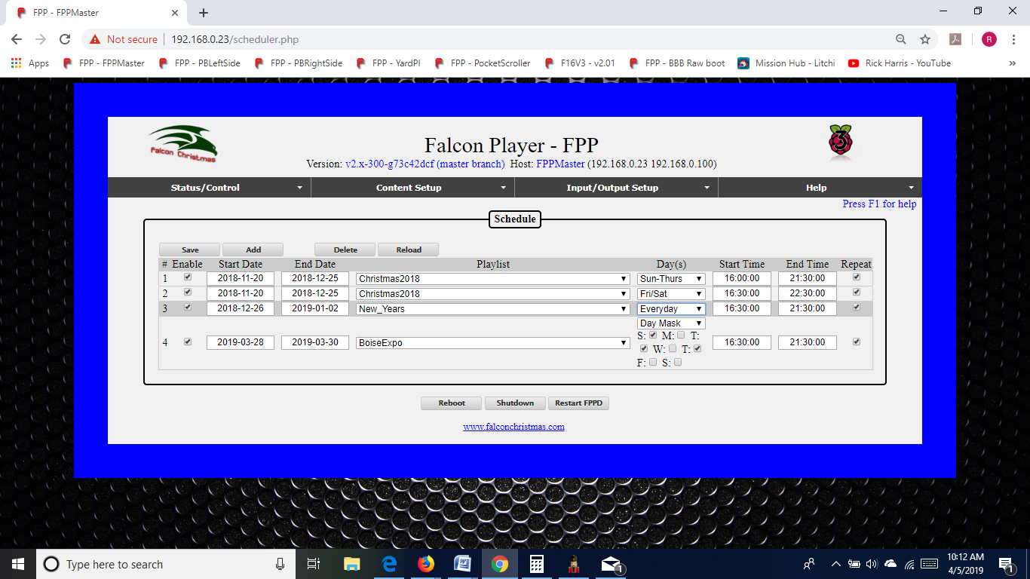

You can have multiple playlist for different days of the week or even different holidays. But you cannot have an **enabled** playlist that is scheduled to play at the same time as another **enabled** playlist, the results of that can give you various problems.

The Save button must be clicked after any additions/modifications in order for them to be saved.

The Delete button will temporarily delete the selected schedule; to make it permanent, click on the Save button after it is deleted.

The Reload button will reload the saved Schedule, so if you make changes but have not saved them, this will load what is currently saved to take you back to the beginning.

To create a schedule, click on the Add button and then fill in the items pertaining to the playlist (to edit an existing playlist, just modify the sections as needed)

Enabled-This will allow you to select whether you want the playlist to be active or not. You might have playlists that you want to manually change that are scheduled for the same time frame and you can select which one is enabled.

Start Date-This is the date that you want the chosen playlist to start playing. This can be a date way in the past and the playlist will play when the next start Time/Day is reached.

End Date-This is the last day that you want to playlist to play. It can be far into the future if you desire. The playlist will stop playing after the selected end date.

Playlist-This is the playlist that you want to play during the selected timeframe.

Days(s)-You can select any combination of days for your playlist to play. Several of the more common day combinations are listed in the drop down. If the combination you want is not listed, then select the Day Mask and place a check next to the days that you want the playlist to play.

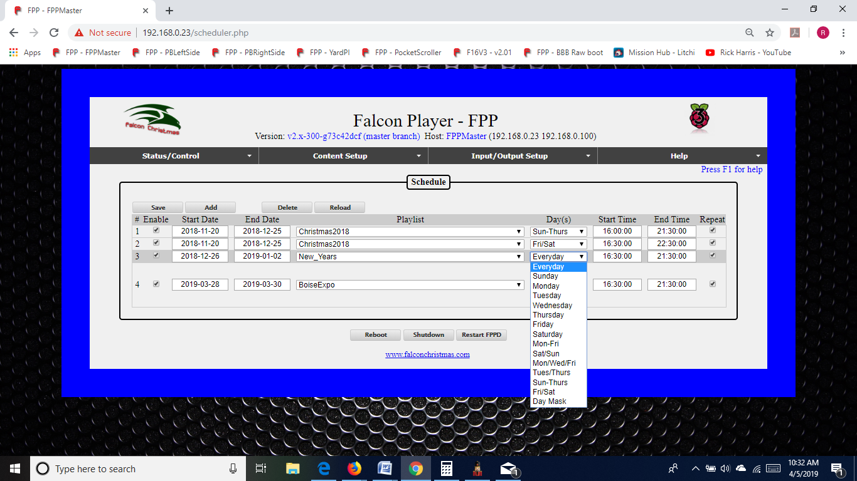

Start Time-This is the time that you want your playlist to begin. The time has to be entered in the 24 hour format. When you click on the Start Time box, there will be listed start times for every half hour. You do not need to select one of those times; you can enter any time that you want. There is also a Sunrise and Sunset option that you can select which will adjust the start time to coordinate with your local Sunrise/Sunset time. In order for this to work properly, you will need to have your Time configurations set up correctly to include your Latitude and Longitude coordinates (see the Config/Set Time section.)

End Time-This is the time that you want your playlist to end. If there is a sequence playing when it reaches this time, the sequence will continue until it is completed so it is possible that your schedule will not end on the exact time selected. The time has to be entered in the 24 hour format. When you click on the End Time box, there will be listed end times for every half hour. You do not need to select one of those times; you can enter any time that you want. There is also a Sunrise and Sunset option that you can select which will adjust the end time to coordinate with your local Sunrise/Sunset time. In order for this to work properly, you will need to have your Time configurations set up correctly to include your Latitude and Longitude coordinates (see the Config/Set Time section.) If your schedule is to go beyond midnight, select the end time that you want your schedule to end. FPP will understand that the end time is actually on the next day and stop accordingly.

Repeat-If this box is selected, then the playlist will continue from the beginning when it is finished and keep repeating the playlist until the scheduled end date/time is reached. If it is not selected, then the playlist will only play once.

Note: A playlist that does not have the repeat option selected will only play if there is no other playlist playing when the selected start time is reached. That means if you have a previous playlist where the time has ended but was still completing a sequence, that sequence will continue to play until it is completed. If the previous sequence does not end until after the start time of the next playlist that does **not** have the repeat option selected, the next playlist will not start. If the repeat option is selected, and one sequence from a previous schedule runs over into the start time (end time had expired but was finishing the current sequence), then the playlist will begin playing when the previous sequence is completed.

Updating a Playlist/Schedule- If you update a Playlist/Schedule during a time period that it was scheduled to play then there are a few things to consider.

* If you upload new sequences and add them to a playlist that is currently playing, they will not be added to the currently playing playlist even though you have saved it. You can update the changes by stopping (or stopping gracefully) the playlist from the Status page and then restart the FPPD, so that the scheduler restarts. As long as the schedule is set to repeat, it will start appropriately if it is within the scheduled time frame. If your playlist is not set to repeat and you wish to re-start it after the scheduled start time has passed, then you will have to manually start it from the Status page. Make sure you do not select the repeat option from here, or it will not stop until you manually stop it.
* If updated existing sequences or events that are already in a playlist, then the updated sequences/events will be played the next time that particular sequence or event is played.

Repeating Schedules- You can create a schedule in FPP that is a continuously repeating schedule based on a certain criteria that will span every month or every year. This is helpful for people that use FPP for more than holiday lighting or more specialized schedules (like landscape or other type of lighting). FPP will ignore any specific field comparisons if there is a 0 entry in a particular field, i.e. 00 for Month and 0000 for year.

For example, here are a couple schedules:

|  |  |  |
| --- | --- | --- |
| Start Date | End Date | Result |
| 0000-02-14 | 0000-02-14 | Plays every February 14th (Valentine’s Day) |
| 0000-00-01 | 0000-00-07 | Plays the first week of every month |

You can also have a 24 hour schedule by entering a date in the Past and a date way in the future and set the start time to be 00:00:00 and end time of 24:00:00.

## Script Repository Browser

Scripts are small program codes to perform specific functions that have a wide range of functionality. There are several scripts available from FPP or you could write your own.

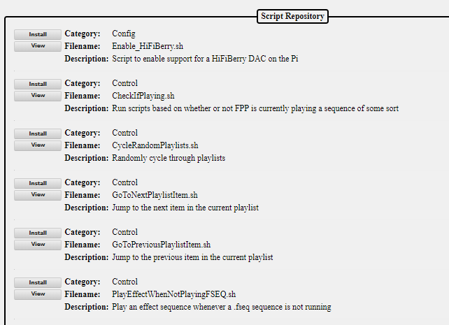

The Script Repository lists the scripts by category based on the functionality of the script. Scripts can be used as a part of a playlist or as part of a plugin. You can install the script or view the actual script code from this screen. Once the script is installed, it can be managed from the File Manager section of the FPP. You may be required to edit some scripts to make them functional. For example, the Remote Control example scripts need to be modified to include the IP address of the remote FPP instance that you wish to control.

## Plugin Manager

Plugins are additional components that have been developed by the developers or individuals to provide functionality that can then be used from within the FPP. You can develop your own Plugin or install a Plugin from a third party if you wish. These are used to perform more complex operations than scripts.

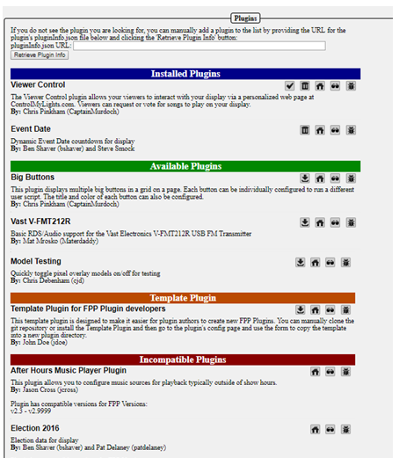

The Plugin page has 5 sections in order to ease navigation.

### Retrieve Plugin Info

This section is where you can enter the URL for a Plugin that has not been incorporated into the official release of FPP and FPP will download the relevant information from the plugin. The URL needs to point to the location that the pluginInfo.json file for the plugin is located. If there isn’t a valid pluginInfo.json file, the plugin will not be installed.

### Installed Plugins

This section contains plugins that have been installed and next to the plugin there are several options.



 is used to check for updates to the selected plugin.

 is used to delete the selected plugin.

 is used to go to the home page for the plugin and can be useful for installation information.

 is used to view the source code page for the plugin.

 is used to go to the bug reporting page for the plugin.

### Available Plugins

This section contains plugins that are directly available through the FPP interface but haven’t been installed. To install the plugin, click on the install icon.

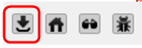

Note: Most plugins will require some sort of configuration or setup before they will operate correctly. The plugin author will determine which menu heading the plugin should fall under. The plugin’s configuration and other relevant pages will be located at the bottom of the menu dropdown. There might be more than one plugin page for the plugin.

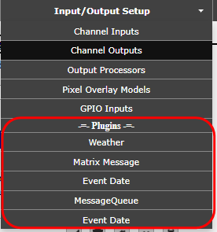

Refer to the plugin’s home page or help page for more information on the configuration and usage of the plugin. Some of the more common plugins have setup instructions in Plugins section of this manual.

### Template Plugin

This section is to assist plugin authors in creating a plugin for FPP and the structure required for a FPP Plugin. See the Plugins section in the Advanced Settings section for more details on creating a Plugin.

### Incompatible Plugins

This section will list available plugins that have compatibility issues with the installed version of FPP. You can go to the developer’s website and view the code and possibly fix the code to make it work for your application.

# Input/Output Setup

The Input/Output section is used to primarily define the channel/universe configurations of the controller connected to the FPP. It is also used to configure the GPIO pins for input triggers or to trigger output signals as well.

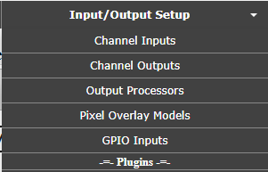

## Channel Inputs

The Channel Inputs is to identify the E1.31 Universes that this instance of FPP is going to be receiving in Bridge Mode (do not enter E1.31 Universes that other FPPs are using.)

Bridge Mode is where the FPP will accept the E1.31 data coming in and pass it through the selected network port to a controller or other E1.31 device; or to an attached Hat/Cap/Cape. If you have events or other output processes that are triggered by channel data, they will be processed.

(Note: if you are using DDP, then you do not need to setup E1.31 Bridge Mode Universes. FPP will automatically receive and recognize DDP packets with no configuration needed)

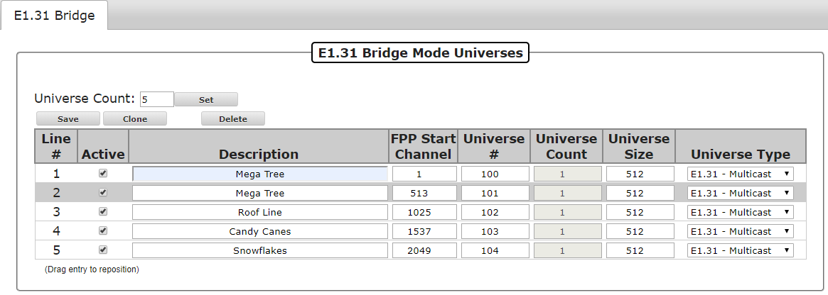

E1.31 Bridge mode is useful if you want to control your lights/props directly from xLights, xSchedule or other software and is useful in testing from xLights as well. If you are not going to use Bridge Mode, then you don’t need to setup any Universes in the Input page but it could be helpful in testing.

**Important! Your E1.31 Bridge Universes/FPP Start channels/Universe size needs to match what you setup in your show player (e.g. xLights/xSchedule) and the controller. If you need additional information on Universes, refer to the Resources section about** **Universes and Channels**

If you are using xLights, you can export the E1.31 Bridge configuration into your FPP by using the controller upload in the Setup Tab of xLights.

You can use the Description field to explain what the Universes are associated with.

Universes are identified by Line #. Each Line # can have 1 or several Universes per line. When you first create your Universes, you will be creating the number of lines that you want to create. The Universe Count will be 1 and the channel numbers will be calculated accordingly based on the default Universe size of 512 channels. Most people will use a Universe Count of 1 for each line, but there is the option of grouping same sized Universes together.

**Important! If you change the FPP Start Channel numbers, Universe #, Universe Count or Universe size after you have configured your Universes, make sure that you adjust any of the other Universe Lines because FPP will not “auto correct” your Universe #s or FPP Start Channel numbers.**

### Adding E1.31 Bridge Mode Input

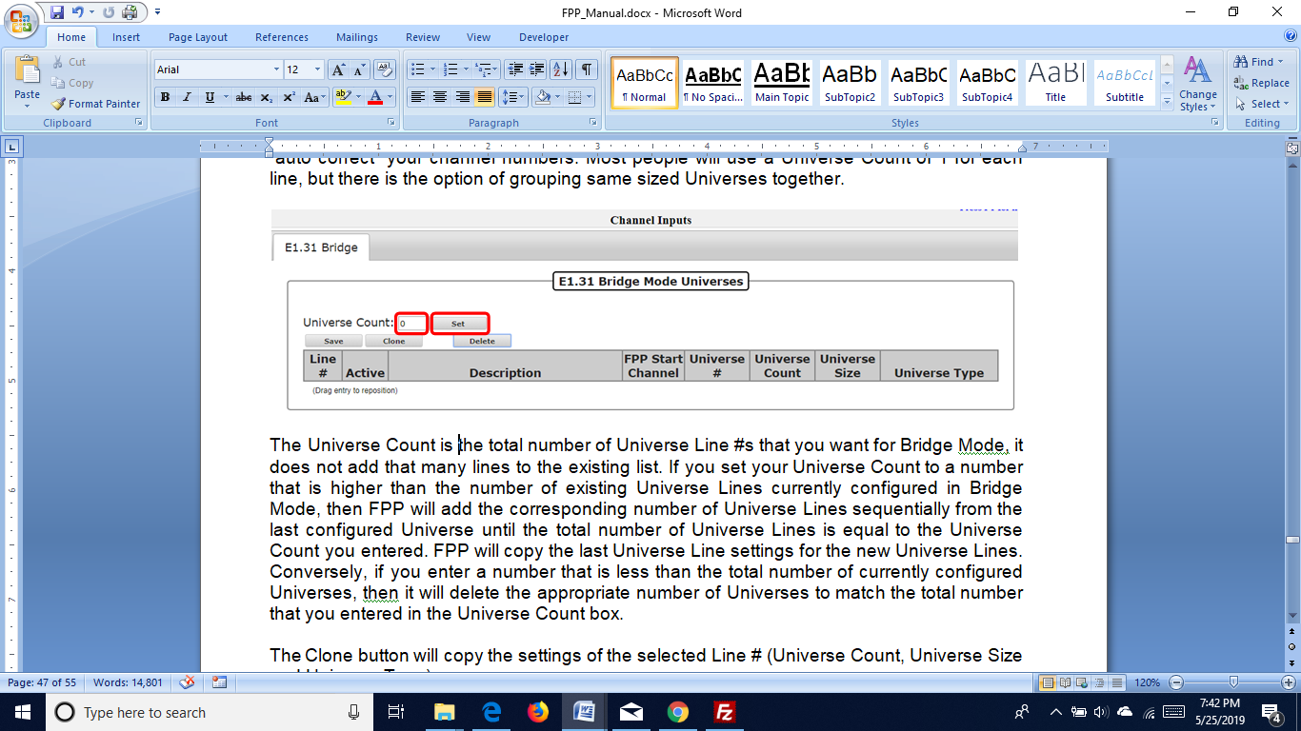

The Universe Count is the total number of Universe Line #’s that you want for Bridge Mode, it does not add that many lines to the existing list. If you set your Universe Count to a number that is higher than the number of existing Universe Lines currently configured in Bridge Mode, then FPP will add the corresponding number of Universe Lines sequentially from the last configured Universe until the total number of Universe Lines is equal to the Universe Count you entered. FPP will copy the last Universe Line settings for the new Universe Lines. Conversely, if you enter a number that is less than the total number of currently configured Universes, then FPP will delete the appropriate number of Universes to match the total number that you entered in the Universe Count box.

The Clone button will copy the settings of the selected Line # (Universe #,Universe Count, Universe Size and Universe Type). FPP will then ask how many Universe lines you want to clone.

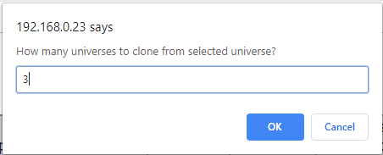

When you click OK, FPP will paste the settings into the number of Universe lines that you entered below the selected Universe line and increment the Universe # on each cloned line.

Note: You have to enter a valid number of Universes to clone. If you select more Universes to clone than there are Universe lines below the selected Universe, then the clone process will not be completed.

You can also delete a Universe line by selecting it and clicking on the Delete button.

**Important! You have to click on the Save button after you make any changes in order for them to be saved. After you save the configuration, you will get a message at the top of your screen indicating that you have to restart FPP for the change to take effect.**

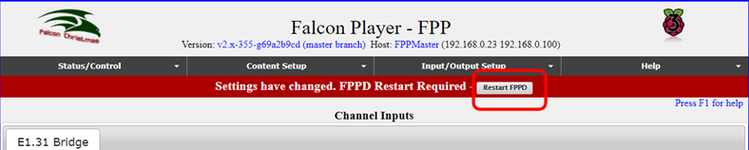

## Channel Outputs

The Channel Outputs page is where you configure FPP to output the channel data it receives to the various controllers/hats/capes that are connected to the FPP. There are several types of output configurations and you will have to configure the output that is appropriate for your application. Depending on the SBC (Pi or BeagleBone) that you have connected, the Channel Output tabs will be different.

Pi Channel Outputs

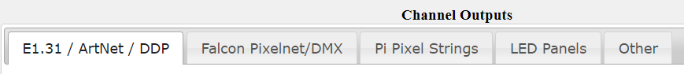

BeagleBone Channel Outputs

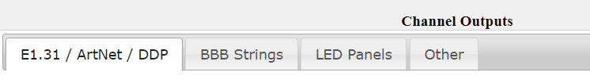

You will need to setup your channel outputs to match the controller that is connected to your FPP device.

Here are the Channel output types and typical usage.

* E1.31/ ArtNet/ DDP- Any device that receives E1.31 data (like Falcon Controllers, Advatek PixLite controllers, and SanDevices controllers) and output the signal to the pixels. This is also where you would setup Channel output for devices that receive ArtNet or DDP data. (There are not many ArtNet devices and DDP is a newer technology so there are not that many devices that are using these protocols yet.)
* Falcon Pixelnet/DMX- Lynx and older Falcon Controllers used the Pixelnet protocol. This is where you will also setup your connections to any DMX controllers you might be using.
* Pi Pixel Strings- There is a Pi Hat for the Raspberry Pis with 2 string ports.
* LED Panels- This is for setting up P10/P5 panels that are connected to either a BB OctoScroller type controller or a Pi Matrix hat type controller.
* BBB Strings- There are several capes that you can add to the BeagleBone series SBC to control up to 40 strings of pixels.
* Other-There are several other output types that are not commonly used but available, such as DMX Pro, LOR, Renard, Triks-C to name a few.

### E1.31/ ArtNet/ DDP

### 

**Important! Your E1.31 Universes/FPP Start channels/Universe size needs to match what you setup in your show sequencer (e.g. xLights) and the controller. If you need additional information on Universes, refer to the Resources section about** **Universes and Channels**

* Enable E1.31/Artnet/DDP output- If you need your FPP to output this type of data, then make sure you check the box to enable E1.31/Artnet/DDP output.
* Source Interface- Select the interface that you want the data to be sent out
* Universe Count- You can enter a Universe Count here. This allows you to set the number of Universe Line #s that you want.
* Line #- This is used to Identify each line of Universe(s) saved on your FPP. You can set multiple universes on each line if you want.
* Active- A Universe line can be Active or not. If it is not active, then data will not be transmitted to all the universe(s) on that Line #.
* Description-This can be used to provide information on how each Universe Line # is assigned.
* FPP Start Channel-This normally reflects the Absolute Channel that is reflected in your Sequencing Program (xLights, Vixen, etc.)
* Universe #- This shows the starting universe number for the Universe Line #.
* Universe Count-This will indicate how many Universes are defined fro that line. You can define multiple Universes on a line.
* Universe Size- This is how many channels the Universe is designated. If the Universe count is greater than one, then all Universes on that line will have the same number of channels.
* Universe Type- Is used to identify how the Universe Data is going to be transmitted. This is normally Multicast or Unicast, but for specialty configurations it can be set for Artnet or DDP protocols
* Unicast Address- If you are using Unicast, then the IP address of the device you are sending the data to needs to have it entered in this box.
* Priority- You can select a priority for the E1.31 packages. If a device receives E1.31 data from 2 sources, then the device will use the one with the highest priority. This is only valid for controllers that support the E1.31 priority function.

If you are using xLights, you can export the E1.31 Channel Output settingsinto your FPP by using the controller upload in the Setup Tab of xLights.

Universes are identified by Line #. Each Line # can have 1 or several Universes per line. When you first create your Universes, you will be creating the number of lines that you want to create. The Universe Count will be 1 and the channel numbers will be calculated accordingly based on the default Universe size of 512 channels. Most people will use a Universe Count of 1 for each line, but there is the option of grouping same sized Universes together.

**Important! If you change the FPP Start Channel numbers, Universe #, Universe Count or Universe size after you have configured your Universes, make sure that you adjust any of the other Universe Lines because FPP will not “auto correct” your Universe #s or FPP Start Channel numbers.**

#### Adding E1.31 Output Channels

### 

The Source Interface specifies which network interface the FPP is going to output the channel data to the controller. This is most commonly done through the eth0.

The Universe Count is the total number of Universe Line #’s that you want to output; it does not add that many lines to the existing list. If you set your Universe Count to a number that is higher than the number of existing Universe Lines currently configured in your Output, then FPP will add the corresponding number of Universe Lines sequentially from the last configured Universe until the total number of Universe Lines is equal to the Universe Count you entered. FPP will copy the last Universe Line settings for the new Universe Lines. Conversely, if you enter a number that is less than the total number of currently configured Universes, then FPP will delete the appropriate number of Universes to match the total number that you entered in the Universe Count box.

The Clone button will copy the settings of the selected Line # (Universe #, Universe Count, Universe Size and Universe Type). FPP will then ask how many Universe lines you want to clone.



When you click OK, FPP will paste the settings into the number of Universe lines that you entered below the selected Universe line and increment the Universe # on each cloned line.

Note: You have to enter a valid number of Universes to clone. If you select more Universes to clone than there are Universe lines below the selected Universe, then the clone process will not be completed.

You can also delete a Universe line by selecting it and clicking on the Delete button.

**Important! You have to click on the Save button after you make any changes in order for them to be saved. After you save the configuration, you will get a message at the top of your screen indicating that you have to restart FPP for the change to take effect.**

### Falcon Pixelnet/DMX

### 

This page is for setting up DMX or Pixelnet output data. The first versions of the Falcon controllers used a Pixelnet protocol. There are several different DMX devices that can be utilized with FPP.

* Enable FPD output-If you are outputting Pixelnet or DMX data, make sure you check the Enable FPD output box.
* FPD Start Channel Offset- Some controllers will default to Channel 1 as the start channel for its input, if this is the case for your controller, then you will need to enter the offset that FPP needs to adjust the channels to start at 1.
* Save- Selecting this will save your configuration.
* Clone String- Selecting this will copy the settings of the selected string to the number of strings selected below. It will update the Start Channel to follow after the previous string.
* #- This is the output line number and is used for reference when you have several output lines.
* Act- A Pixelnet/DMX line can be Active or not. If it is not active, then data will not be transmitted to the channels that correspond to that Line #.
* Type- This identifies the type of Pixelnet/DMX data you want to transmit either Pixelnet or DMX
* Start-This is the start channel address for each output type.

### Pi Pixel Strings

### 

If you are using a PiHat type of controller, you will setup your channel outputs here.

* New Type- Select the type of pixels that you are going to be connecting to your Pi. You can choose between RPIWS281X or spixels. RPIWS281X is used for most pixels such as WS2811, WS2812, etc. protocol.
* Add Output- Selecting this will allow you to add spixel type strings to your Pi hat. Spixels can drive 16 independent strings of APA102, LPD6803, or LPD8806 pixels directly off the Raspberry Pi's GPIO ports by emulating SPI outputs in software. The data and ground lines attach directly to the Pi while power for the pixels is injected from another source.
* Clone String- Selecting this will copy the settings of the selected string to the number of strings selected below. It will update the Start Channel to follow after the previous string.
* Save- Selecting this will save your configuration.
* Revert- Selecting this will revert the screen to the currently saved configuration
* Output Enabled-Check this box to enable the Pi Pixel String output.
* Port- Indicates the number of the output port on the hat.
* Protocol- Indicates the protocol for the pixels attached to the port of the hat.
* Description- You can enter a description for the pixels attached to the port.
* Start Channel- Enter the start channel that corresponds to the start channel in your sequencing software (xLights, Vixen, etc.)
* Pixel Count- Enter the number of pixels connected to that port of the hat.
* Group Count- If you have groups of pixels that are going to be illuminated exactly the same all of the time, you can put them in groups.
* End Channel- This indicates the ending channel for the string.
* Direction- Selecting reverse will reverse the data sent to the pixels so that it will act like the data is coming in from the end of the string.
* Color Order- You can select a color order to match the color order for the pixels you are using.
* Null Nodes- If you are using Null Nodes in the beginning of your string to help boost the transmission distance, then enter the number of Null Nodes you have in the string.
* Zig Zag- This setting is useful for items like a Mega Tree where one string is used for more than one strand of the tree. This is more commonly setup in the sequencing software (xLights, Vixen, etc.) Enter the number of times the string changes direction. **Do not use Zig Zag if you used the Strands/String setting in your sequencing software.**
* Brightness- You can set the brightness for your pixel string. Many dense props are very bright and a lower brightness might look better. This also reduces the power required to light the pixels.
* Gamma- This is a correction factor that can be entered due to the way that our eyes perceive colors in the dark. It can also be used to correct color variations on pixel strings from different vendors

### LED Panels

### 

This tab is for configuring P10 or P5 Panels.

* Enable LED Panel Output- If you are using a P10 or P5 panel, this needs to be checked.
* Panel Layout (WxH)- enter the number of panels you are using in Width by Height.
* Single Panel Size (WxH)- Enter the size in pixels of each individual panel and the scan rate. (P10 panels are 32x16 and P5 panels are 64x32)*
* Model Start Corner- This should typically be upper left if you are using xLights and bottom left if you are using Vixen. For other Sequencing software, you should match the setting in that software.
* Brightness- You can adjust the overall brightness with this setting.
* Panel Gamma- You can apply a Gamma correction to help correct the way our eyes process colors in dim situations.
* Panel Interleave- some outdoor panels (possibly others) use a non-standard transmission of the data. If they do, then this setting will need to be modified to match the transmission method of your panels.
* Color Depth- Is used to set the number of possible colors. The color depth can be reduced to reduce flicker on larger sets of panels if needed.
* Connection- This is to identify the type of LED Panel controller you are using and will usually auto-populate to the correct connection type.
* Start Channel- This is the start channel for your LED Panel and is usually the Absolute address identified in your sequencing software.
* Channel Count- This is the total number of channels that your panel array will require.
* Default Panel Color Order- Panels can have a different color order. You can set the color order for your panel with this option.
* Wiring Pinout- This setting is to identify which SBC the LED panel controller is being used. It will normally auto-populate with the correct selection if it can be detected.
* Save- this will save your configuration.

*- Some 1/4 scan and 1/2 scan panels use a non-conventional addressing mode and you might have to use one of the A, AB or ABCD addressing mode panel types. There usually is no indication on the panels so it might be trial and error to select the correct one.

#### LED Panel Layout

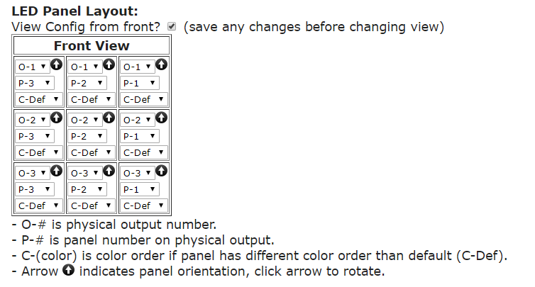

The way you connected your LED panels together and the way they are connected needs to be reflected exactly the same way in FPP.

Make sure that you are referencing the panels correctly. You can configure the panels as if you are looking at the panels from the front or from the rear, more commonly referred as a “wiring view.” To change the view, toggle the “View Config from front” checkbox. Make sure you save any changes made before you change the view.

The panel arrows can go in any direction you like to make wiring easier but they have to match in FPP. To change the arrow orientation, click on the arrow in corresponding LED panel and it will rotate each time you click it.

### BBB Strings

The BeagleBone series of SBCs has several capes and configurations and is very versatile. There are several capes available from <http://kulplights.com>.

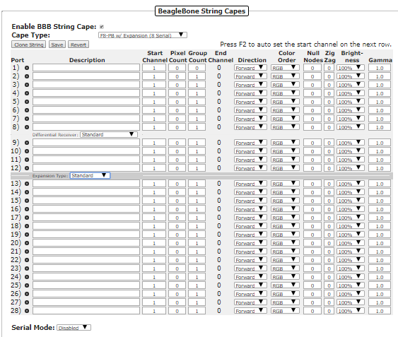

The F8 series of capes from KulpLights.com can drive 8 ports of 700 pixels per port at 40 fps (roughly 1450 per port at 20 fps). The F8 can also drive other components to control additional pixels like an Expansion Board, Differential Expansion Board, Differential Receiver, or Smart Differential Receivers from <http://pixelcontroller.com>.

The F8 has 3 RJ45 ports and 2 of them can be used to drive 4 channels of serial data each. If you do not send any serial data then you will have all 3 ports available to connect Differential Receivers. Each RJ45 port can connect to one Differential Receiver or up to 3 daisy-chained Smart Differential Receivers with an Ethernet cable up to 250 feet to the furthest Receiver. The Differential Receivers and Smart Differential Receivers each have 4 ports for pixel string connections.

At the top of the page, you have the following options:

* Enable BBB String Cape- If you are using a BBB Cape then this box needs to be checked
* Cape Type- You will need to select the type of Cape that you are using and the type of output you are going to use. If you are using one of the Expansion Boards the select one of the options with the Expansion Board Setting. If you are going to use any of the RJ45 ports for outputting serial data, then select one of the options that corresponds to the number of serial channels you are going to output (Each RJ45 port outputs 4 serial channels). If you are not going to output any serial data from the F8, then select the (No Serial) option.
* Clone String- If you select a string port, you can clone the data to the string ports below. Once you select a string port, click on the Clone String button and you will be asked how many copies of the string you want to clone below the selected string.
* Save- This will save your settings
* Revert- This will revert to the last saved settings.
* Press F2 to auto set- When you complete a row of the configuration, you can press F2 and it will fill in the start channel on the next row. This is helpful if you have several ports that are running contiguous channels.

You can add only one Expansion Board or one Differential Expansion Board to the F8.

* Expansion Board- This will add 16 more ports to be connected locally.
* Differential Expansion Board- This will add the ability to add up to 4 Differential Receivers. Each Differential Receiver has 4 ports and each Differential Receiver can be located up to 250 feet from the F8 with an Ethernet cable connecting them. If you use Smart Differential Receiver boards, then you can add up to 3 Differential Receiver boards to each port of the Differential Expansion board by connecting them in a daisy chain.

Each port on all of the controllers/receivers have the following options:

* Description- You can enter a description for the pixels attached to the port.
* Start Channel- Enter the start channel that corresponds to the start channel in your sequencing software (xLights, Vixen, etc.)
* Pixel Count- Enter the number of pixels connected to that port of the hat.
* Group Count- If you have groups of pixels that are going to be illuminated exactly the same all of the time, you can put them in groups.
* End Channel- This indicates the ending channel for the string.
* Direction- Selecting reverse will reverse the data sent to the pixels so that it will act like the data is coming in from the end of the string.
* Color Order- You can select a color order to match the color order for the pixels you are using.
* Null Nodes- If you are using Null Nodes in the beginning of your string to help boost the transmission distance, then enter the number of Null Nodes you have in the string.
* Zig Zag- This setting is useful for items like a Mega Tree where one string is used for more than one strand of the tree. This is more commonly setup in the sequencing software (xLights, Vixen, etc.) Enter the number of times the string changes direction. **Do not use Zig Zag if you used the Strands/String setting in your sequencing software.**
* Brightness- You can set the brightness for your pixel string. Many dense props are very bright and a lower brightness might look better. This also reduces the power required to light the pixels.
* Gamma- This is a correction factor that can be entered due to the way that our eyes perceive colors in the dark. . It can also be used to correct color variations on pixel strings from different vendors

### Other

### 

The other Output tab is to define other less common output types.

## Output Processors

## 

The output processors page is utilized to modify the outgoing data. This can be useful for several things such as moving a prop after the .fseq file has been save to the FPP, or adjusting the brightness if your controller does not support dimming.

The Output Processors are:

* Remap-

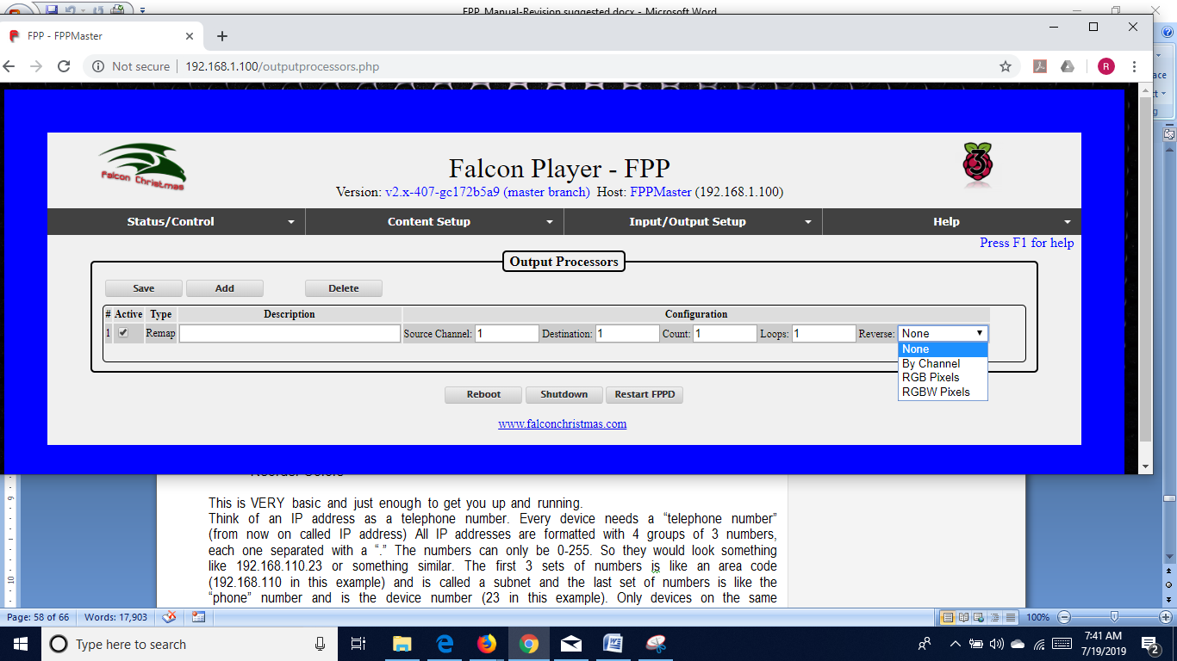

The remap processor is beneficial for several things such as when a prop has been moved because a port on the controller isn’t working or you have to replace a “dumb” string with a pixel string.

* Description-This can be used to identify the reason for the remapping for future reference.
* Source Channel- Enter the first channel you want to remap to another location.
* Destination- Enter the first channel that you want the data remapped to.
* Count- Enter the total number of channels that you want remapped.
* Loops- Enter the number of times that you want this remapping to occur, this can be helpful if you need to replace a dumb string with a pixel string. Enter the Source Channel and the Destination Channel and enter 3 for the Count. Then enter the number of pixels that are in the replacement string in the Loops box.
* Reverse- This can be useful if you wired a prop in reverse or changed a controller connection to the opposite end of a string. The reverse can be by channel or by pixel type.
* Brightness-



You can modify the brightness or Gamma correction on a range of channels. This can be useful if your controller doesn’t support the brightness/gamma correction or if you can’t reach your controller via the web interface.

* Set Value-



You can set the value for range of channels.

* Reorder Colors-

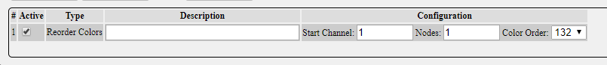

You can change the color order. This is helpful if you have to replace a string or part of a string and it has a different color order than the section replaced.

## Pixel Overlay Models

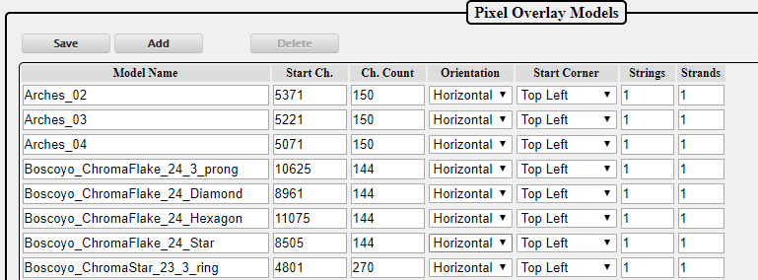

The Pixel Overlay Models feature of the Falcon Player allows the user to manipulate channel data in real-time via Plugins or scripts before it is sent out to the controllers. This can be done while the rest of your display and channels are playing sequenced data from a .fseq sequence file. The Pixel Overlay Models can be turned on and off independently of each other and may be used when sequence data is playing or not playing. When a Pixel Overlay Model is enabled, the data input via the Pixel Overlay feature overrides channel data in the sequence file allowing you to take control of a portion of your display real-time. This can be used for examples such as the following:

* Displaying real-time dynamic text on a matrix or pixel tree
* Displaying the current time or a Christmas countdown timer on a matrix
* Turning on/off individual channels for items such as a Tune-To sign, or inflatables without having to sequence the channels for these items in every one of your sequence files.

The Matrix Tools plugin available via the Plugin install page uses the Pixel Overlay feature to allow display and scrolling of dynamic text on a Pixel Overlay Model using a web interface. As an example of the power and flexibility of the Real-Time Pixel Overlay feature, you can also use the Matrix Tools plugin to draw in Real-Time on your matrix using your mouse and web browser. Future Matrix Tools support will include the ability to display live video being captured from a webcam attached to the Falcon Player.

The Pixel Overlay Models can be exported from xLights to your FPP using FPP Connect.

## GPIO Inputs

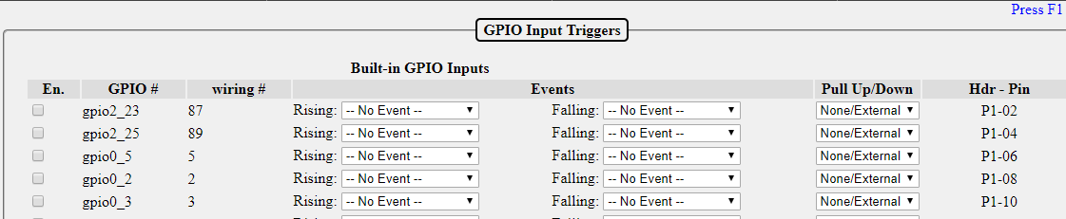

GPIO Inputs allow the triggering of internal FPP Events via external input. Each GPIO Input is connected to a pin on the FPP’s GPIO header or attached to an add-on I/O board such as the PiFace. GPIO Inputs allow two events to be attached to each pin, one rising event and one falling event. In FPP, you can set the GPIO state to either high (pull up) or low (pull down) using the internal resistors or you can set the state using external pull up or pull down resistors. If you select the None/External option, make sure your circuitry connected to the pin establishes either a high or low state or else the pin will be floating which can cause false triggers.

* En- If you are going to use the GPIO input function, then the pin you are using needs to be enabled by placing a check in this box.
* GPIO#- This is the Pin Label as identified by the manufacturer and for reference only.
* Wiring#- This is the WiringPi library number in case you are using WiringPi functions.
* Events- In this section, you can select a previously saved event for the rising and or falling events. Refer to the Events section for more details.
* Pull up/Down- You can set the internal pull up or pull down resistor in this box.
* Hdr-Pin- This is for reference to locate the pin on the headers

Input triggers can be useful for various things such as a button to start or stop a sequence, a motion sensor to activate a sequence or another external device just to name a few.

# Help

This section is for information on troubleshooting, references and updates.

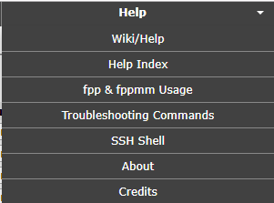

## Wiki/Help

If your computer has an internet connection, clicking this link will take you to the FPP Wiki site. The Wiki site might not have the most current information.

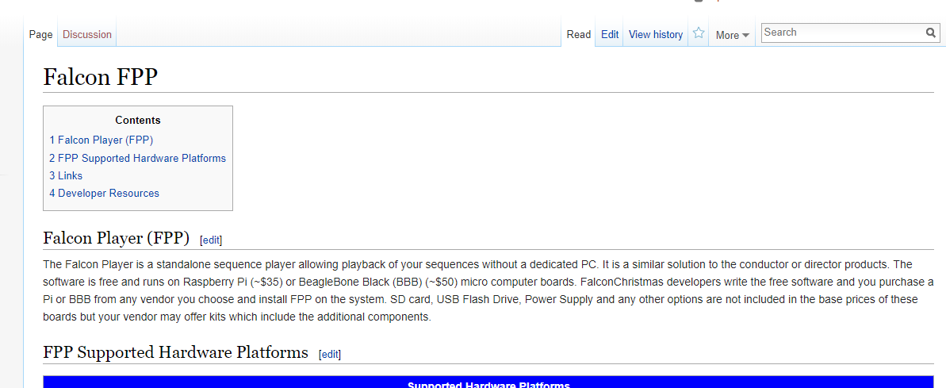

## Help Index

The Help Index has links to various topics and information regarding those topics as a quick reference. The user manual has more detailed information on these subjects.

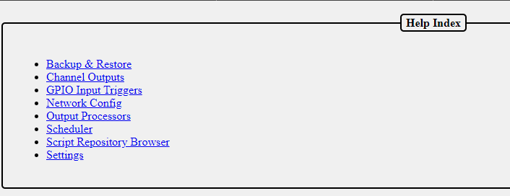

## fpp & fppmm

This page provides information on some of the fpp and fppmm commands that can be used in the shell or in scripts.

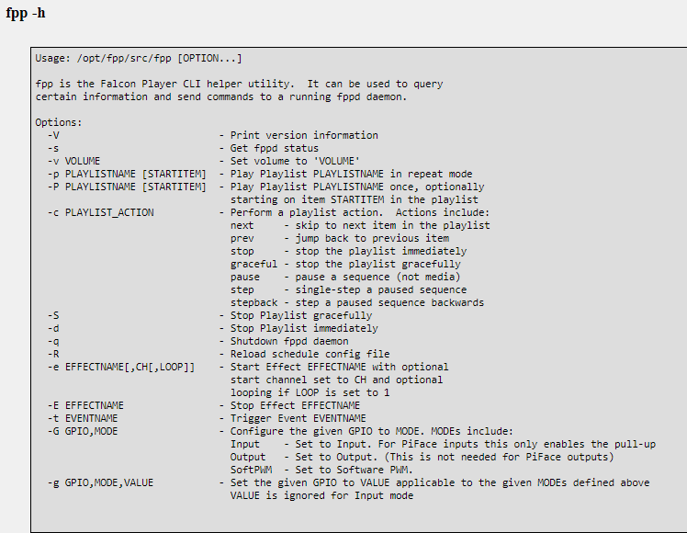

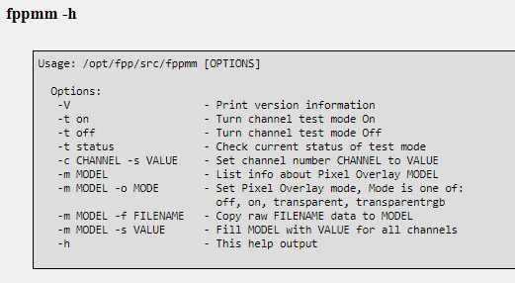

## Troubleshooting Commands

When you click on this link, the FPP will run several troubleshooting commands that can be useful to diagnose problems.

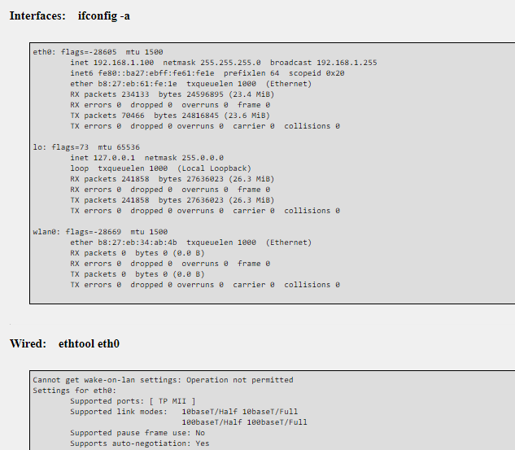

The commands that it runs are:

* ifconfig –a

This displays the configuration of all network interfaces on the FPP device.

* ethtool eth0

This displays the current parameters of the eth0 interface.

* iwconfig

This displays the current parameters of the wireless interface

* netstat –rn

This displays the routing tables

* ping –c 1 $(netstat –rn | grep ‘^0.0.0.0’ | awk ‘{print $2}’)

This will ping the default gateway and display the results.

* ping –c 1 github.com

This will ping github.com to check for a network connection and display the results.

* sudo lsblk –I

This lists all of the storage devices.

* sudo fdisk –I

This will list all of the partitions on your storage devices.

* df –k

This displays the file system information.

* mount | grep – v password

This displays the details of all of the mounted devices.

* date

This displays the current FPP system date and time and also the time zone.

* pgrep ntpd > /dev/null && ntpq -c peers

This will check to see if the Network Time Protocol Deamon is running and then list the peers that the program is getting its time from.

* sudo hwclock –r –f /dev/rtc0

This will determine if a real time clock is installed and display the time if there is one.

* free

This displays the amount of used and free physical and swap memory.

* uptime

This displays how long the FPP daemon has been running.

* top –bn1 | head -20

This displays the CPU Utilization.

* cat /proc/cpuinfo

This displays the CPI information.

* sudo lsusb –t

This displays the USB information in a tree format.

* sudo lsusb –v

This displays detailed information on the USB devices.

* sudo aplay –I

This displays all of the audio playback devices

* (bin/ls -1d /proc/asound/card[0-9] |sed –e “s/.*\/card//” …

This displays all of the mixer devices

* sudo gpio readall

This displays the GPIO table (for Raspberry Pis only)

* unmame -a

This displays the kernel information

* lsmod

This displays all of the kernel modules that are installed.

* I2cdetect

This displays if you have any devices connected to the i2c bus suck as an oled display.

* ps –edaf –forest

This displays a list of the currently running processes.

## SSH Shell

You can use the SSH Shell for advanced operations or troubleshooting using Unix commands. The user is fpp and the password is falcon.

Normally users do not need to use the SSH Shell for operations or configuring the FPP. The SSH Shell is typically used by advanced users that want to customize the FPP.

## About

The About page provides information about the current FPP version and statistics relevant to the running FPP. This is also the page that you will navigate to in order to perform a manual update.

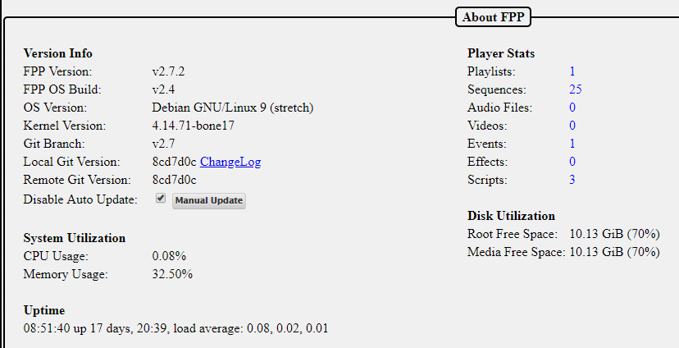

This page has information that can be useful for troubleshooting or updating your FPP system.

### Version Info

* FPP Version- This is your current FPP Version.
* FPP OS Build- This is the current operating system build.
* OS Version- This lists the SBC base operating system version.
* Kernel Version- This lists the Kernel Version.
* Git Branch- This lists the Git branch for the installed system
* Local Git Version- This lists the current Git version that is installed. The ChangeLog link will show a summary of changes that have occurred.
* Remote Git Version- This lists the most current Git version available. If this shows “Unknown” then your FPP does not have access to the internet. Possibly due to network configuration errors. If there is an update available, then a Preview Changes link will be available so you can view what changes the update will provide.
* Disable Auto Update- This allows you the option to have FPP automatically update the software. It is recommended to have this option selected during the time that you are displaying your show as the update could interrupt your show.
* Manual Update- If there is an update available, FPP will indicate this and you can manually update the software by clicking on this button

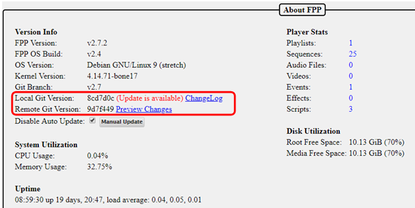

### System Utilization

* CPU Usage- This will show the utilization of the CPU at the time the page loads, it does not update until the page is refreshed.
* Memory Usage- This will show how much of the RAM is being used at the time the page loads, it does not update until the page is refreshed.
* Uptime- This shows the current system time and how long the FPP has been running.
* Player Stats- This shows an overview of the files saved on your system. If you click on the number next to the item, it will take you to the appropriate page where these are stored.
* Disk Utilization- This shows the free space on your storage devices.

## Credits

The Credits gives credit to the major developers and contributors to the FPP software.

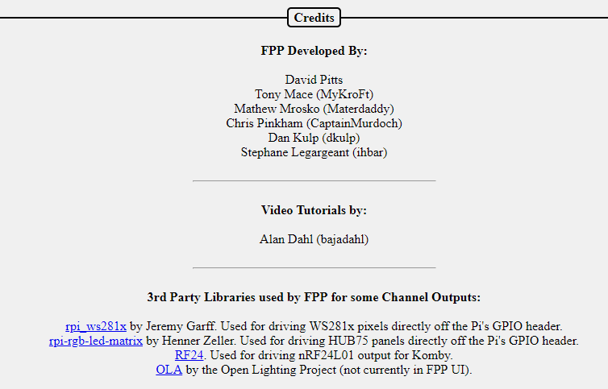

# Glossary

Absolute Channel- A numbering system to uniquely identify each channel in each pixel and/or DMX device. It is simply 1 to the last channel needed. In xLights, you can have gaps in the numbering sequence. Due to the number of pixels utilized in most displays, the total number of channels can become quite large and difficult to manage.

BBB- A single board computer used to play sequences or act as a controller interface for animated holiday lighting. BBB is an acronym for BeagleBone Black. This acronym is commonly used for all of the BeagleBone series Single Board Computers.

Broadcast- A method of transmitting network data where the same data is sent to every device on the network.

btrfs- A filesystem for Linux that implements advanced features including compression.

Channel- An identifier for a component in a lighting display. This is commonly used for pixels to set the color and brightness, but it can also be used for other items such as DMX channels for other components.

DHCP- Dynamic Host Configuration Protocol is a network management protocol where IP addresses can be dynamically assigned to devices on a network. This allows devices the ability to automatically communicate within a network. The IP addresses assigned to a device is not a permanent assignment and a device can get a different IP address the next time it connects to the network. To utilize DHCP, you have to have a DHCP server in your network. Most routers have a DHCP server on them.

DNS- Domain Name System is a naming system for devices or domains in a network. All devices in a network are identified by an IP address, such as 192.168.0.1. The DNS allows users to use more human friendly Host Names to access devices on the network. That way you can type something like google.com to access their website. But in reality Google’s website is actually 172.217.11.238 (that is one of several devices on Google’s domain.) This will also allow you to type something like fpp or whatever other host name you have saved on your FPP or other devices in your local network. To utilize DNS, you have to have a DNS server in your network and it has to be identified in the network settings. Most routers have a DNS server on them.

E1.31- A network protocol that is used to transmit DMX data. This is the most commonly used protocol in the animated holiday lighting hobby.

Effect- is a small sequence usually for just one model and can be used to overwrite the data that is being played by a sequence. It is commonly used with an event or via a manual trigger.

eMMC- Is a flash memory on the BeagleBone Black and BeagleBone Green computers. You can store the FPP operating system on the eMMC if you want.

eth0- The wired network portion of the FPP.

Event- An event can be a sequence or a script to run when a trigger is activated or it can be activated manually through the FPP interface.

ext4- The standard file system for Linux operating systems.

FPP- Falcon Player is a widely used player and operating system used in animated holiday lighting.

fseq file- The standard format for the raw data files used to inform controllers how to illuminate each light or which DMX channel to be activated.

Gateway- The IP address that a device will send network data to that it doesn’t know how to properly route. This is usually your router or a FPP device where it is connected to two different subnets.

Git- A distributed version control system for coordinating work among developers and the core of the Github software hosting system.

Host Name- A human friendly name that you can assign a device to access through a web interface instead of typing the IP Address.

IP address- A numerical label to address devices in a network. This number is four parts separated by a decimal point. Each part can be between 0 and 255.

Master/Remote- An FPP method to synchronize several FPP devices by sending small sync signals to all of the remotes. This can be useful for very large displays or displays that are widespread and running Ethernet cables could be problematic.

Multicast- A method of transmitting network data where the same data is sent to all the devices that requested it but not to the devices that did not request it..

MultiSync- A way to identify relevant FPP instances in a Master/Remote configuration and to keep then synchronized with each other

Netmask- A numerical mask to identify the size the size of a subnet. This is typically 255.255.255.0 in the holiday animated lighting networks.

Network- A group of devices connected through a digital telecommunications network to provide a method for these devices to share data.

NTP- Network Time Protocol is a networking protocol used to keep network system’s clock(s) synchronized with the accurate time.

P10/P5 panel- An electronic component that is roughly 6 inches in height by 12 inches in width. These panels have pixels that are spaced according to the panel type, i.e. P5 panels have pixels that are spaced 5 millimeters apart. These panels can be combined to make larger panels and are commonly used as a “Tune To” sign to display informational text and/or more detailed graphics.

Pixel- This usually refers to an LED light with individually addressable channels so that each pixel in a string/strand can be identified and lighted in a color that is independent from the other pixels in the string.

Playlist- A playlist is an ordered list of various items to display and is used by FPP to control the lights and other props used in the animated lighting hobby.

Plugin- A component developed to provide more functionality to the FPP.

Port- The physical connection point on a controller for pixel strings.

Raspberry Pi- A single board computer used to play sequences or act as a controller interface for animated holiday lighting.

Real Time Clock- A component that contains a highly accurate timing crystal used to keep accurate time in certain devices.

SBC- Single Board Computer is a small complete computer built on a single circuit board. The Raspberry Pi and BeagleBone series computers are the most commonly used single board computers in the holiday lighting community.

Script- A small program code used to perform a specific function in the FPP interface.

SSH- Secure Shell is a network protocol that gives users a secure way to access devices through a command line interface. This is usually for advanced users.

Subnet- A portion of a network usually comprised of devices within a range of IP addresses defined by the first 3 segments of a 4 segment IP address, i.e. 192.168.0.xxx where xxx is the identifying address for each device.

Tethering- A method of connecting two network devices directly to communicate between them. This can be done through and Ethernet cable or through Wi-Fi.

UI- User Interface the method in how a user interacts with a device and/or program. FPP’s User Interface is through a web page based interface.

Unicast- A method of transmitting network data where only the data for each device is sent to that device. This is usually more efficient than Multicast or Broadcast unless you want or need to send the same data to multiple devices.

Universe/Channel notation- A numbering system to uniquely identify each channel in each pixel and/or DMX device. It breaks the channels down into user defined groups called Universes. The user can define each Universe to be up to 512 channels in size. This is usually easier to manage than Absolute Numbering. You can have gaps in the Universes and they don’t have to start at the number one.

uSD card- A Micro SD card that is used to store computer data. In FPP this is usually the FPP operating system and related files.

wlan0- The Wi-Fi or wireless network portion of the FPP.

WPA Pre Shared Key- The password to gain access to a Wi-Fi network.

WPA SSID- The technical name for a wireless network.

# Advanced Options

This section is for information that is beyond the basic Setup and configuration settings.

## Network Configuration

In order for all of your devices to communicate with each other, the network has to be configured properly and this has been the source of many people’s problems, especially when you are just beginning in this hobby.

In order to communicate with your devices and setup your show network, you need to know what your home router IP address is and what subnet it is using. It is usually 192.168.0.1 or 192.168.1.1. These are the most common, but other addresses may be used. If you don’t know what your home network’s router IP address is, sometimes it is on a label on the router or you can use the command ipconfig in a command prompt on your PC (ifconfig on Macs). Depending on how your computer is connected to your home network (wireless or wired) the default gateway will be listed in different sections of the report.

IP addresses are in the format of 4 groups of numbers separated by a “.” And the numbers will range from 0 to 255. So an IP address will look something like 192.168.0.1. The first 3 groups of numbers are called the subnet; in this case the subnet is 192.168.0 (192.168.0.1). The device number is the last group of numbers; in this case it is 1 (192.168.0.1). It is important that you know what subnet your home network is using because devices can only communicate directly with devices that are in the same subnet. In order for devices to communicate with devices on a different subnet, you have to tell the systems how to communicate with each other, (more on that later.)

### Common Network Setups

There are four methods of show networking that are the most common; Standalone, Wired on Home Network, Wired on Separate Show Network, and Master/Remote. Each method has advantages/limitations and you will need to decide what works best for you.

Below are some examples and in the chart below the FPP(s) and controller(s) are the typical settings to create your network. You will need to know what the IP address is for your home network’s main router. When numbering your devices, it is suggested to go on the higher end of the range because your router will usually assign DHCP addresses at the bottom end of the range.

The following examples will assume that your home network’s router’s IP address is 192.168.0.1. If that is not the case, then make the appropriate changes as explained above.

#### Standalone

This method has the light show totally separate from the home network without any interaction between the two networks. This has a few advantages/drawbacks.

* There is no connection to the internet so you will have to manage updates and other administrative functions by some manual process.
* There is no Network Time Protocol available so you will need some method to keep accurate time if you are going to use a schedule.
* You will need either a dedicated computer on the show network to make changes to your FPP and/or controller settings or a computer that you can change connections from your home network to your show network.
* If you only have only one controller, then connect FPP directly to the controller with an Ethernet cable connected to the appropriate ports.
* You will need Ethernet cables run from the switch to the FPP and each controller.
* Make sure you have the Channel Inputs/Outputs for each FPP set correctly.
* FPP mode needs to be set to Player (Standalone)

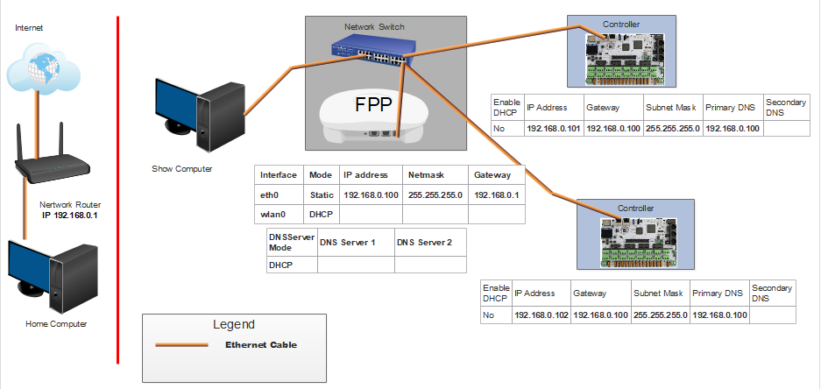

Note: In this case, you can make your FPP IP address any valid IP address. All of your controllers will have an IP address that have the same first 3 sets of numbers as the FPP, and the last set of numbers must be unique.

#### Wired on Home Network

This method will use your home network for the E.131 data transmission. This is not used very often.

* All of your FPPs and controllers will have connection to the internet so updates can be performed from your home computer.
* Your FPP will have access to a Network Time Protocol so it will keep time for scheduling if you set up the NTP.
* If you only have one controller, then you can connect FPP directly to the controller with an Ethernet cable connected to the appropriate ports.
* You will need Ethernet cables run from the home network router to the FPP and each controller.
* Your show data will be transmitted using your home network which might cause a slowdown or lag on your overall network.
* Make sure you have the Channel Inputs/Outputs for each FPP set correctly.
* FPP mode should be set to Player (Standalone)

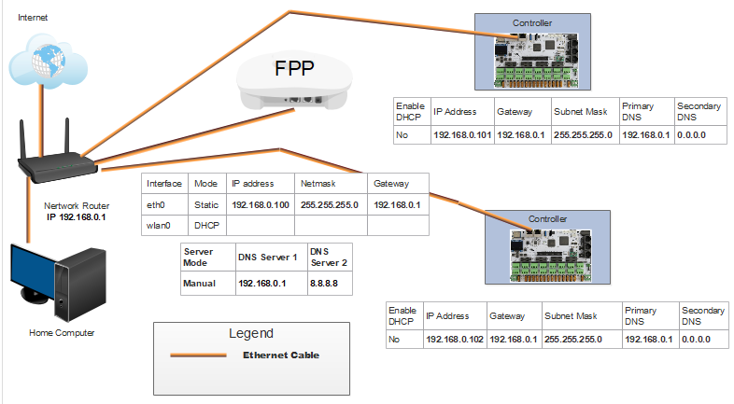

Note: All of the IP addresses have the same subnet (first 3 sets of numbers) as the home network router, in this case, 192.168.0 and the last set of numbers is unique. All of the gateways are the same as the IP address of the home network router, in this case, 192.168.0.1. Your network might be different depending on your home network router’s address.

#### Wired with Separate Show Network

This method will provide a separation of the network traffic from your home network traffic and still allow internet access for FPP/Controller updates. This is one of the more common methods that are used. In order to access the controllers that are on the show network, you have to provide a method for the two networks to communicate with each other. There are two methods, adding a static route in your router or creating a route path in your computer. If you create a static route in your router, then all computers on your home network can access your controllers, but not all routers have a static route function. When adding a route path in a Windows computer, you can make it persistent so that if you turn off the computer, you can still access the controllers when you turn it back on. Macs don’t have the persistent attribute to their route function so you will have to re-enter the route if you reboot your computer.

* All of your FPPs and controllers will have connection to the internet so updates can be performed from your home computer.
* Your FPP will have access to a Network Time Protocol so it will keep time for scheduling.
* If you have more than one controller then you will need a switch. If you only have one controller, then connect FPP to the controller with an Ethernet cable connected to the appropriate ports.
* You will need Ethernet cables run from the switch to the FPP and each controller.
* Make sure you have the Channel Inputs/Outputs for each FPP set correctly.
* Make sure you have the Enable Routing between network interfaces checked in the Network settings of the FPP
* FPP mode should be set to Player (Standalone)

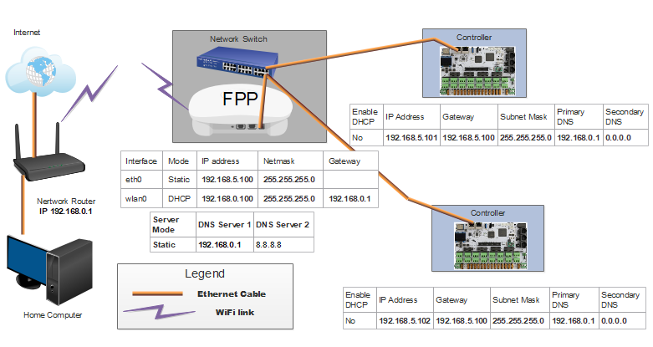

Note: The FPP wlan0 IP address will be on the same subnet (first 3 sets of numbers) as the home network router, in this case, 192.168.0. The eth0 on the FPP and the controllers will be on a different subnet, in this case, 192.168.5 (you pick the subnet). Do not put a gateway address for the eth0 on the FPP. The gateway on the FPP wlan0 should be the same as your home router IP address. The gateway(s) on all of the controllers should be the same as the eth0 IP for your FPP. You will need to set up routing to your controllers. Your network might be different depending on your home network router’s address.

#### Master/Remote

This method eliminates the need for Ethernet cables connecting your FPPs and controllers even though you could use a wired network if you want. You will need an FPP device at each remote location. This is one of the more common methods that are used especially in larger shows or ones that are spread across a large area. The Master FPP will send a very small sync package over your wireless network. Each FPP will need a copy of the .fseq files to play (or the video if you are using the remote FPP to play a video through a projector). In order to access the controllers that are on the show network, you have to provide a method for the two networks to communicate with each other. There are three methods; you can set the FPP device to be a Proxy Host (see Proxy Settings in the Status/Control section), adding a static route in your router or creating a route path in your computer. If you create a static route in your router, then all computers on your home network can access your controllers, but not all routers have a static route function. When adding a route path in a Windows computer, you can make it persistent so that if you turn off the computer, you can still access the controllers when you turn it back on. Macs don’t have the persistent attribute to their route function so you will have to re-enter the route if you reboot your computer.

* All of your FPPs and controllers will have connection to the internet so updates can be performed from your home computer.
* Your FPP will have access to a Network Time Protocol so it will keep time for scheduling if you set up the NTP.
* You do not need a network switch.
* You will need an FPP device at each remote location.
* You will not need any Ethernet cables.
* You will need a good Wi-Fi connection at all of your remote FPP devices.
* The Master FPP will need all media and sequence files stored on it.
* Each Remote will need all the sequence files and any videos, etc that it will be playing directly stored on it.
* Make sure you have the Channel Inputs/Outputs for each FPP set correctly.

# 

Note: The all of the FPPs wlan0 IP addresses will be on the same subnet (first 3 sets of numbers) as the home network router, in this case, 192.168.0. The eth0 on the Remote FPPs will each be on a separate subnet and the attached controller will have an IP address in the same subnet as the eth0 subnet of the attached FPP. Do not put a gateway address for the eth0 on the FPPs. All of the FPP wlan0 gateways are the same as the IP address of the home network router, in this case, 192.168.0.1. Your controller’s gateway will be the eth0 IP of the attached FPP. You will need to set up routing to each your controllers. If you have 3 controllers, then you will have 3 routes. (If your controller is a hat or cape attached to a Pi/BB, then you don’t need to create a route for those) Your network might be different depending on your home network router’s address.

For an in depth discussion, refer to this post:

https://falconchristmas.com/forum/index.php/topic,4231.0.html

## Booting from eMMC on BeagleBone

Normally, FPP is set up to boot from the uSD card. You should keep the default setting of booting from the uSD Card. If you have special requirements, you can have FPP boot from the internal storage on the BeagleBone.

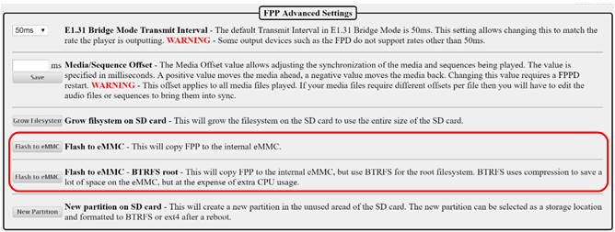

There are two options on the file format that you want the boot system to boot from. You can choose the normal version or the BTRFS. The BTRFS version is a compressed version and will save space, but will impact the CPU performance slightly.

## Using USB for Media Storage

You can use a USB Drive to store your media and sequences. This isn’t really necessary with the price of uSD drives dropping and the better speed that uSD cards provide, but you can use a USB drive to store your media files if you would like.

Go to the Status/Control tab and click on the FPP Settings link.

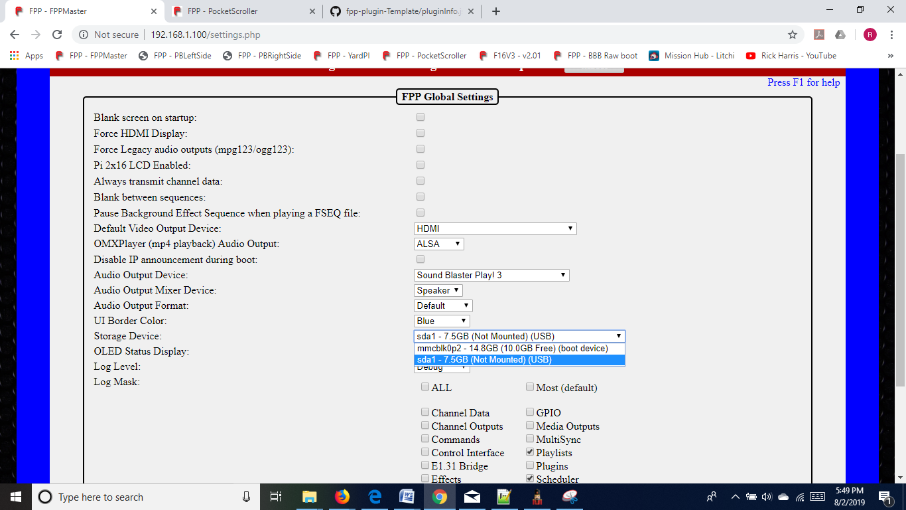

On the Storage Device drop down menu, select your USB device. Once that is selected, you will get this option:

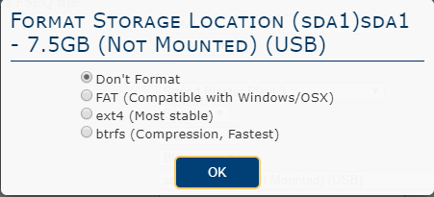

* Don’t Format- This will leave any files that are on the USB drive and will not change the USB Partition type.
* FAT (Compatible with Windows/OSX)- This will erase all of the files on the USB drive and then format the partition to be FAT. FAT formatted drives can be read by both Windows and Mac computers.
* ext4- This will erase all of the files on the USB drive and then format the partition to be ext4. ext4 formatted drives can be read by Linux operating systems (FPP is Linux based) Windows and Mac computers cannot natively read ext4 formatted drives.
* btrfs- This will erase all of the files on the USB drive and then format the partition to be btrfs. btrfs formatted drives can be read by Linux operating systems (FPP is Linux based) Windows and Mac computers cannot natively read btrfs formatted drives.

Once the formatting option is selected, FPP will give you the option to copy your FPP files/settings to the USB drive.

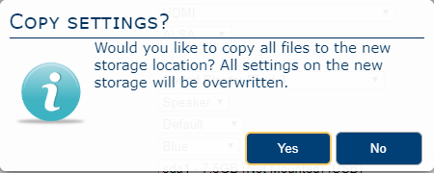

The typical files/settings that are saved on the USB device are your configuration settings, network settings, sequence files, playlists, and media files. This is useful if you need to make a copy of your existing settings and media files onto your USB drive.

## Plugins

There are several Plugins available from the FPP install, but you are not limited to those. You can install Plugins from a third party or create your own. Plugins should have installation information on the developer’s web page. Some of the more commonly used Plugins are:

* Big Buttons- This Plugin will create a web interface within FPP so that a user can click on one of several buttons that will start a predefined script.
* Matrix Tools- This plugin allows you to control a matrix to add text or a drawing in real time.
* Event Date- This will allow you to generate a dynamic countdown to a specific date and display the results on a matrix. This plugin requires a few other plugins to be installed in order to function properly
  + Message Queue Aggregator for Plugins- This is a repository to store and manage messages so that other plugins can send messages to this plugin for processing at a later time.
  + Message Queue to Matrix Overlay- This plugin will coordinate with the Message Queue Aggregator for Plugins to output the accumulated data.
  + Matrix Tools
* Plugin to download Weather information for Message Queue- This will allow you to get the current weather data for a certain location and display it on a matrix. (This is not functioning on FPP >2.5 and when fixed, the manual will be updated.)

### Big Buttons

The Big Buttons Plugin will create a web page with several buttons so that a user can click on one of the buttons which will activate a predefined script such as starting a playlist or a particular song to name a few of the common scripts. To install the Big Buttons Plugin, go to the Plugin Manager in the Content Setup section of FPP and click the download button.

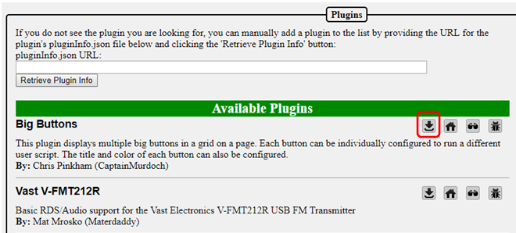

Once the Big Buttons Plugin is installed it will need to be configured. Go to the Content Setup tab and click on the Configure Big Buttons.

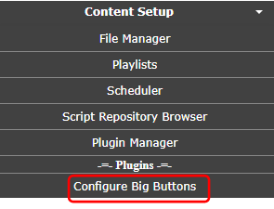

By default, you can have up to 20 buttons and each one can start a different script. You can write your own script or download one from the Script Repository. You can set a title for your Big Button page, select the color for each button, select the text size, and the text for each button.

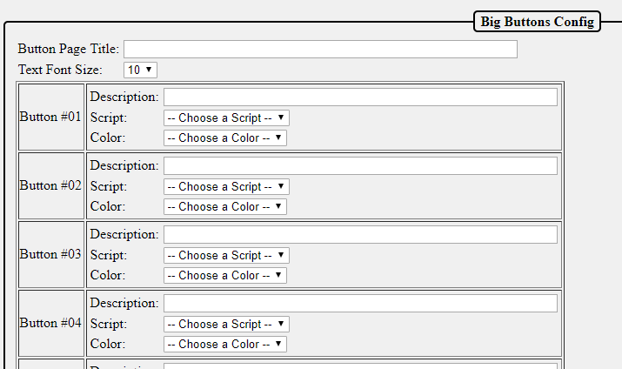

This will demonstrate creating a four button page where three buttons will play a particular song and the fourth button will play the master playlist. You will need to create three one song playlists for the songs that they can select and you have to create a master playlist. You will need to create four scripts for the actions for each button. I used the pre-installed script from the Script Repository.

Here is the script to start the playlist I created for Mary Did You Know.

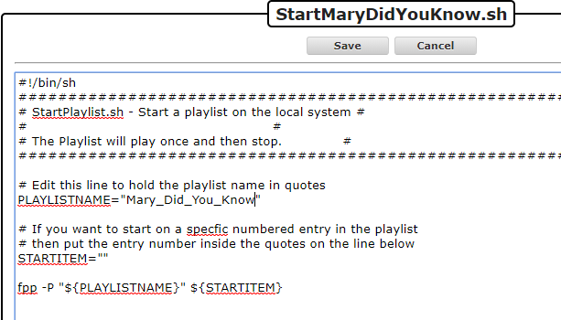

Note: This is a simple script and will immediately start the selected playlist, if you want the playlist that is playing to end gracefully, then you will have to modify the script accordingly.

1. Add a page title.
2. Select the font size.
3. Enter the description for the first button.
4. Select the predefined script to start the selected song.
5. Select the color for the button.
6. Repeat for the other 2 buttons
7. Enter the description for the fourth button.
8. Select the predefined script to play the master playlist.
9. Select the color for the button.

Note: There is no Save button, once you enter the information, it is saved.

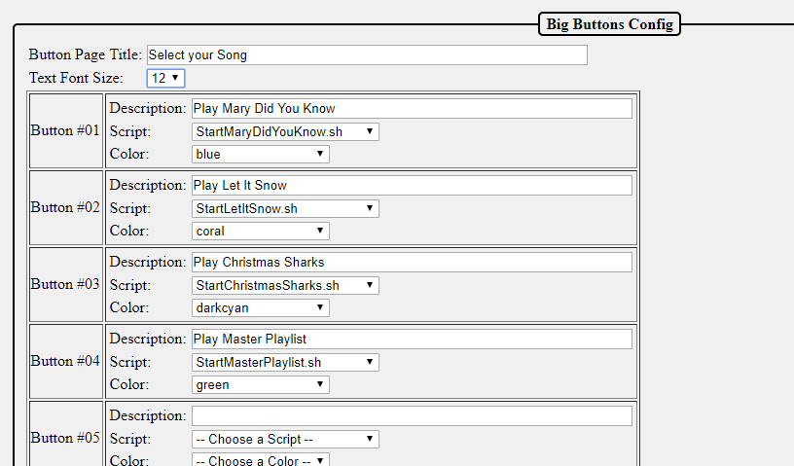

To load the page, go to the Status/Control section and select the Big Buttons Plugin

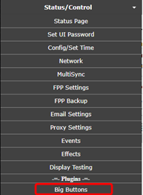

You will get a screen similar to this:

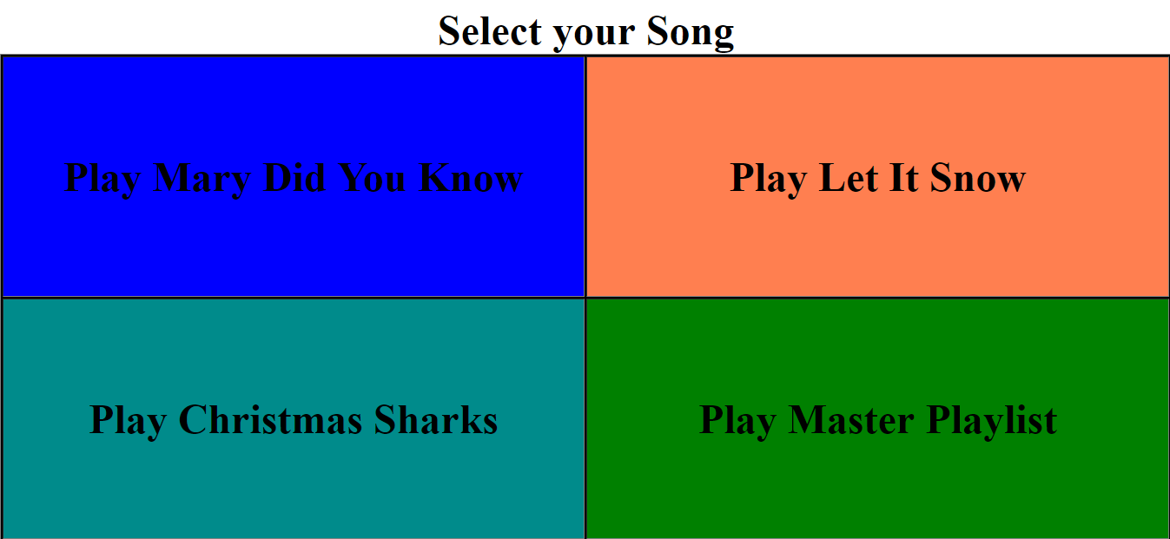

Clicking on the button will start the selected playlist. The button will momentarily change color when clicked to indicate it was pressed. The buttons can control just about anything in FPP as long as you can write a script for it.

### Matrix Tools

The Matrix Tools Plugin will allow a user to display text and or draw on a matrix in real time. Other Plugins can use the Matrix Tools as well to draw on the matrix. To install the Matrix Tools Plugin, go to the Plugin Manager in the Content Setup section of FPP and click the download button.

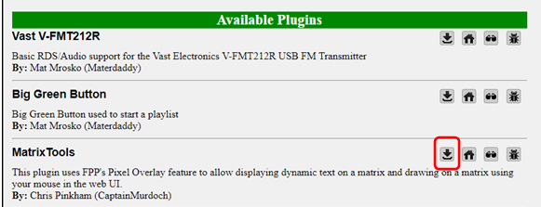

In order to use the Matrix Tools, you need to create a Pixel Overlay Model for your matrix. You can manually enter this in the Input/Output Setup section of FPP or export your models from xLights. Make sure that the channel numbers are correct in the Channel Outputs>LED Panels and the Pixel Overlay model.

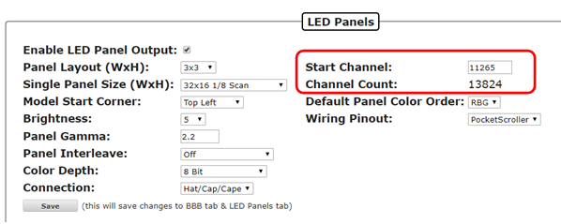

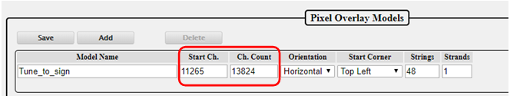

Once the Matrix tools are installed and you have the Pixel Overlay Model configured, you can open the Matrix Tools from the Status/Control section of FPP.

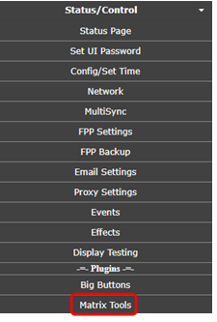

You will get a screen similar to this:

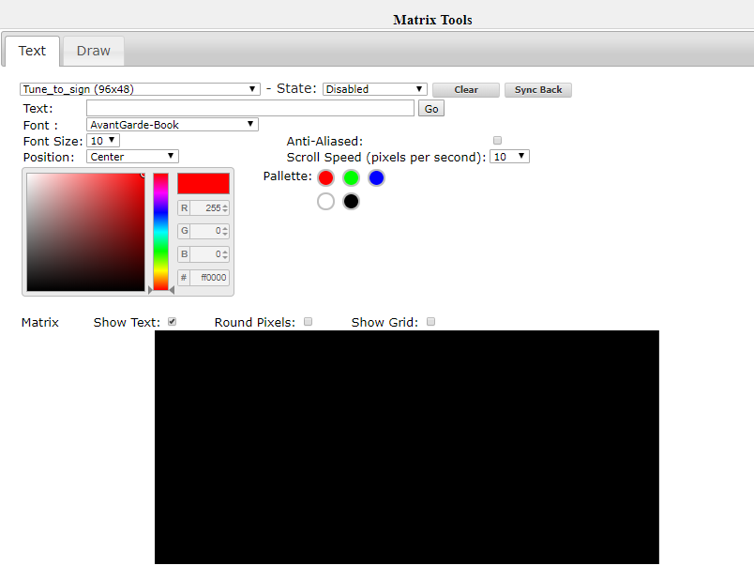

If you have more than one Pixel Overlay Model configured on this FPP then you will have to select the Pixel Overlay Model for your matrix in the first box. There are two tabs to use for the Matrix Tools, Text and Draw. Text allows you to type text and show that on the matrix with several options to display the text. The Draw tab allows you to directly draw on the matrix. You can have text displayed and draw on the Pixel Overlay Model.

Both tabs share:

* Pixel Overlay Model- This will list all of your Pixel Overlay models; choose the model that you want to display the live data.
* State- There are four different states
  + Disabled- This is the inactive state for the Matrix tools
  + Enabled- This will stop all other data going to your Pixel Overlay Model and display only the data from the Matrix Tools.
  + Transparent- This will not stop other data coming into the Pixel Overlay Model and will display the Matrix Tools data at the same time. This will combine the channel data so will not display RGB colors correctly. This is only recommended for single color matrices.
  + Transparent RGB- This will not stop the other data coming into the Pixel Overlay model and any Matrix Tools data will override the other data being displayed and this is the recommended setting if you want to display the Matrix Tools data over the other incoming data.
* Clear- This will clear any Matrix Tools data that is displaying on the Pixel Overlay Model.
* Sync Back- This will synchronize the data that is displaying on your Pixel Overlay model, not just the Matrix Tools data. **This is not recommended as it very CPU and web interface intensive and will slow everything down.**
* Color Picker- You can select the color using various methods in the color picker. You can click in the Hue slider to get the approximate color and then select the exact shade in the main window, enter the RGB value or enter the hexadecimal value for the color.
* Palette- You can select some of the basic colors which will in turn update the color picker to the palette color you selected.
* Preview screen- This will show you an approximation of how your text is displaying. You can change the appearance on the Preview Screen to be round or square pixels and you can show a grid to indicate the positions of all the pixels

The Text tab displays:

* Text- Type the text that you want to display.
* Go- After you have entered all of the attributes for the text to display, press the go button to display the text.
* Font- Select the type of font that you want the text to display.
* Font Size- Select the size of the font for the text to display.
* Position- You can select where you want the test to display, either centered, or scroll from left to right, right to left, bottom to top or top to bottom.
* Anti-Aliased- This will add shading to help eliminate the sharp edges.
* Scroll Speed- Sets the speed at what the text will scroll if you select one of the scrolling options.

The draw tab displays an auto fill and block fill option to fill the entire Pixel Overlay Model. To draw on the Preview screen, left click and hold down the mouse button and draw your desired design.

### Message Queue Aggregator for Plugins

The Message Queue Aggregator for Plugins is a helper plugin used to store and manage messages from other Plugins. To install the Message Queue Aggregator for Plugins, go to the Plugin Manager in the Content Setup section of FPP and click the download button.

.

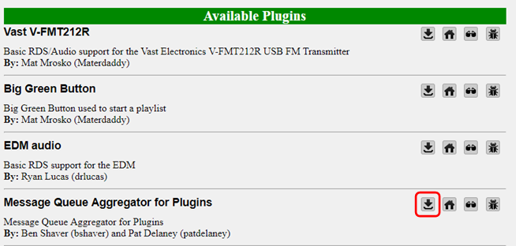

Once it is installed, you will have to go to the MessageQueue Plugin page from the Input/Output Setup section in FPP.

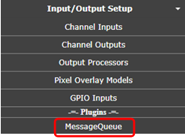

On this page you have to enable the plugin to activate it. You can manually delete any messages that are stored in the database from this page if you want. You can change the message database file path but it is not recommended to do so.

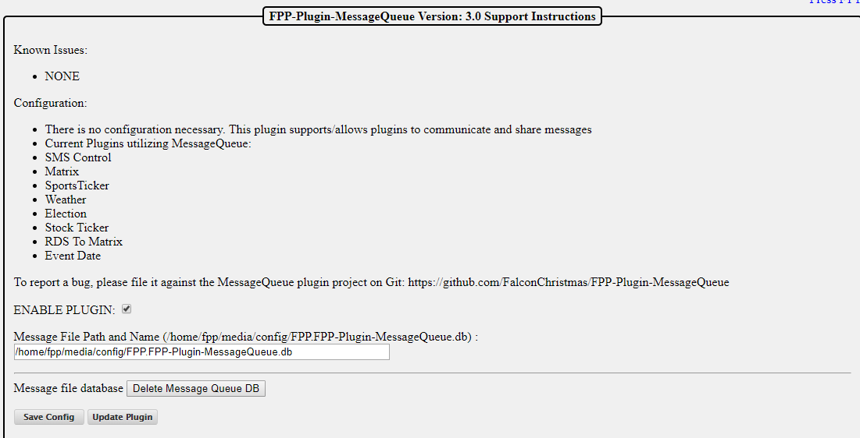

### Message Queue to Matrix Overlay

The Message Queue to Matrix Overlay Plugin is another helper plugin and it is used to read the messages in the Message Queue Aggregator Plugin and display the data when it is requested from another Plugin. To install the Message Queue to Matrix Overlay, go to the Plugin Manager in the Content Setup section of FPP and click the download button.

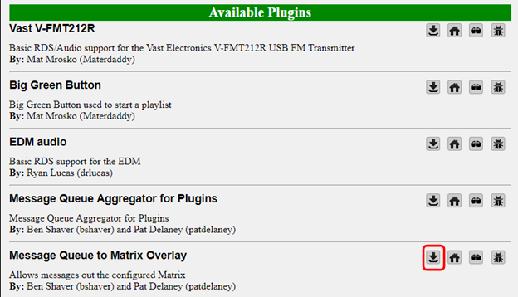

Once it is installed, you will have to go to the MatrixMessage Plugin page from the Input/Output Setup section in FPP.

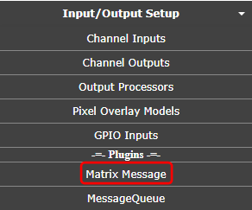

From this page, there are several configurations

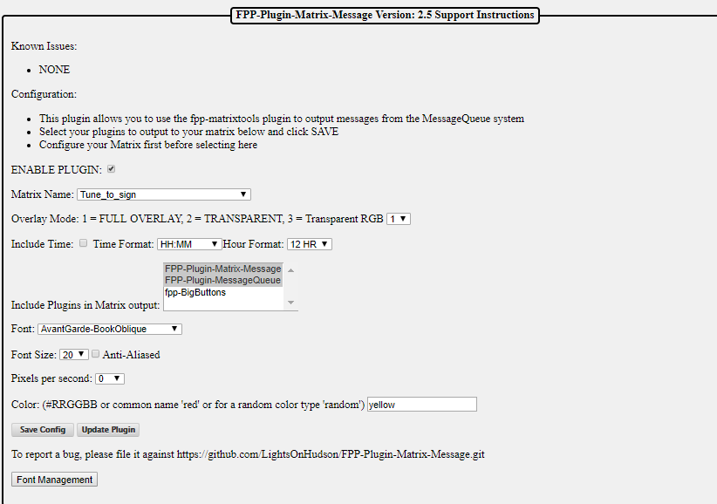

You need to configure the following settings:

* Enable Plugin- This needs to be checked to make the plugin active.
* Matrix Name- This is the Pixel Overlay Model that is your matrix.
* Overlay Mode- This is the setting from the Matrix tools on how to display the message. Select the number that corresponds to the effect you want. Full Overlay is the most common.
  + Full Overlay will block all other data being sent to the matrix.
  + Transparent will not stop other data coming into the Pixel Overlay Model and will display the Matrix Tools data at the same time. This will combine the channel data so will not display RGB colors correctly. This is only recommended for single color matrices.
  + Transparent RGB will not stop the other data coming into the Pixel Overlay model and any Matrix Tools data will override the other data being displayed and this is the recommended setting if you want to display the Matrix Tools data over the other incoming data.
* Include Time- If this box is checked, the when the messages are displayed, it will include the current system time so make sure you have an NTP or Real Time Clock configured.
* Include Plugins in Matrix Output- Select the plugins that are sending information to the Message Queue and that you want to display on your matrix. To select more than one plugin, hold down the Ctrl key and click each additional plugin that you want to manage.
* Font- Sets the font style that you want to display.
* Font Size- Sets the font size that you want to display.
* Anti-aliased- Will try to eliminate the jaggy edges on some fonts by applying shading.
* Pixels per Second- The speed that the message will scroll across the matrix.
* Color- The color for the displayed text. You can use the hexadecimal color notation or the common color name.
* Save Config- Will save the current configuration.
* Update Plugin- You can update the plugin if there is one available.
* Font Management- You can install other fonts if you need to from this function.

### Event Date

The Event Date Plugin will allow your matrix to display a dynamic countdown to a particular event. You can have other text included with the countdown if you desire. The Event Date Plugin needs 3 other plugins installed and configured in order to work correctly.

* Message Queue to Matrix Overlay
* Message Queue Aggregator for Plugins
* Matrix Tools

To install the Event Date Plugin, go to the Plugin Manager in the Content Setup section of FPP and click the download button.

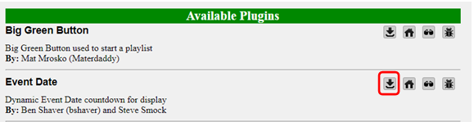

Once it is installed, you will have to go to the Event Date Plugin page from the Input/Output Setup section in FPP.

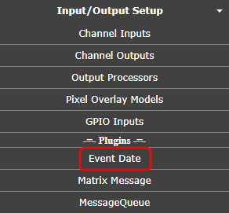

You need to configure the following settings:

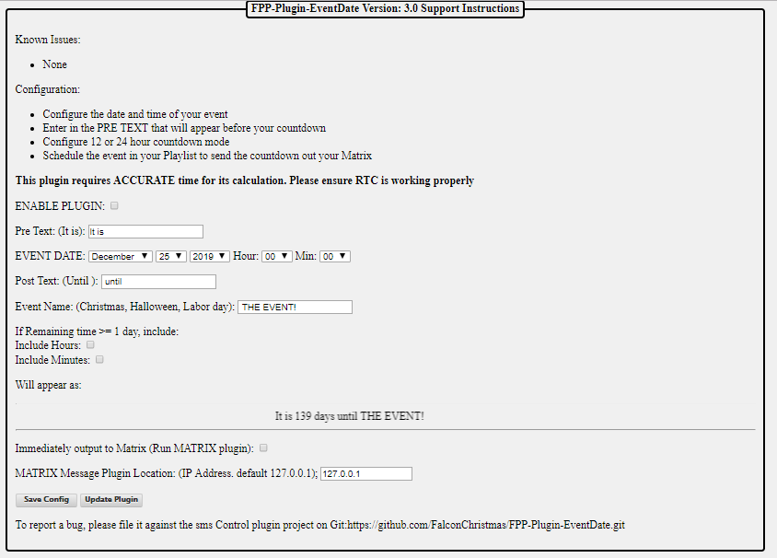

You need to configure the following settings:

* Enable Plugin- This needs to be checked to enable the plugin.
* Pre Text- Enter the text that you want to display before the countdown date.
* Event Date- Enter the date of the event.
* Post Text- Enter the text that you want to display after the countdown date.
* Event Name- Enter the name of the event that you are counting down.
* If Remaining time >= 1 day include.
  + Include Hours-
  + Include Minutes-

On the last day, the countdown will display the hours and minutes to the event, you can include the hours and minutes for the entire countdown by checking this box.

* Will appear as- This shows how the display will look.
* Immediately output to Matrix- If this box is checked, anytime the EventDate plugin is triggered, the message will be displayed on the matrix. If it is not checked, then the EventDate data will be stored until it is displayed using the RUN-MATRIX.sh script.
* Matrix Message Plugin Location- By default the IP address is 127.0.0.1 which is the loopback address of the Pi and should not be changed unless you are using some advanced configurations.
* Save Config- This will save the changes that you have made to the Plugin.
* Update Plugin- This will check for updates to the Plugin and install them.

To use the EventDate Plugin you have to run the RUN-COUNTDOWN-SCRIPT.sh script that is in the Script section of the File Manager (you will need to have the “Immediately Output to Matrix” checked). This is usually accomplished by incorporating the RUN-COUNTDOWN-SCRIPT.sh in a playlist but it can be triggered manually, through events or any other method that can trigger a script.

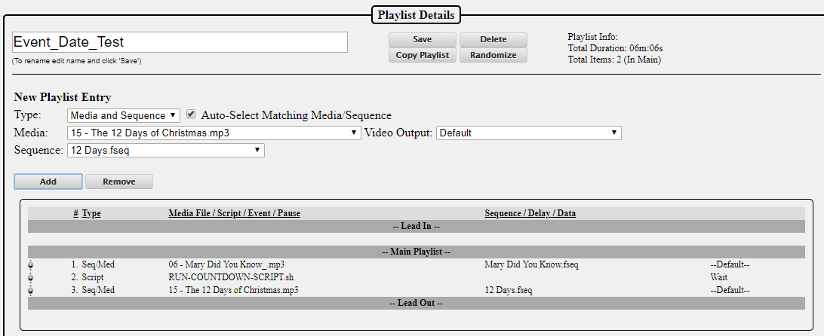

A script does not act like a sequence, it is just a trigger so if you have a sequence playing after running the script, then you will need to indicate in the playlist to wait for the script to complete before starting the next item in the playlist.

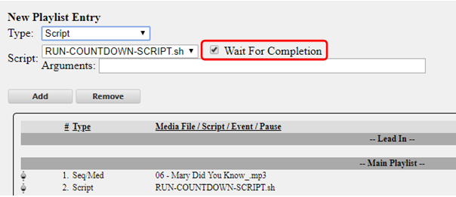

### Plugin Development

If you want to develop a plugin, then you can go to the Plugin Manager in the Content Setup section of FPP.

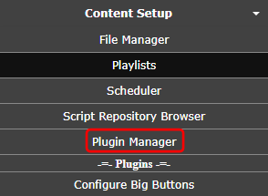

On this page is a Plugin template that has a shell for all the components that you will need to incorporate a plugin into FPP.

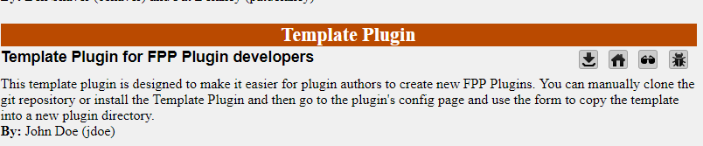

The best method is to go to the website for the template and clone the files into a GitHub repository of your own. Clicking on the Source Code or Home buttons will take you to the GitHub repository for the Template Plugin.

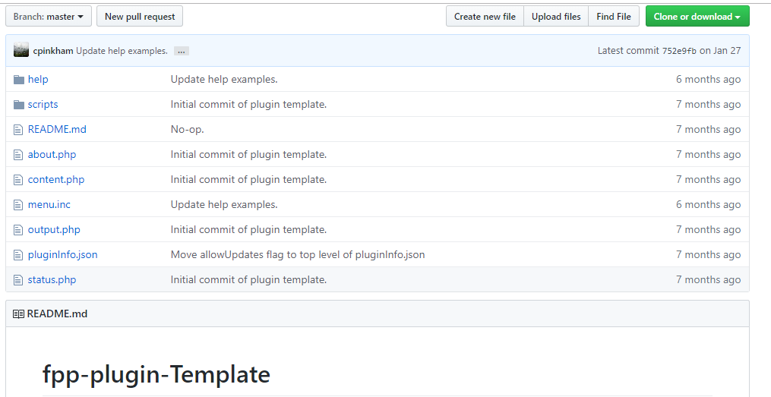

The template has the following files and it is recommended to follow this file structure:

* Help- This is a folder to hold the relevant help files for your plugin and it is highly recommended to document the installation, configuration and operation of your plugin. The Help files will be available to the user when they hit the F1 key or click the “Press F1 for Help” link at the top of your page. The file name for your Help file needs to match the file name for the page it is related to, but you are not limited to the suggested files. You can have pages with a different file name, you will need to include a matching help file with the same file name The Help folder has the following files and if you don’t have a page with a matching name, then you can (not mandatory) delete the file.
  + content.php- This will have the help information, formatted in html, for your content.php file in the main directory.
  + help.php- This will have the help information, formatted in html, for your help.php file in the main directory.
  + output.php- This will have the help information, formatted in html, for your output.php file in the main directory.
  + status.php- This will have the help information, formatted in html, for your status.php file in the main directory.
* Scripts- This is a folder to hold scripts needed for your Plugin. There are some scripts that will run automatically at the appropriate time. These do not get saved in the Script folder in FPP. If there are scripts that the user will need to use, the Plugin author will need to copy those scripts into the FPP scripts folder, usually this can be accomplished by adding the copy routine in the fpp_install.sh file. The Scripts that run automatically are:
  + fpp_install.sh- This script will run when the user installs the plugin. If there are any special requirements for your plugin such as scripts or other files to be copied in the correct place, this might be the place to perform those functions.
  + fpp_uninstall.sh- This script will run when the user uninstalls the plugin. If you created any special files and they are not needed for any other application, then you can delete these and perform any other cleanup functions in this script.
  + postStart.sh- This script will run after fppd starts. If your plugin needs any processes to run prior to the user accessing your plugin, this is where you should put these functions.
  + postStop.sh- This script will run after fppd stops and can be used for any cleanup processes.
  + preStart.sh- This script will run right before fppd starts.
  + preStop.sh- This script will run right before fppd stops.
* README.md- This file is used to display relevant information in regards to your plugin and will be displayed in the GitHub main page for your plugin. If your plugin requires another plugin to function, you might want to include it here as well.
* about.php- If you want to have an about informational page for your plugin, then you can use this template to display your about webpage. You will need to provide a link to it.
* content.php- This is a placeholder file for demonstration purposes. You can name your plugin file(s) anything you want, just make sure you link them properly in the menu.inc file.
* menu.inc- This file is required to provide navigation for your plugin.
* output.php- This is a placeholder file for demonstration purposes. You can name your plugin file(s) anything you want, just make sure you link them properly in the menu.inc file.
* pluginInfo.json- This is a required file.
* status.php- This is a placeholder file for demonstration purposes. You can name your plugin file(s) anything you want, just make sure you link them properly in the menu.inc file.

Once your plugin has been created, you can load your plugin by following the instructions for Retrieving Plugin Info in the Plugin page. If you would like to have your plugin available to other users, post the information in the Plugin section of the Falcon Christmas forum and if approved, a link will be added to the Available Plugins section.

# Resources

## Help

There are several resources available for help, here are a few of the more popular help resources are:

<http://falconchristmas.com/forum/> -This forum is very active and you can usually get a response fairly quickly.

<http://auschristmaslighting.com/forums/> -This forum is also very active and you can usually get a response fairly quickly. You don’t have to be from Australia to post here.

<https://auschristmaslighting.com/> - This is the parent site for the auschristmaslightingforums and there are several resources there, one that is a must have is the AUSManual101.pdf. You need to register it in order to download the manual.

[http://www.xLights.org](http://www.xlights.org) This website has links to several resources including a forum. The information is geared towards xLights users but it is not exclusively xLights.

[http://videos.xLights.org/](http://videos.xlights.org/) -This website has several videos on all aspects of the Holiday Lighting hobby.

<https://www.youtube.com/channel/UCby1v6Kbi8AHMkV2yMyF1MQ/featured> - This is the Canispater Christmas YouTube channel and there are many very informational videos.

<https://zoom.us/j/175801909> - This website will take you to a live video conference site. They have xEssential training classes every Wednesday at 8:00 PM Eastern time, but there is usually someone there most of the time and is a good way to get instant help. You will have to install the software the first time you go to the website.

## Networks

Networks have been troublesome for most of the people getting started in the animated holiday lighting hobby. This is a **very basic overview** and should give you enough information to understand networks and troubleshoot them.

A network is a group of computer devices identified by an IP address. Networks are broken down into groups, typically called subnets. Think of an IP address as a telephone number. In order for devices to be able to communicate with each other, every device needs a “telephone number” (from now on called IP address) and they need to be a unique number. All IP addresses are formatted with 4 groups of numbers, each one separated with a “.” The numbers can only be 0-255. So they would look something like 192.168.110.23 or something similar. The first 3 sets of numbers are like an area code (192.168.110 in 192.168.110.23) and is called a subnet and the last set of numbers is like the “phone” number and is the device number (23 in 192.168.110.23). Only devices on the same subnet (having the same numbers in the first 3 groups) can communicate directly with each other. Any device in your network can communicate **directly** to any other device in your network that is in the same subnet, “area code” just like you can call someone directly by only dialing the 7 digit phone number.

If one device needs to communicate with another device that is on a different subnet, then that is similar to you trying to call someone in a different area/country code. You have to enter some additional “routing” information so the call can be routed to the correct number. When a device on a network receives a request to “call” a device in a different subnet, it does not know how to process the request so it will send the request to a Gateway. A Gateway is similar to an old fashioned operator. The Gateway can be any device that has an IP address but on the same subnet as the device sending the request and the Gateway needs to be able to process the routing of the data. The Gateway is usually your home network router or FPP device that is between a controller and the show network. The Gateway only has a small “phonebook” to know how to route the traffic. If the Gateway receives an IP address that it doesn’t know how to process, it will forward that request to the Gateway it has designated in its settings. Sometimes special instructions need to be given to the Gateway in order for the signals to get where they need to go and this is commonly done by establishing what is called a Static Route.

You can set up a Static Route in your computer. When you have set up a static route in your computer and your computer is told to send information to an IP address that is in the Static Route table, it will attach the routing information to the data package and route it directly to the IP address. If the IP address isn’t in within the computer’s subnet, then it will send this routing information and data to its Gateway for processing. By having a Static Route set up in your computer, then only that computer will be able to communicate with the device that you are trying to communicate with unless you set up Static Routes on every computer in your network. Most routers will let you set up Static Routes and that way all computers in the local network will have access to the routing information. In Windows, you can set up the route to be persistent, meaning that it will be permanently stored on the computer. Mac computers do not have the persistent ability, so if you turn off or reboot your computer, you will need to add the Static Route again.

## Universes, Channels and Ports, oh my!

Many people have problems understanding the terminology and usage of channel addressing and ports. The developers are working on a few methods to eliminate the need to understand this but until it gets implemented this should help. A port is just a place to connect your string of pixels. The controller will usually have several ports and the controller needs to know what data to send to each port. Our lighting networks usually have tens of thousands of channels and there needs to be a way to identify where each pixel is located. In other words, all of your devices (and you) need to know where every pixel is, what model it is on, what controller is sending the data for that model and what port(s) are being used to send the data to the pixel strings.

The animated holiday lighting evolved from DMX data and incorporates its protocol to send data and that protocol is Universes and Channels. By definition a Universe can have any number of Channels in it up to a maximum of 512 channels (you are the one who decides how many channels you want your Universes to address).

You can use Absolute Addressing where each pixel is assigned 3 channels and it is basically just a numbering from 1 to however many channels you need but this can sometimes get confusing and difficult to manage. You can break it down into Universes and Channels to help make it easier to manage.

Think of it this way, your lights are a long string of pixels. Let’s correlate the pixels to people. The people have families, some are bigger than others. The families are equivalent to the models in your show. All the families are going to go on a train ride. The train cars only have single file seating so it is one person in front of the other. All the passengers will get a drink while on the train. The drink represents the data sent to your pixels to know what color to create. The travel agent (equivalent to the sequencing software) will create a list of all the passengers and the drink they ordered. The travel agent does not know what size the train cars are going to be so it will just assign the passengers’ seating from front to back and assign their drink order to the position in the list. The train Terminal (equivalent to the controller) will coordinate the passenger seating and drink order with the attendants (the attendants are similar to the ports on your controller). The attendants, for whatever reason (union issues maybe? LOL), do not deliver drinks to the same number of people. The Terminal will know what size each train car is going to be for this trip and how many drinks each attendant will serve. The train car comes in different sizes but the biggest one can hold 512 people. The cars correspond to Universes. So to deliver the correct drink to the correct person, the Terminal will give each attendant the drinks they need in the order of the passengers in their section and tell them where to start serving.

For example, a particular trip will have 1578 people. This particular trip will use cars that hold 512 people, but the cars don’t always have to be the same size. The Terminal will assign 4 cars for this trip to hold everyone. Attendant 1 can serve 490 drinks, attendant 2 can serve 560 drinks, attendant 3 can serve 520 drinks and attendant 4 can serve 580 drinks. The Terminal will give attendant 1 490 drinks in order and tell him to start at car 1 seat 1. The terminal will give attendant 2 560 drinks in order and tell him to start at car 1 seat 491 (he will have enough drinks to serve the last section of the first car, the entire second car and 26 people in the third car). Then give attendant 3 520 drinks in order and tell them to start at car 3 seat 27 and give attendant 4 8 drinks in order and tell him to start at car 4 seat 35 (you should be able to do the math to see how this worked).

This is very similar in many ways to how Universe/Channel addressing works. When you are setting up your show, YOU decide how big your Universes are as long as they are no bigger than 512 channels. You can have Universes of different sizes (be careful with this as it might cause confusion).

A few things to note:

* There is no direct correlation between ports on a controller and the Universe/Channel addressing. The port just needs to know which Universe and channel to start on and how many pixels it is sending data to just like the attendant doesn’t care how many cars are on the train or how many passengers are on the train. They just need to know which car to get on and which seat to start serving drinks to and when he runs out of drinks, he is done.
* The cars can have an arbitrary number assigned to them, the Terminal can have a number printed on the car and call the first car 100 the second car could be number 215 and as long as the attendants know the car number and what seat to start with, it works. Just like your universes don’t have to start at number 1 and don’t need to go up sequentially.
* The cars can be any size (up to 512) and not all cars have to be the same size. Again, the ports (attendants) only need to know which car to get on and what seat to start serving drinks.
* A port can supply data to part of a Universe or more than one Universe.
* A port doesn’t need to start at the beginning of a Universe or even at the beginning of a model, just like an attendant doesn’t need to start at the beginning of a car or beginning of a family. But for management purposes there are some times that you might want to start at the beginning of a Universe or a model. The choice is yours.